**Course Number: 420-DW4-AS**

**Course Title: Web Server Applications Development II**

**Session: Autumn 2024**

**Group: 7278**

**FINAL PROJECT REPORT**

**DUE DATE:**

**December 4th, 2024**

**SUBMITTED TO:**

**Teacher: QUANG HOANG CAO**

**BY:**

**Student ID: 2231473**

**Student Name: HUYNH TU ANH CHAU**

Contents

Project description 6

Project development 6

Phase I – Analysis 6

The Requirements 6

Functional Requirements Document 6

Phase II – Design 8

Tables 8

Relationship Diagram 11

System Architecture 11

Phase III – Implementation 11

Home Page (after running this program): 11

Owner Dashboard (after logging-in as an owner): 11

Manager Dashboard (after logging-in as a manager): 12

Tenant Dashboard (after logging-in as a tenant): 12

Phase IV – Testing 12

Screenshots 14

Home page when first running the app 14

Owner Login Screen 15

Manager Login Screen 16

Tenant Login Screen 17

Owner Registration Screen 18

Owner Registration Validation Screens 19

Tenant Registration Screen 21

Tenant Registration Validation Screens 22

Owner Dashboard After Logging-In Successfully 23

Owners Edit Their Profile Screen 23

Owner’s Details Screen 24

Owner Delete Validation Screen 24

Owner Views All Buildings and Having Details Button Only Screens 25

Owner Searches for Buildings Result Screens 25

Owner Views One Building’s Details Screen 26

Owner Views All Apartment and Having Details Button Only 27

Owner Searches for Apartments Result Screens 27

Owner Views One Apartment’s Details Screen 28

Owner Views All Tenants with CRUD Actions Screen 29

Owner Searches for A Tenant by Email Result Screens 29

Owner Edit One Tenant’s Details with Validation Screens 30

Owner Views One Tenant's Details Screen 31

Owner Deletes One Tenant with Confirmation Screen 32

Owner Views All Managers Screen 32

Owner Searches for A Manager Result Screen 33

Owner Creates a Manager Account with Validation Screen 33

Owner Views All Created Messages to a Manager with CRUD actions Screen 34

Owner Sends a Message to a Manager (fetching from database) with Validation Screen 34

Owner Edits a Message Screen 35

Owner Views One Message’s Details Screen 35

Owner Deletes a Message with Confirmation Screen 36

Owner Views Assigned Events Screen 36

Owner Edits Status of Assigned Events Screen 37

Owner Views One Event’s Details Screen 38

Manager Dashboard After Logging-In Screen 38

Managers Edit Their Profile with Validation Screen 39

Managers Delete Their Accounts with Confirmation Screen 40

Manager Views Assigned Buildings with CRUD actions Screen 40

Manager Edits One Building with Validation Screen 41

Manager Views One Building’s Details 42

Manager Deletes One Building with Confirmation Screen 43

Manager Searches for A Building Result Screens 43

Manager Creates a New Building with Validation Screen 44

Manager Views All Apartments related to Assigned Buildings with CRUD actions Screen 45

Manager Edits an Apartment’s Details with Validation Screen 45

Manager Views an Apartment's Details Screen 46

Manager Deletes an Apartment with Confirmation and Informative Message Screens 46

Manager Views Assigned Message Sent by Owners Screen 47

Manager Responses to A Message Screen 48

Manager Views One Message’s Details Screen 48

Manager Deletes a Message with Confirmation Screen 49

Manager Views Assigned Messages Sent by Tenants Screen 49

Manager Responses to a Message Screen 50

Manager Views a Message’s Details Screen 50

Manager Deletes a Message with Confirmation Screen 51

Manager Views All Created Appointments with CRUD actions Screen 51

Manager Edits an Appointment with validation Screens 52

Manager Deletes an Appointment with confirmation Screen 53

Manager Creates an Appointment with Tenants (fetching from database) with Validation Screens 54

Manager Views All Created Events with CRUD actions Screen 55

Managers Views and Edits Description of an Event Screen 55

Manager Views Details of an Event Screen 56

Manager Deletes an Event with Confirmation Screen 56

Manager Creates an Event with Validation Screen 57

Tenant Dashboard After Logging-In Screen 57

Tenants Edit Their Profile with Validation Screen 58

Tenants View Their Profiles’ Details 58

Tenants Delete Their Profile with Confirmation Screen 59

Tenant Views Only Available and Assigned Apartments with Details Button Screens 59

Tenant Searches for an Apartment Result Screens 60

Tenant Views All Created Messages with CRUD actions Screen 61

Tenant Edits a Message with Validation Screen 62

Tenant Views a Message’s Details Screen 62

Tenant Deletes a Message with Confirmation Screens 63

Tenant Creates a New Message to Managers (fetching from database) with Validation Screen 64

Tenant Creates a New Appointment with Validation Screen 64

Tenant Views All Created Appointments with CRUD actions Screen 65

Tenant Edits an Appointment with Validation Screen 65

Tenant Deletes an Appointment with Confirmation Screen 66

Conclusion 66

Sample Data for User Login 66

Login as an Owner 66

Login as a Manager 66

Login as a Tenant 67

Bibliography 67

# Project description

The project is a **Property Rental Management System** designed for Property Owners, Managers, and Tenants to interact with the system and perform their respective operations seamlessly. The system is developed using the **ASP.NET MVC Framework** and **Entity Framework** (Database First approach) for efficient database management. Development was carried out in **Visual Studio 2022**, while the database was designed and managed using **SQL Server Management Studio (SSMS) 19**.

This project utilizes **session-based tracking** to ensure that each user type (Owner, Manager, Tenant) has access only to functionalities specific to their session. The interface is designed with a focus on **user-friendliness** and **responsiveness**, allowing each user type to perform CRUD (Create, Read, Update, Delete) operations easily and securely.

Currently, the system supports **one Owner only** for interaction and management purposes. **Notice:** While this limitation is in place for further testing, the application currently allows new owners to be registered through the web interface.

**Testing Note:** During testing, it has been observed that if a record is deleted without fully handling dependencies (e.g., other records relying on that data), errors may occur. This behavior has been identified and is under further updates and testing to ensure proper dependency checks and handling in the code.

# Project development

## Phase I – Analysis

### The Requirements

include providing roles for Property Owners, Managers, and Tenants to interact with the system and perform specific CRUD operations.

### Functional Requirements Document

#### Owners can:

* + - * 1. Manage managers account (CRUD operations).
        2. Search for any managers by email.
        3. Edit, view details, and delete any tenant accounts.
        4. Search for any tenants by email.
        5. View all buildings and apartments (optional)
        6. Search for buildings by address, city, province, etc. (optional)
        7. Search for apartments by address, city, postal code, etc. (optional)
        8. Send messages to a manager.
        9. Edit message’s content, view details of message, delete sent messages which sent to a manager. (optional)
        10. View, update, and view details assigned events which are created by managers.
        11. Edit or view details or delete their own accounts. (optional)

#### Managers can:

* + - * 1. Manage buildings, apartments (CRUD operations).
        2. Search for assigned buildings by address, city, province, etc. (optional)
        3. Search for assigned apartments by address, city, postal code, etc. (optional)
        4. Manage appointments with tenants (CRUD operations).
        5. Response(Edit) to owners’ messages.
        6. View details or delete owners’ messages.
        7. Response(Edit) to tenants’ messages.
        8. View details or delete tenants' messages.
        9. Manage events with owners (CRUD operations).
        10. Edit or view details or delete their own accounts. (optional)

#### Tenants can:

* + - * 1. Register to Property Rental Management Web Site.
        2. View all apartments.
        3. Search for apartments by address, city, province, etc. (optional)
        4. View Details for each apartment. (optional)
        5. Send messages to a manager.
        6. Edit message’s content, view details of message, delete sent messages which sent to a manager. (optional)
        7. Book appointments with a manager.
        8. Edit or view details or delete their own accounts. (optional)

## Phase II – Design

### Tables

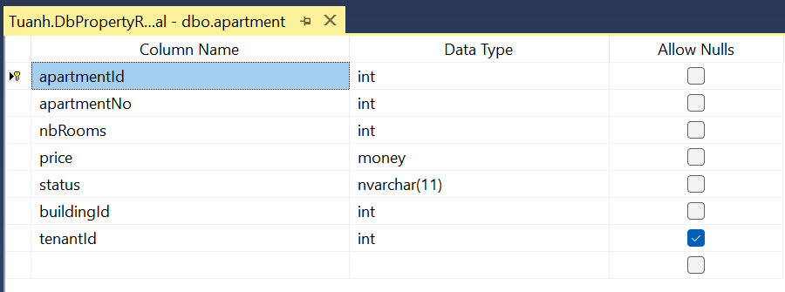

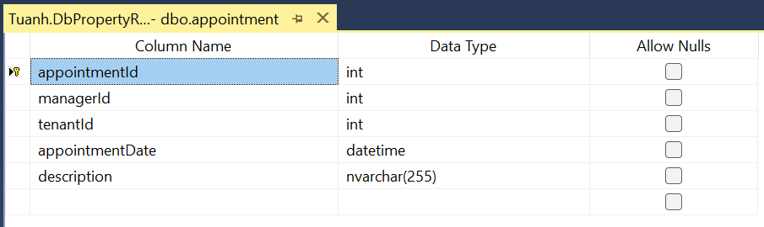

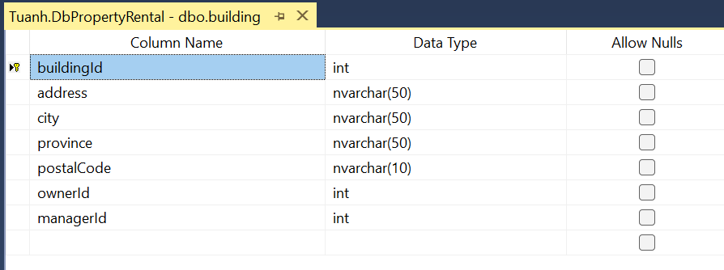

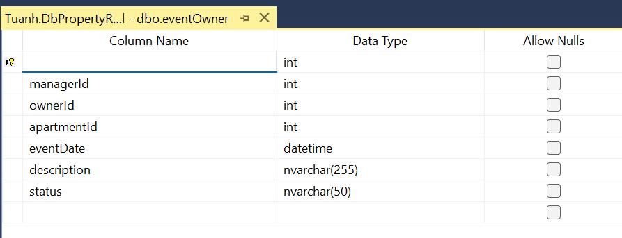

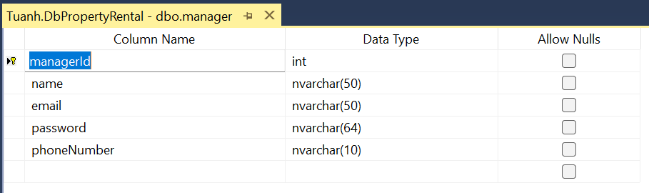

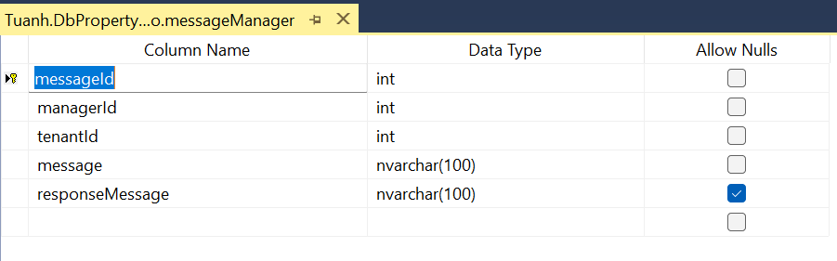

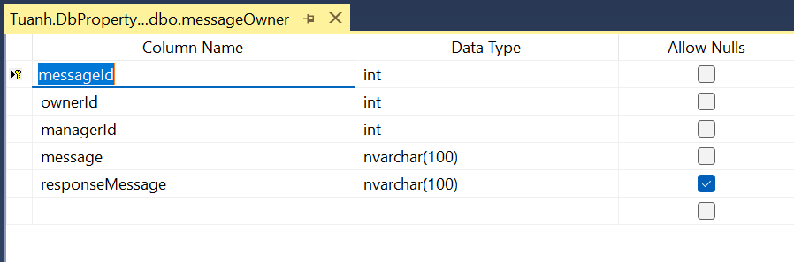

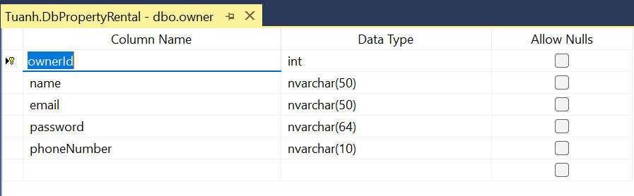

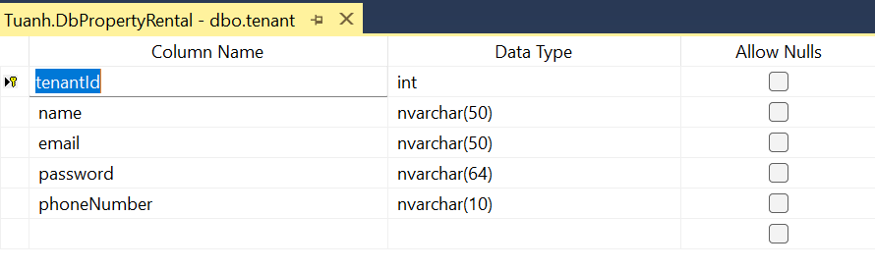

### A computer screen shot of a computer flow chart Description automatically generatedRelationship Diagram

### System Architecture

* + - * MVC (Model-View-Controller) pattern.
      * Session-based access control.

## Phase III – Implementation

### Home Page (after running this program):

* + - * Displays system information and **lists** available apartments.
      * Includes a **search bar** for filtering apartments by apartment ID.
      * Includes tabs to **login** as **owner/manager/tenant.**
      * Include tabs to **register** as **owners or tenants**.

### Owner Dashboard (after logging-in as an owner):

* + - * Edit or view details or delete their own accounts.
      * Access to manage **Managers** (CRUD operations and search functionality).
      * Access to manage **Tenants** (CRUD operations and search functionality).
      * View details of all **Buildings** and **Apartments** with search functionality.
      * Manage **messages** to a manager (CRUD operations)
      * View assigned **events** and update its status or view its details.

### Manager Dashboard (after logging-in as a manager):

* + - * Edit or view details or delete their own accounts.
      * Access to manage **Buildings** (CRUD operations and search functionality).
      * Access to manage **Apartments** (CRUD operations and search functionality).
      * Access to manage **messages** which are created by **owners**. Manager can response, view details, and delete messages.
      * Access to manage **messages** which are created by **tenants**. Manager can response, view details, and delete messages.
      * Access to manage **appointments** with **tenants** (CRUD operations).
      * Access to manage **events** with **owners** (CRUD operations).

### Tenant Dashboard (after logging-in as a tenant):

* + - * Edit or view details or delete their own accounts.
      * View all **Apartments** with search functionality.
      * Access to manage **messages** to **managers** (CRUD operations).
      * Access to manage **appointments** to **managers** (CRUD operations).

## Phase IV – Testing

|  |  |  |
| --- | --- | --- |
| **User Role** | **Functional Requirements** | **Result** |
| Owner | Create/Update/Delete/Search/List any property manager account | Passed |
| Owner | Not allowing to edit/create manager’s email that already existing. | Passed |
| Owner | View details of all Buildings and Apartments with search functionality. | Passed |
| Owner | Update/Delete/Search/List any potential tenant account. | Passed |
| Owner | * Not allowing to edit tenant ‘s email that already existing. * Allow bypassing Tenant model validation if leaving password field empty if owner does not want to edit existing password of the chosen tenant account. | Passed |
| Owner | Perform CRUD operations related to messages which will be sent to managers. | Passed |
| Owner | * Not allowing to edit manager ‘s email that already existing. * Allow bypassing Manager model validation if leaving password field empty if owner does not want to edit existing password of the chosen manager account. | Passed |
| Owner | Update assigned event’s status (Pending/Resolved) or view its details which are sent by managers. | Passed |
| Manager | Perform CRUD operations related to buildings, including search functionality. | Passed |
| Manager | Perform CRUD operations related to apartments, including search functionality. | Passed |
| Manager | Keep track of apartments status | Passed |
| Manager | Schedule potential tenants ‘appointments (CRUD operations). | Passed |
| Manager | Respond to potential tenants ‘messages (Edit, View Details, Delete operations). | Passed |
| Manager | Access to manager messages to owners (CRUD operations). | Passed |
| Manager | Report any events to the property  owner when necessary (CRUD operations). | Passed |
| Tenants | Create an on-line account through Property Rental Management Web Site | Passed |
| Tenants | View any available and already assigned apartments suitable for their needs | Passed |
| Tenants | Make an appointment with the property manager | Passed |
| Tenants | Send necessary messages to the property manager (CRUD operations). | Passed |
|  |  |  |

# Screenshots

## Home page when first running the app

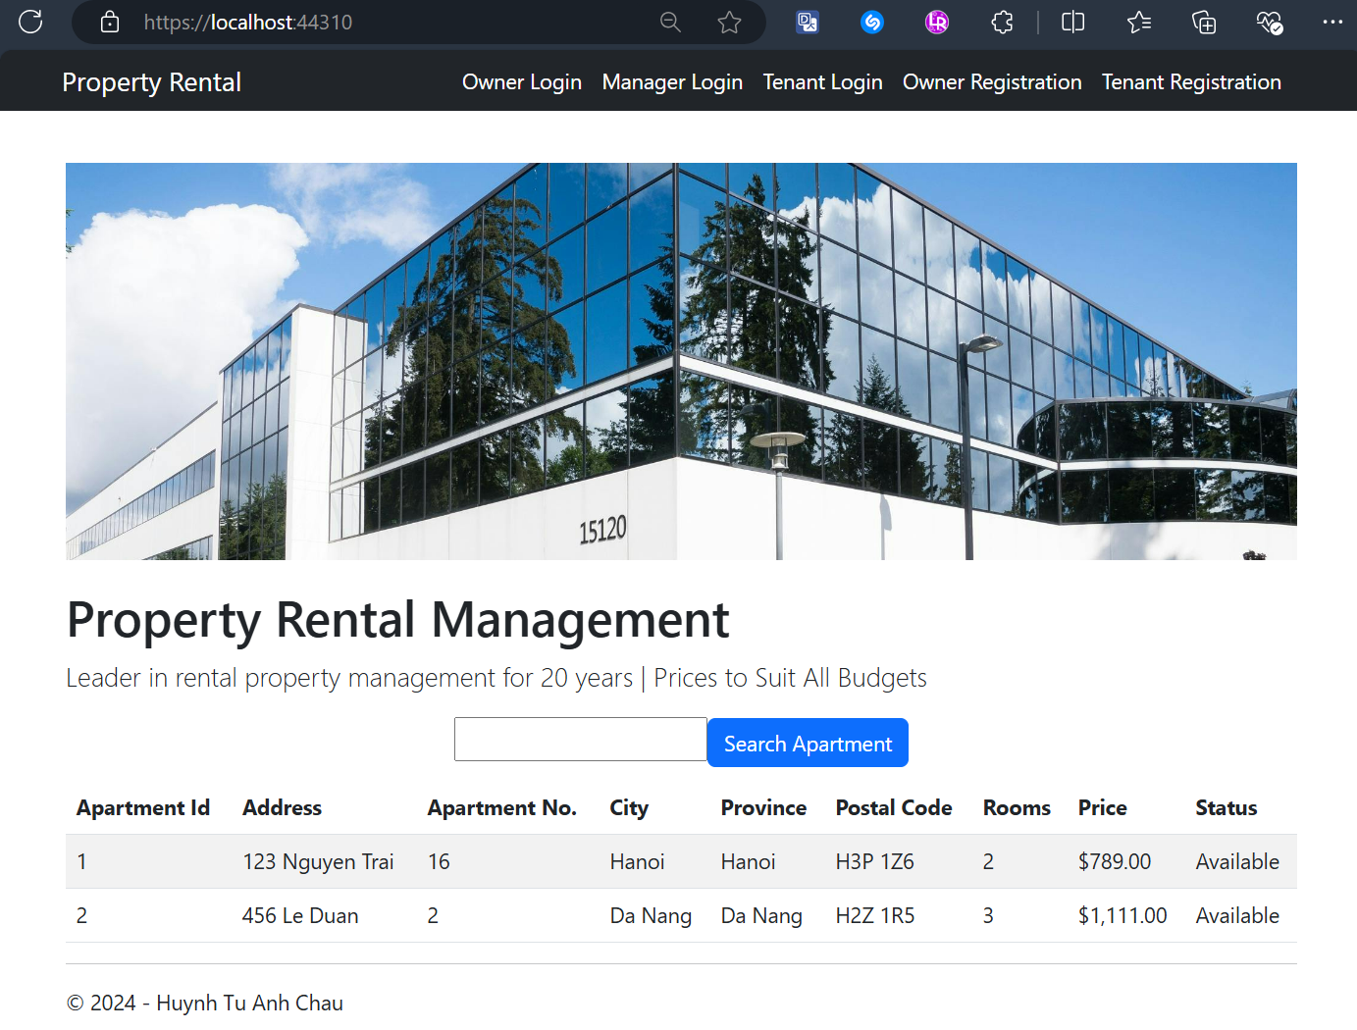

## Owner Login Screen

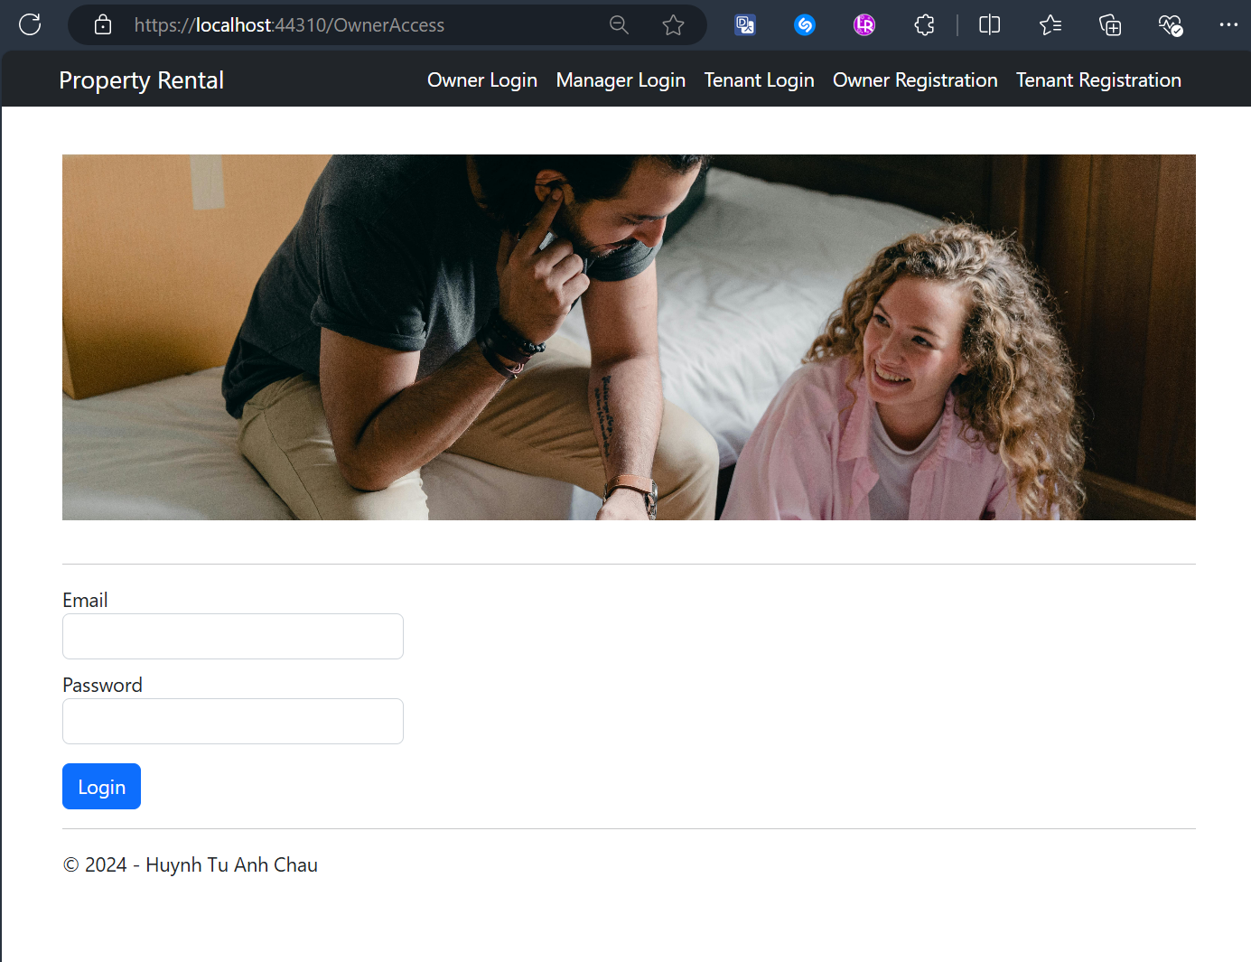

## Manager Login Screen

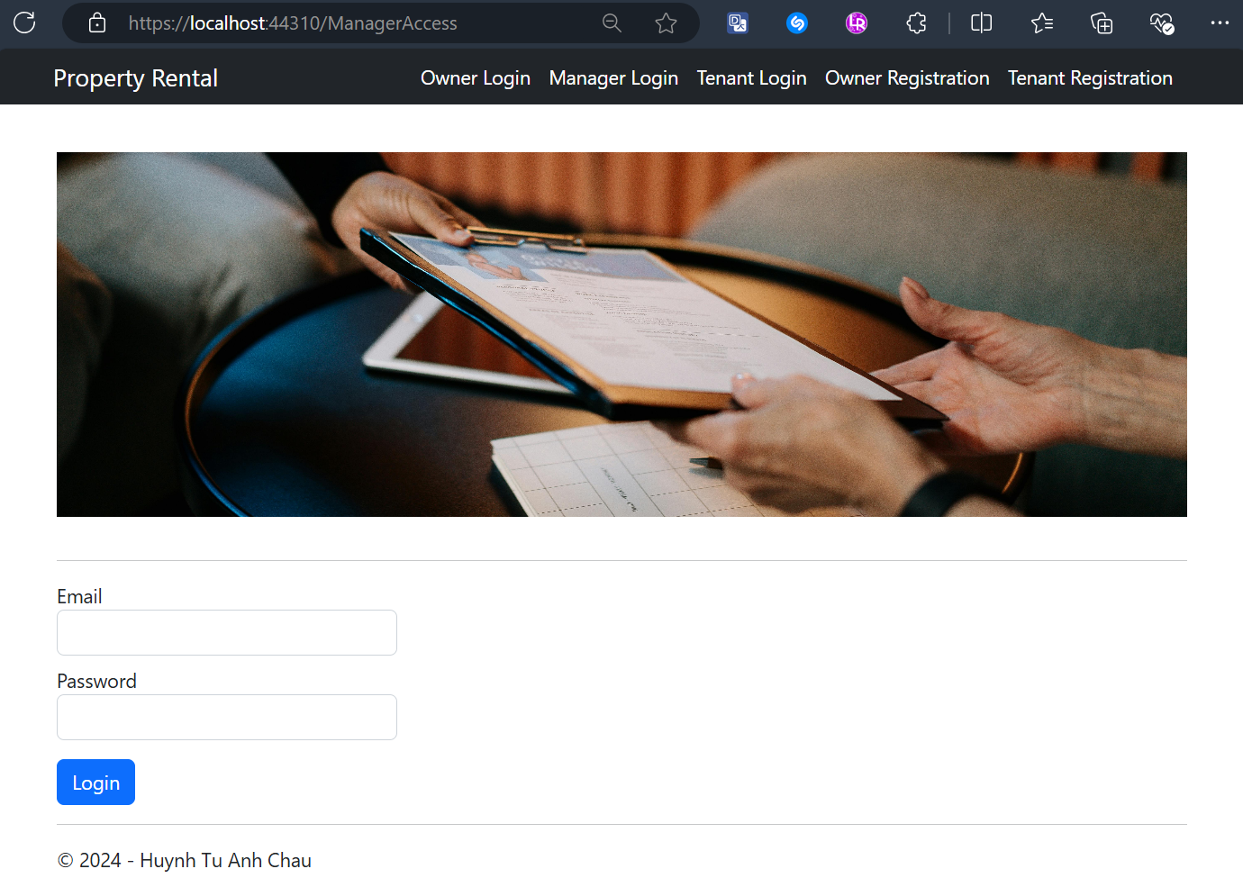

## Tenant Login Screen

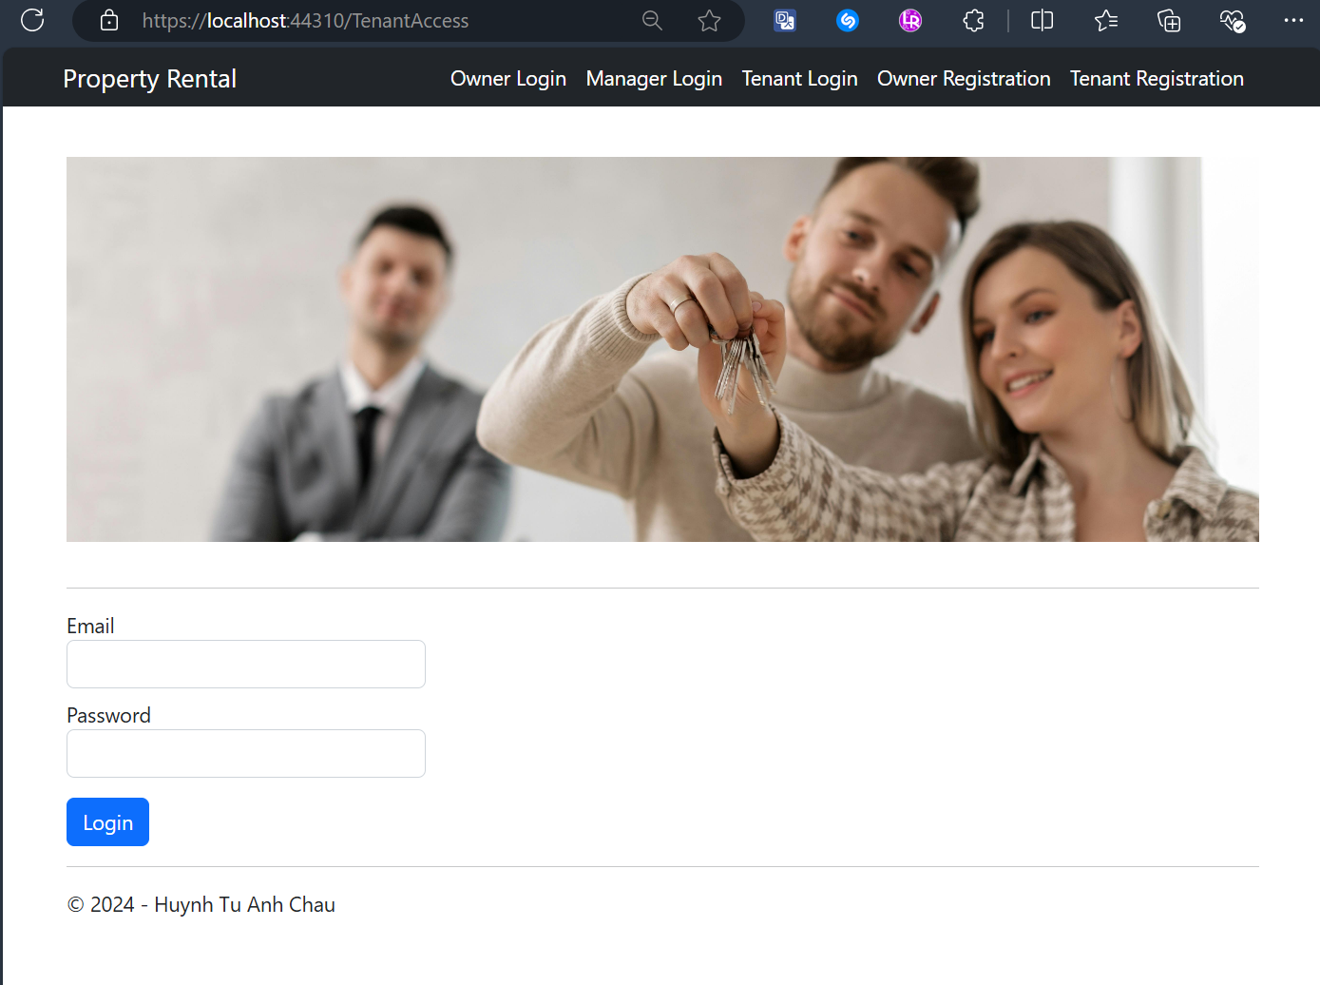

## Owner Registration Screen

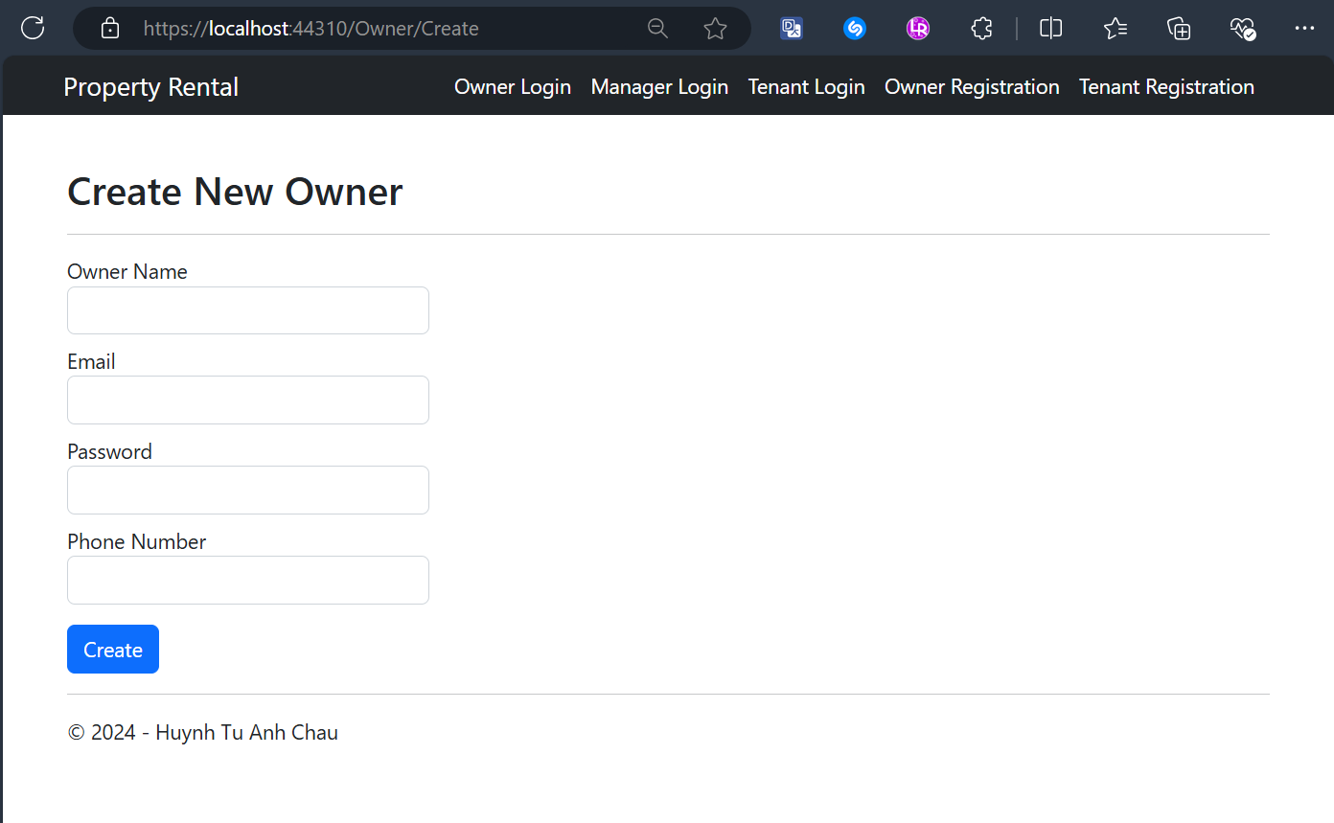

## Owner Registration Validation Screens

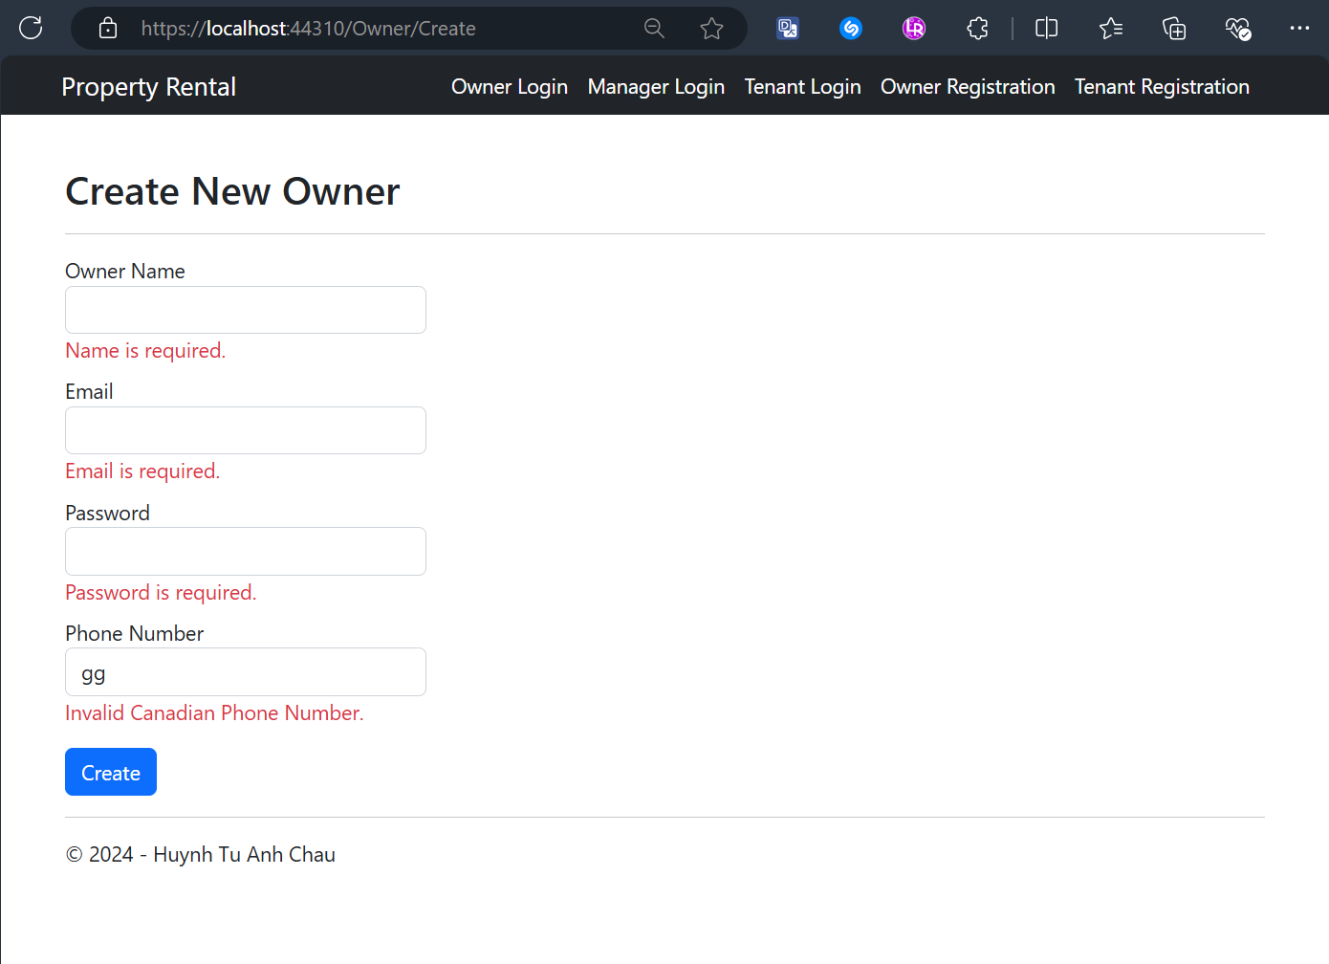

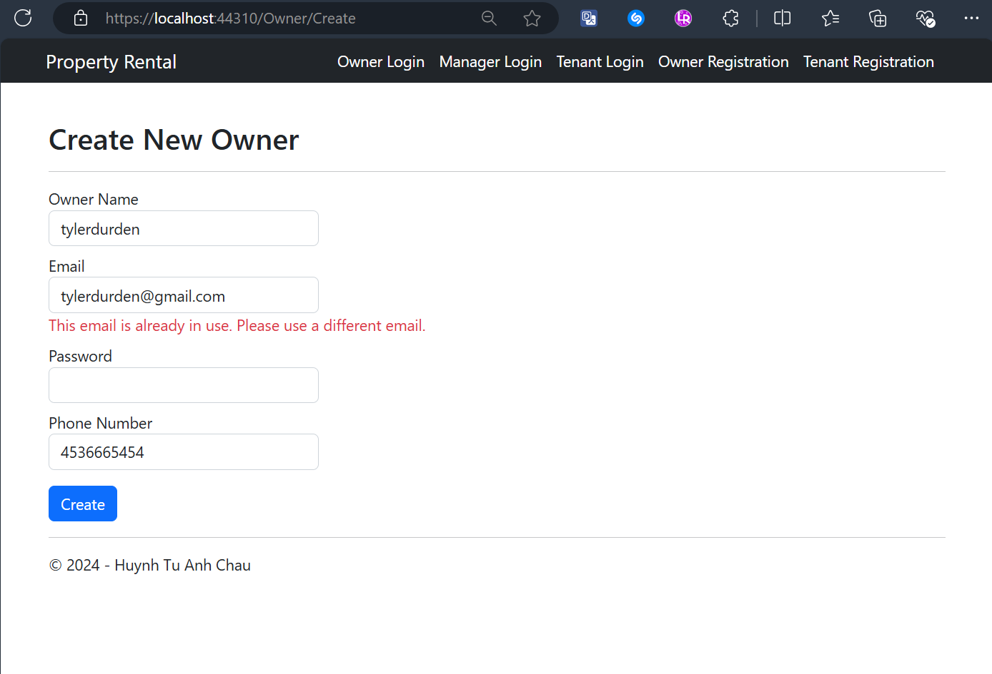

## Tenant Registration Screen

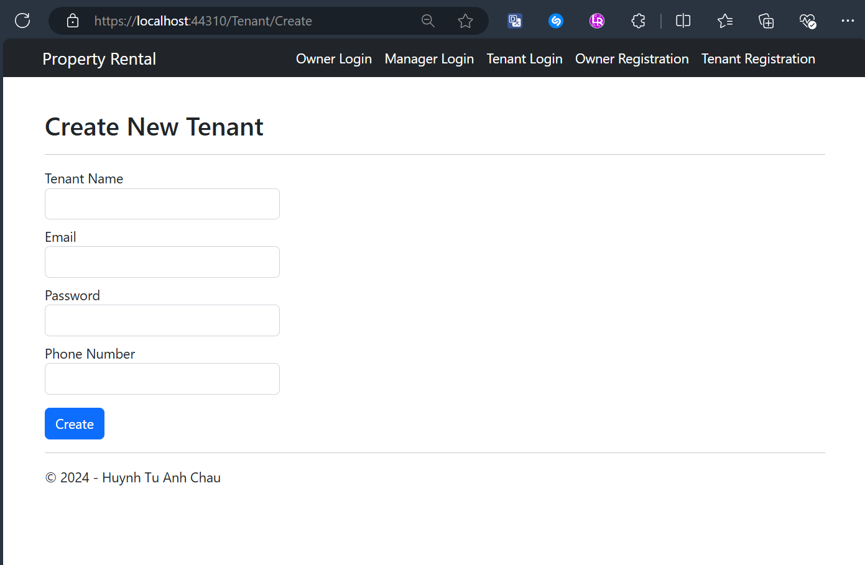

## Tenant Registration Validation Screens

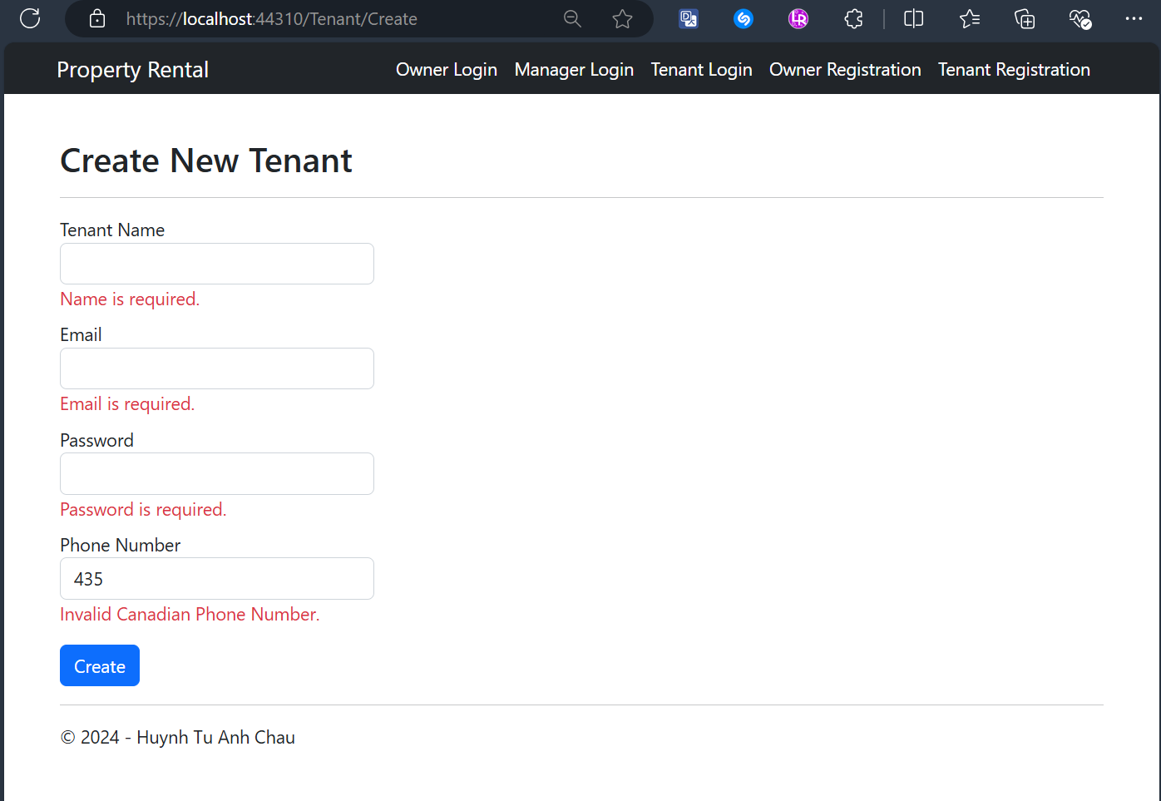

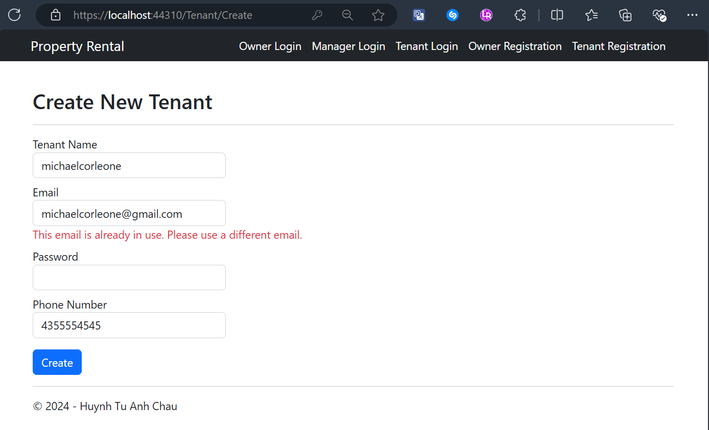

## Owner Dashboard After Logging-In Successfully

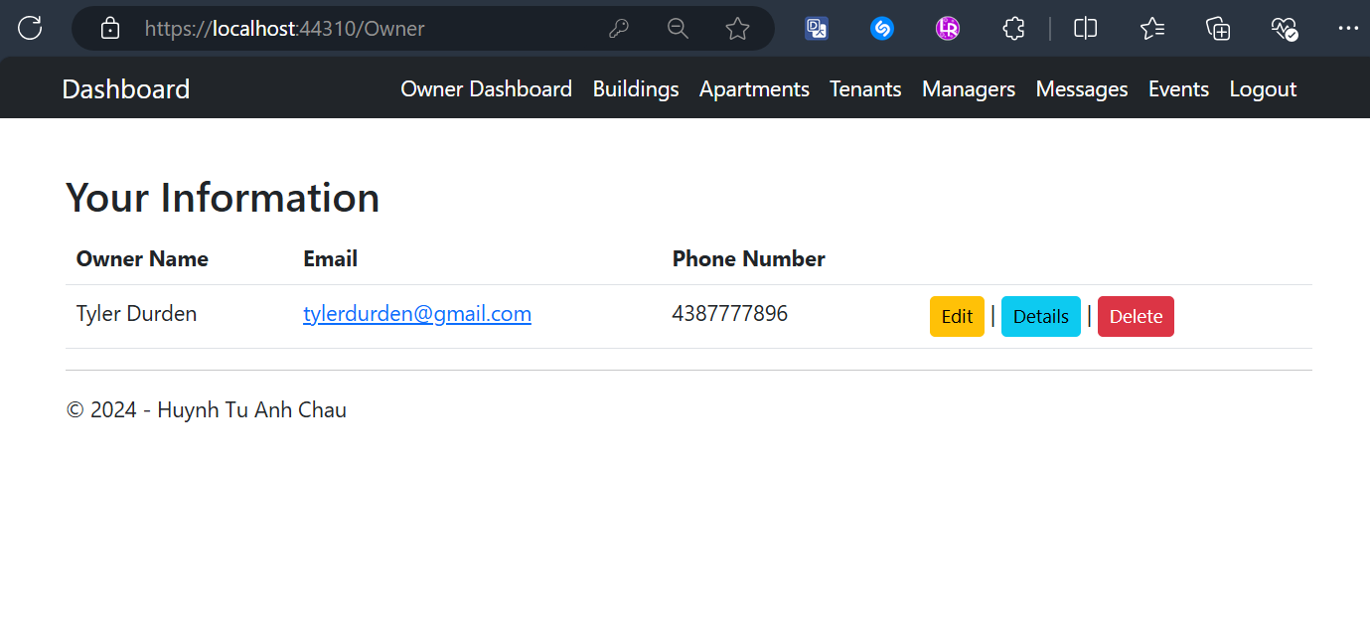

## Owners Edit Their Profile Screen

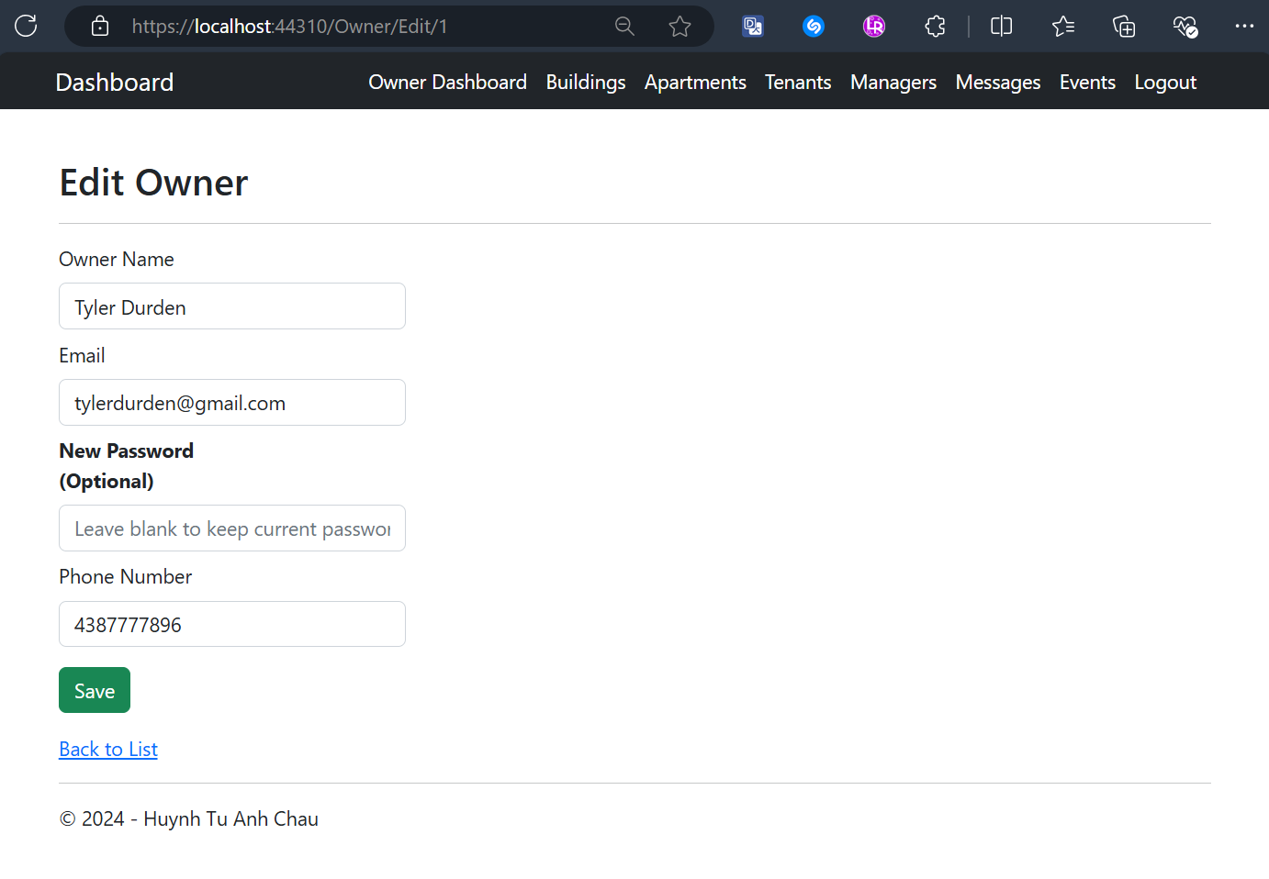

## Owner’s Details Screen

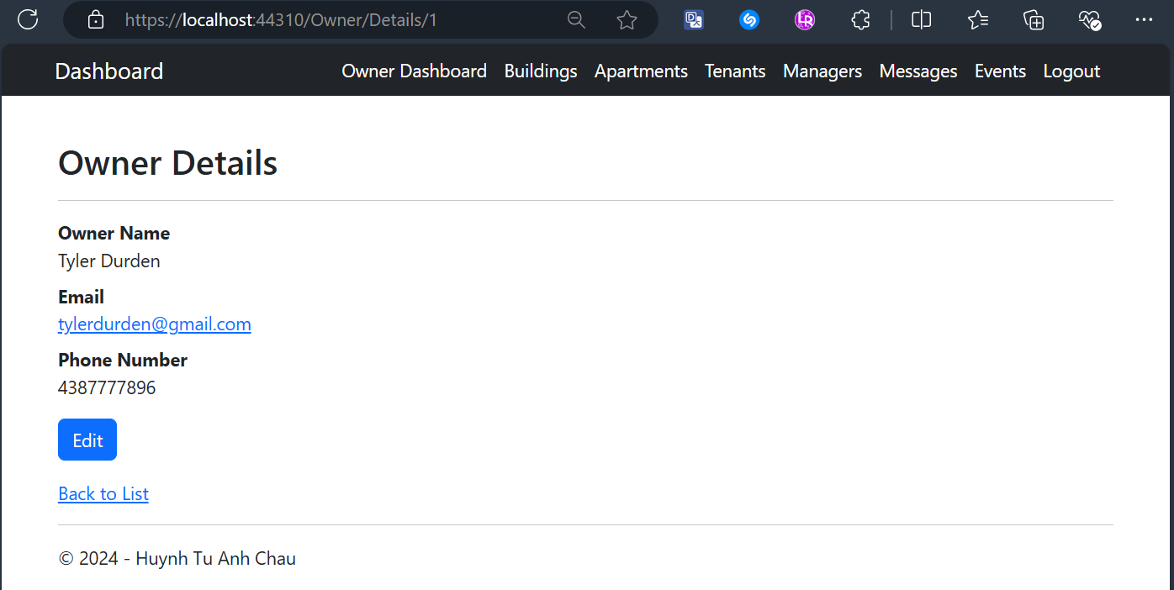

## Owner Delete Validation Screen

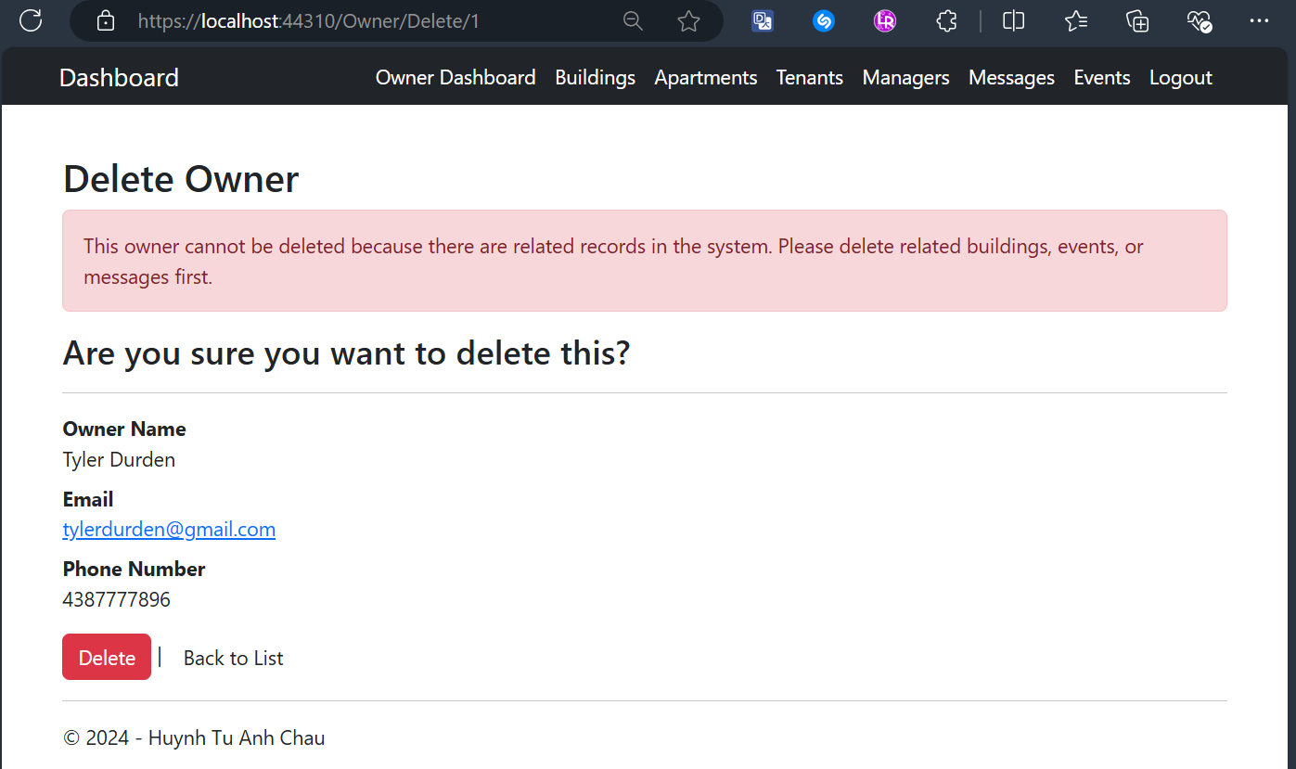

## Owner Views All Buildings and Having Details Button Only Screens

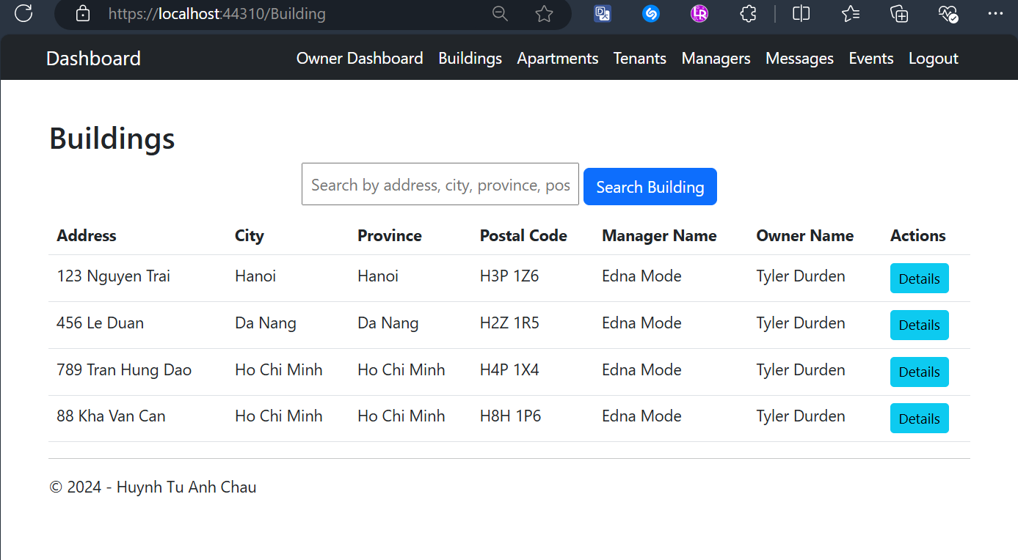

## Owner Searches for Buildings Result Screens

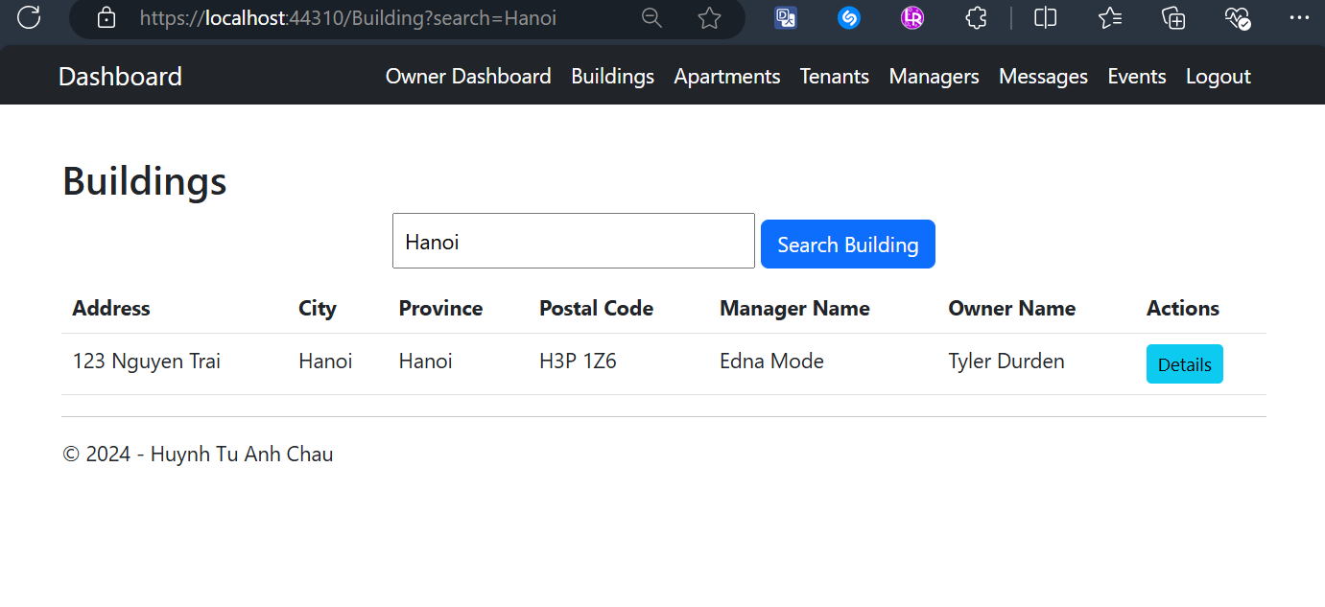

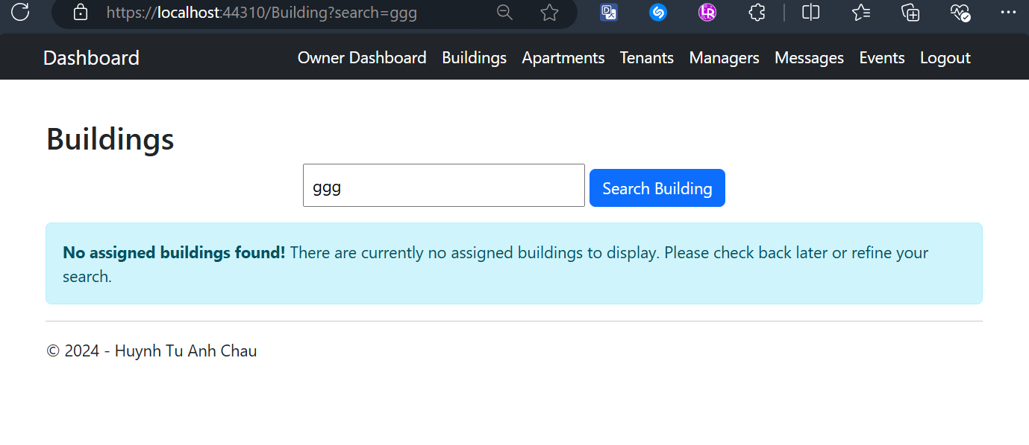

## Owner Views One Building’s Details Screen

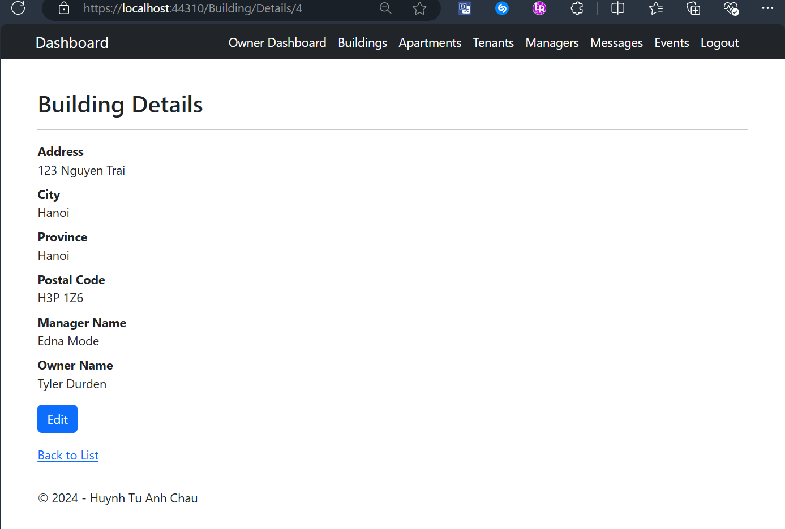

## Owner Views All Apartment and Having Details Button Only

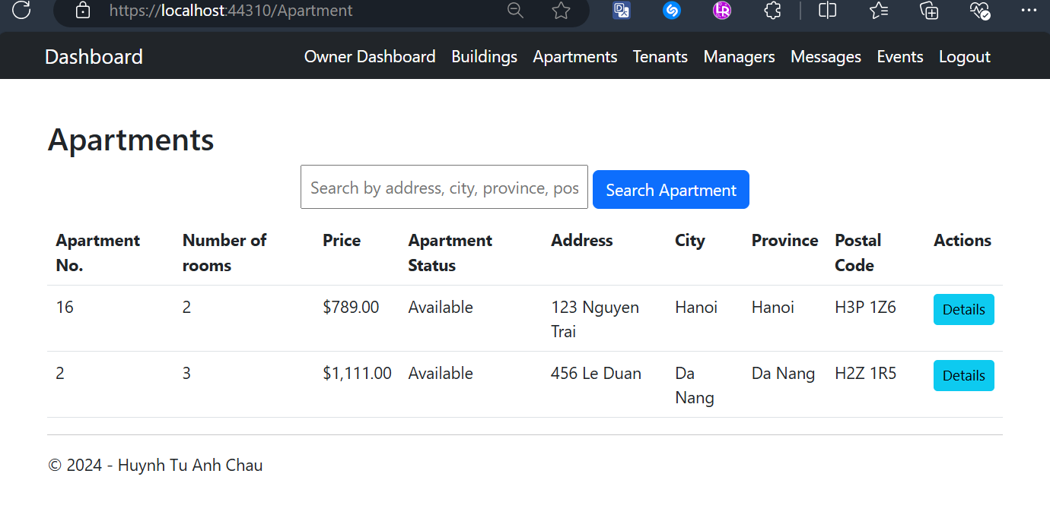

## Owner Searches for Apartments Result Screens

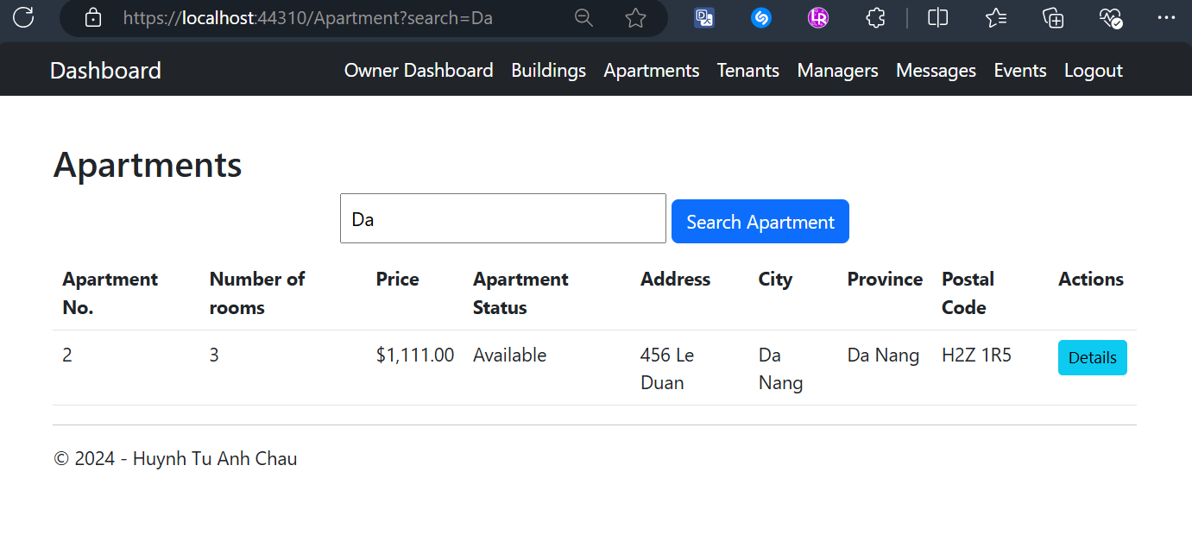

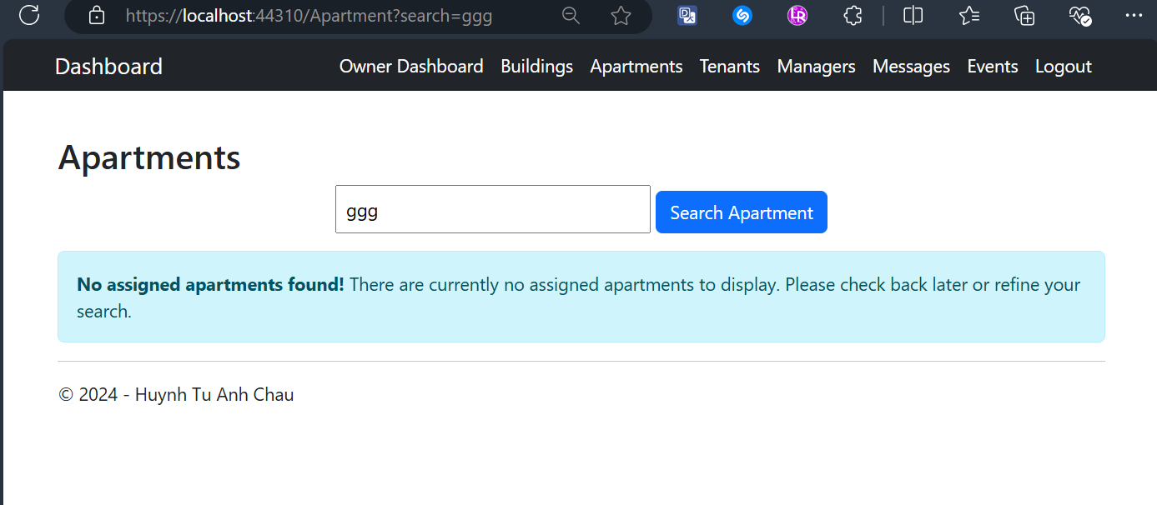

## Owner Views One Apartment’s Details Screen

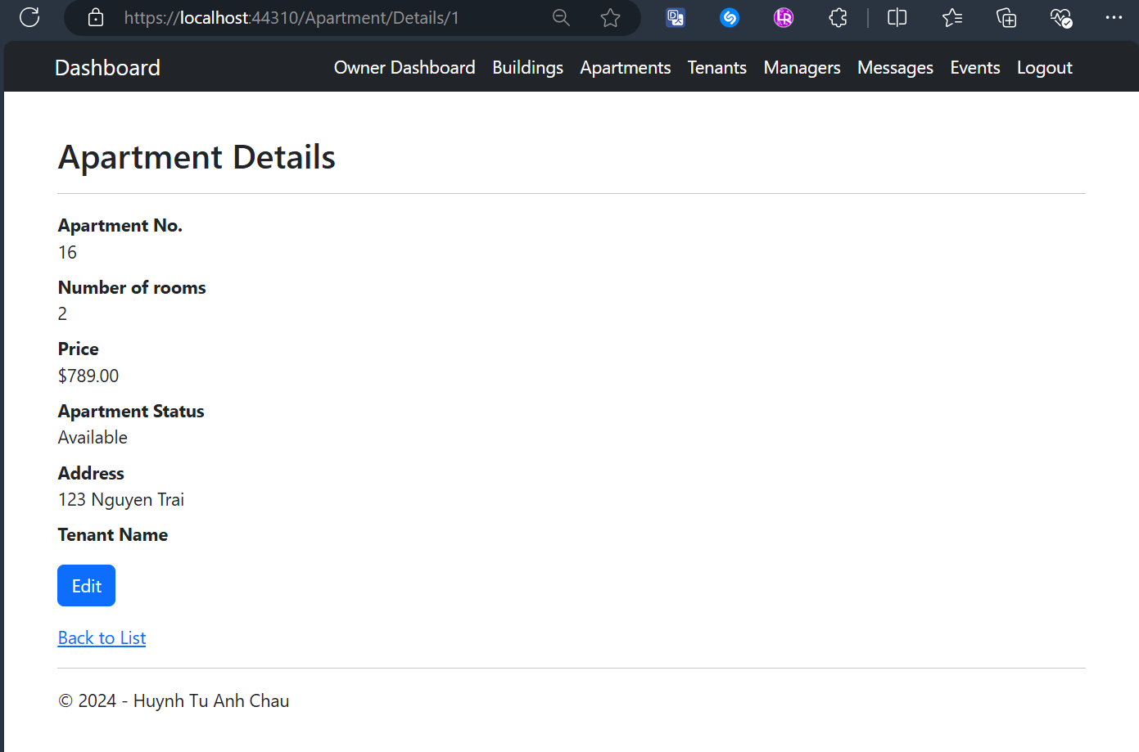

## Owner Views All Tenants with CRUD Actions Screen

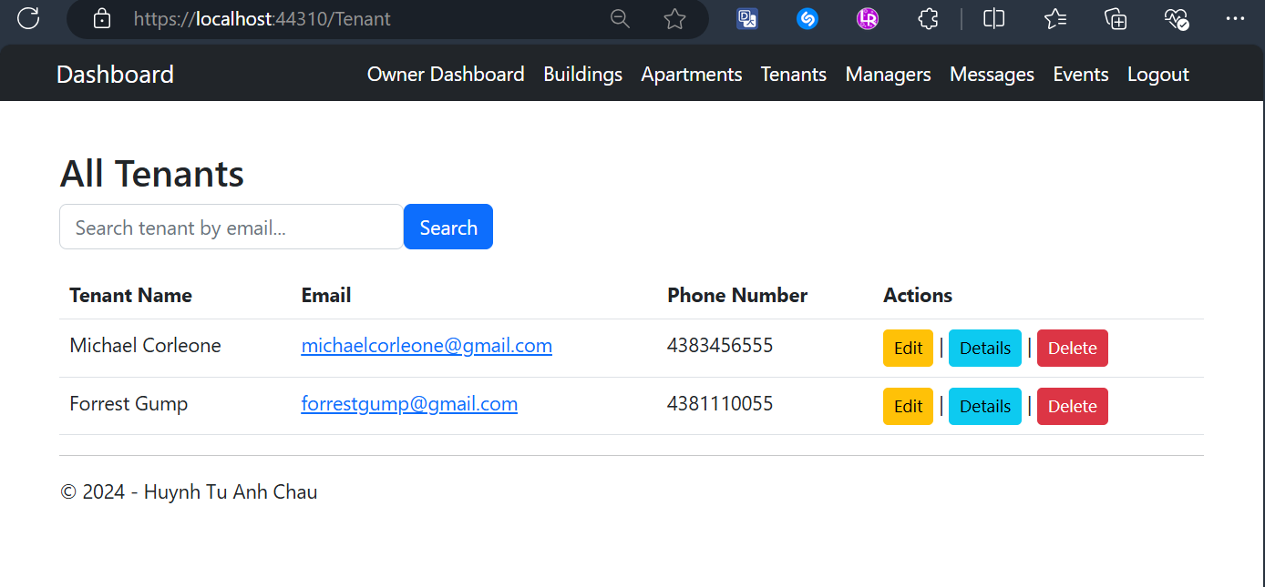

## Owner Searches for A Tenant by Email Result Screens

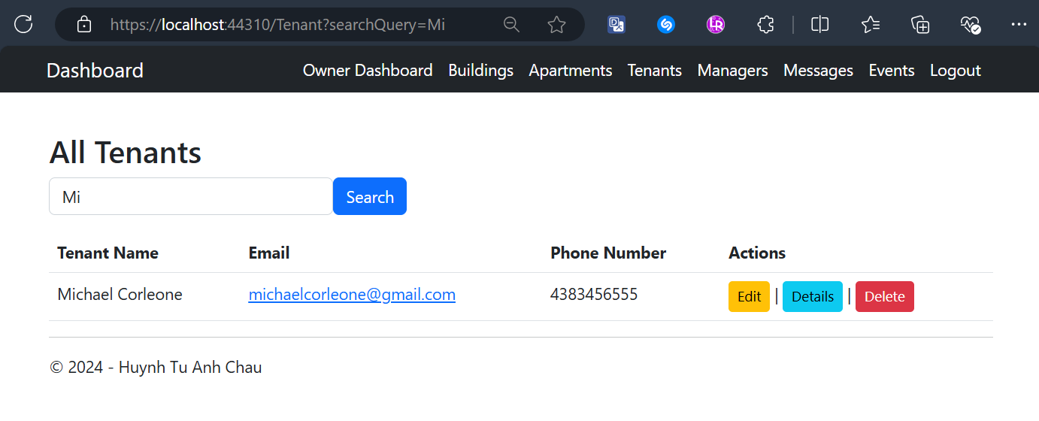

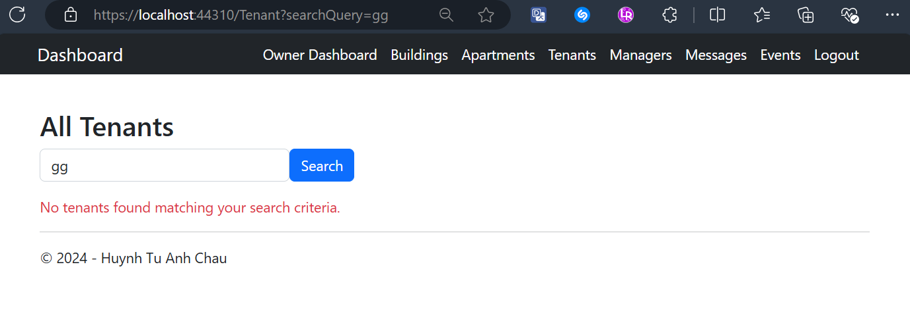

## Owner Edit One Tenant’s Details with Validation Screens

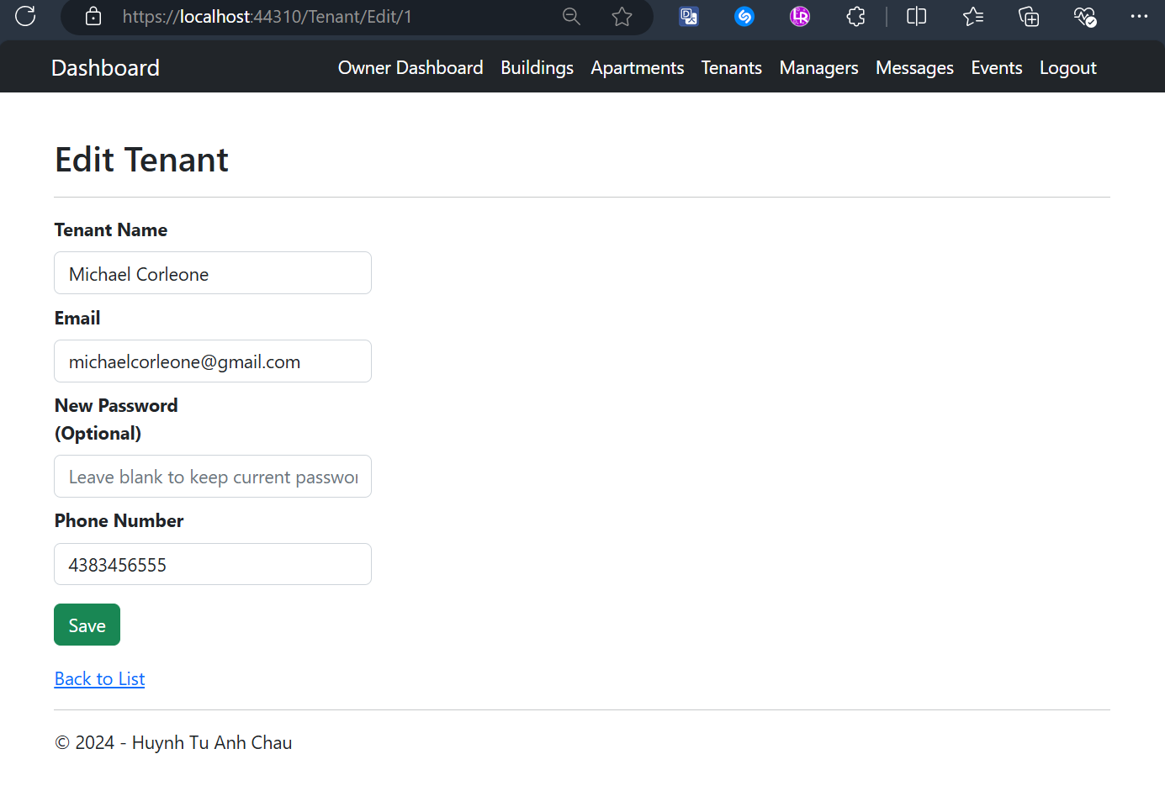

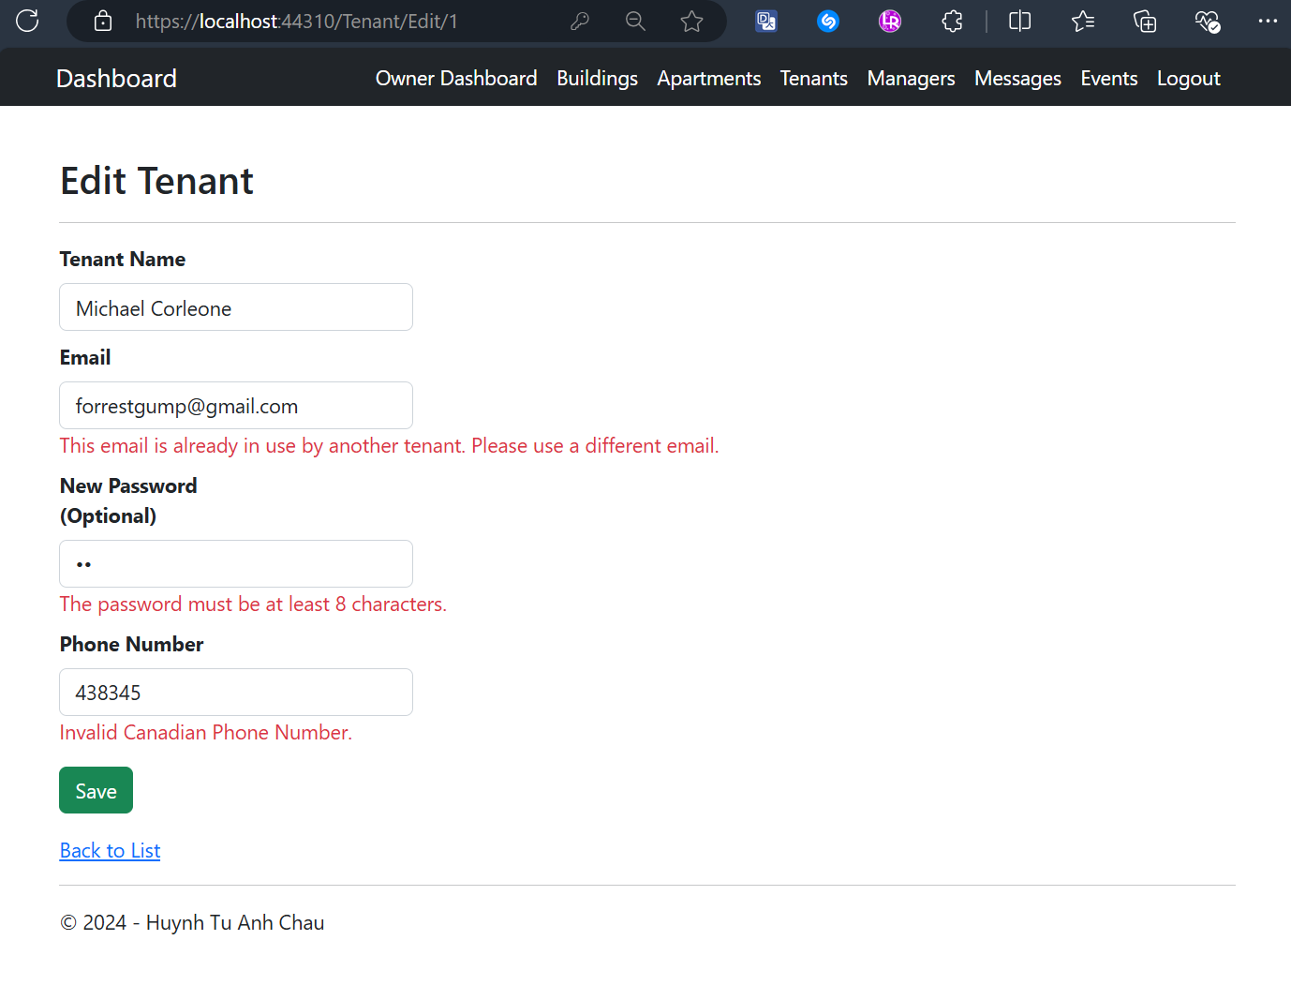

## Owner Views One Tenant's Details Screen

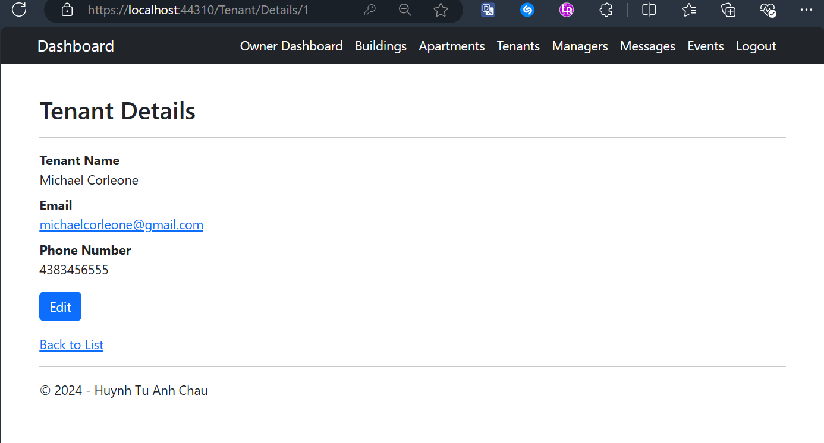

## Owner Deletes One Tenant with Confirmation Screen

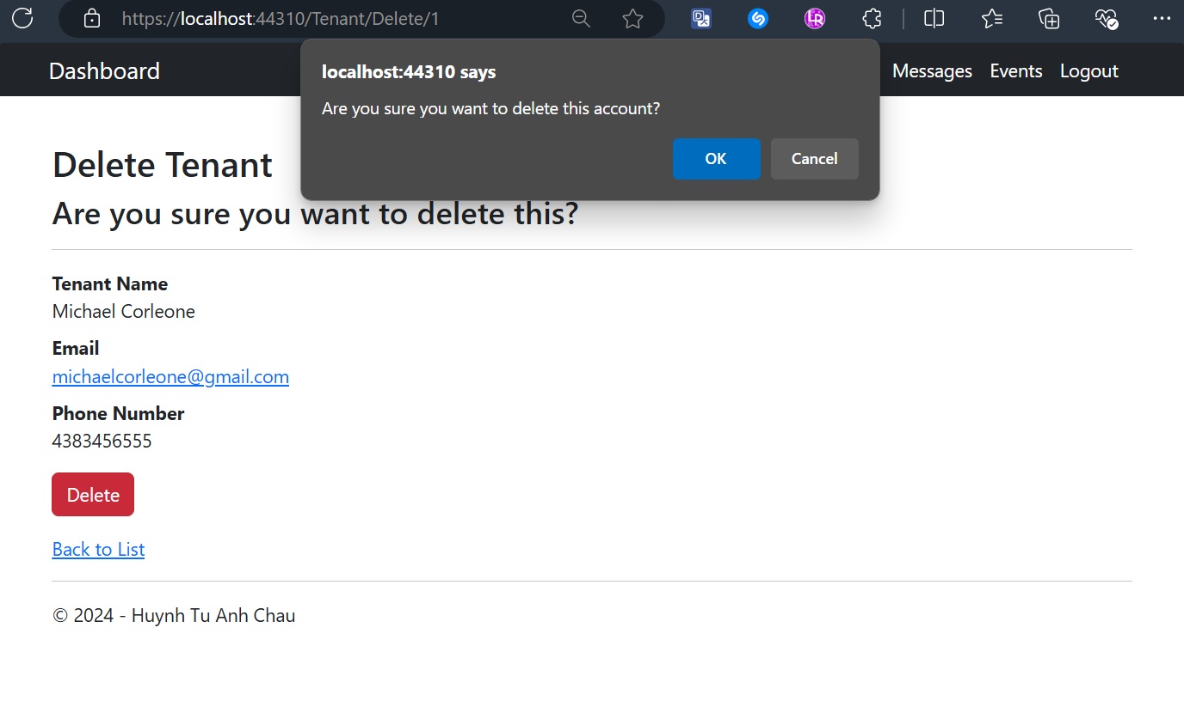

## Owner Views All Managers Screen

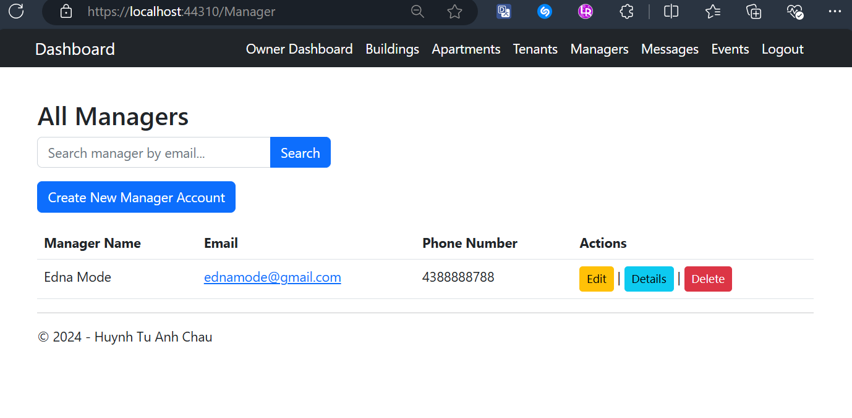

## Owner Searches for A Manager Result Screen

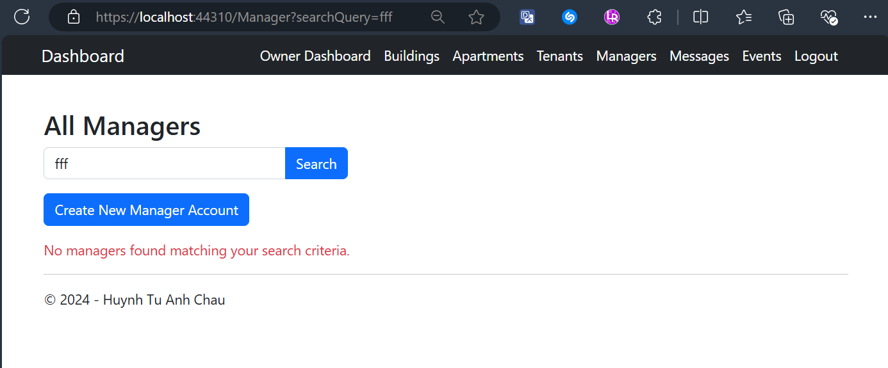

## Owner Creates a Manager Account with Validation Screen

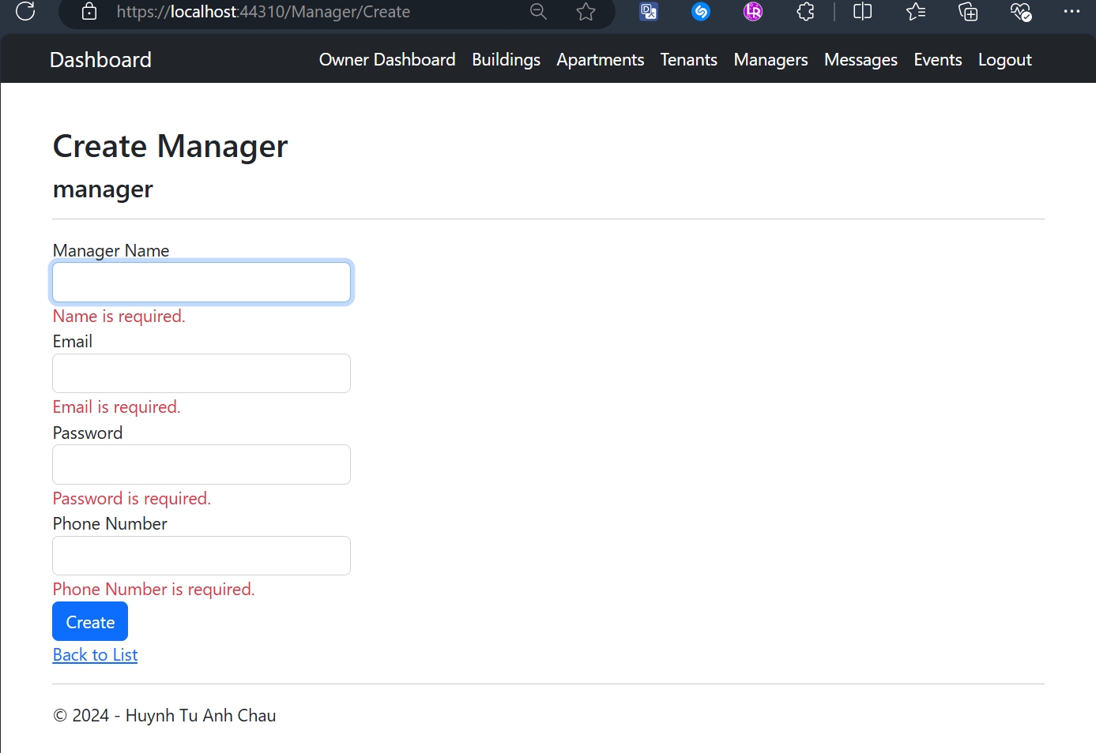

## Owner Views All Created Messages to a Manager with CRUD actions Screen

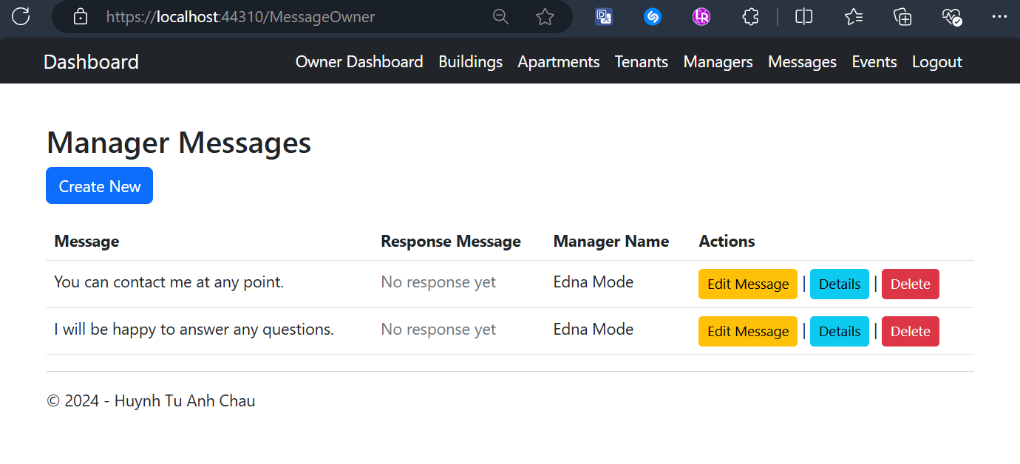

## Owner Sends a Message to a Manager (fetching from database) with Validation Screen

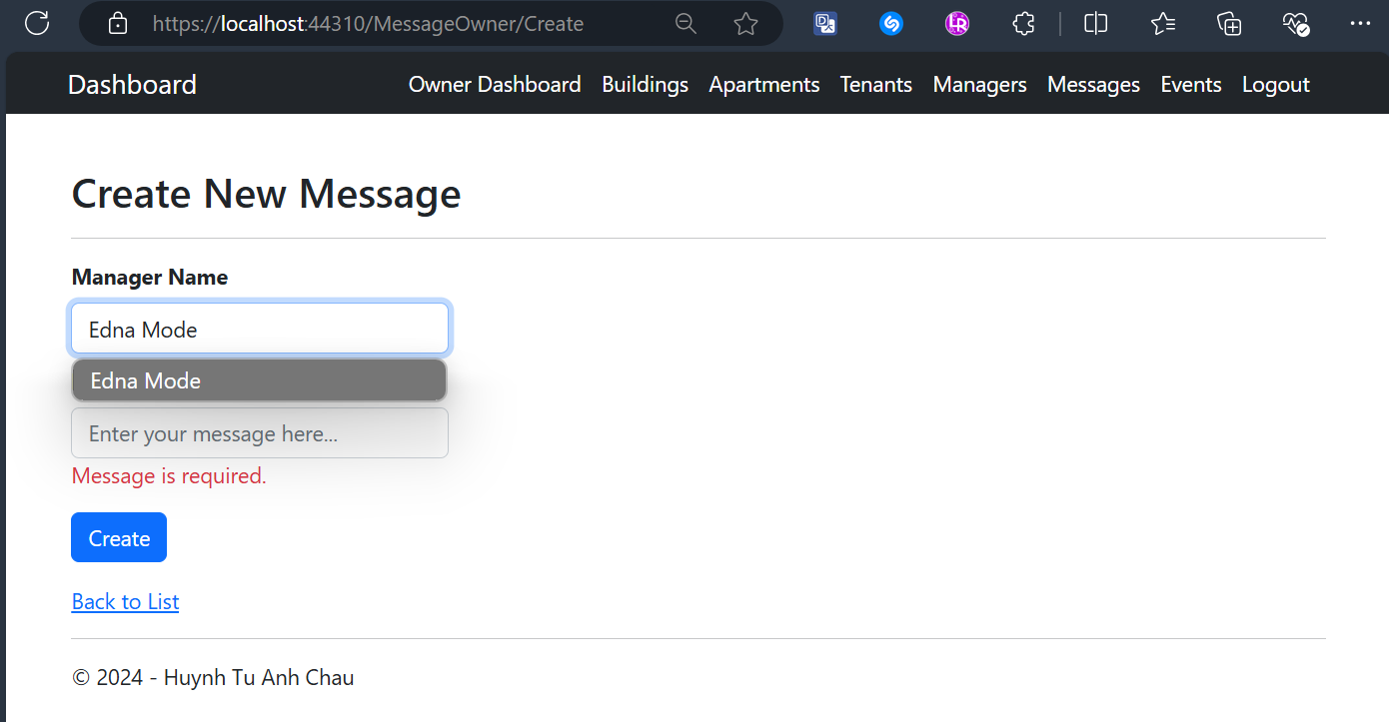

## Owner Edits a Message Screen

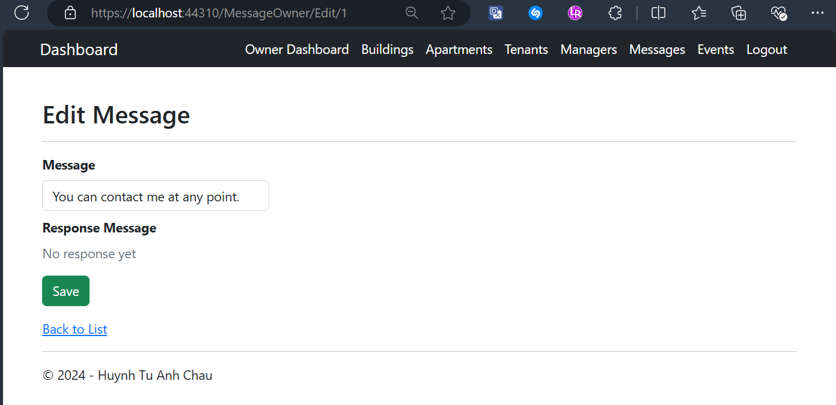

## Owner Views One Message’s Details Screen

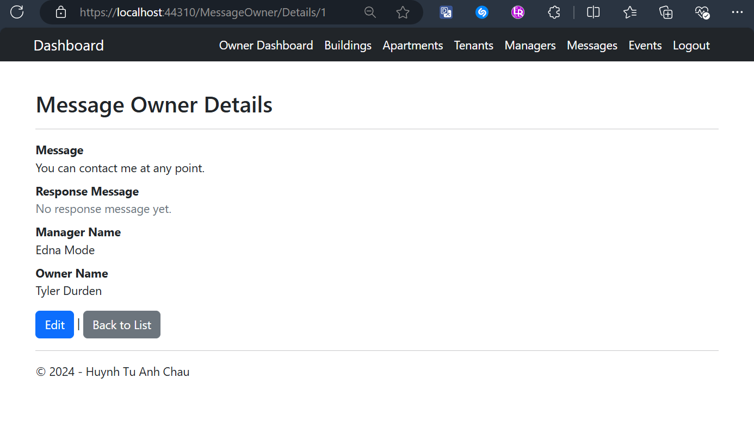

## Owner Deletes a Message with Confirmation Screen

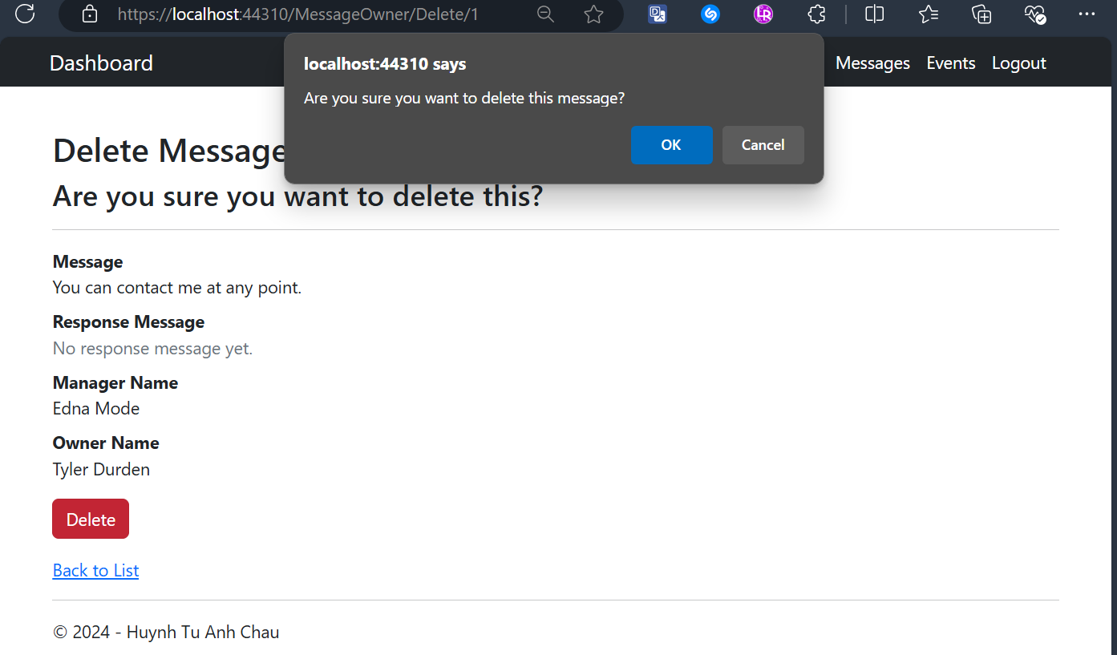

## Owner Views Assigned Events Screen

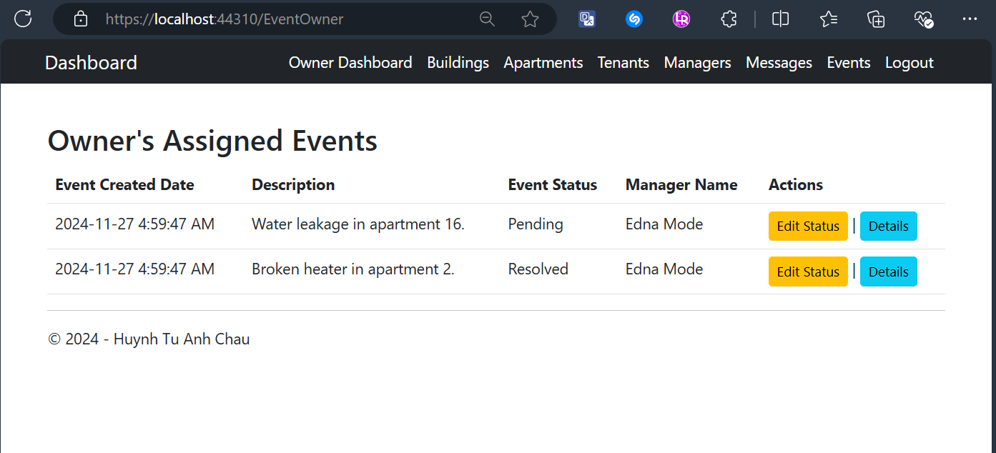

## Owner Edits Status of Assigned Events Screen

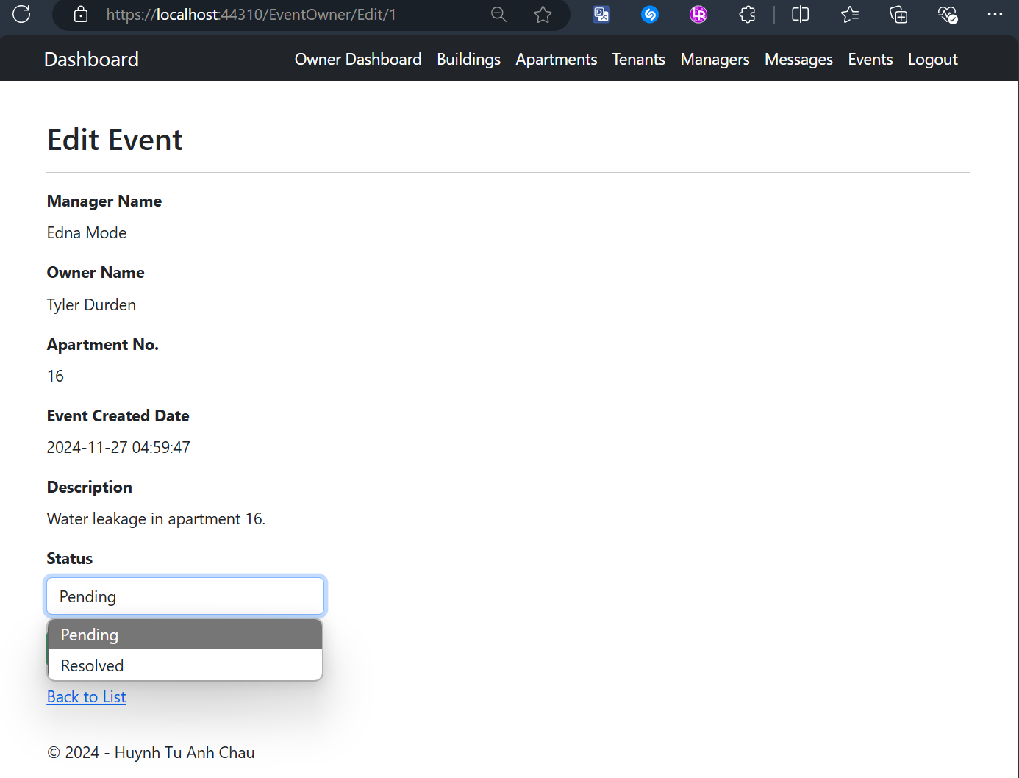

## Owner Views One Event’s Details Screen

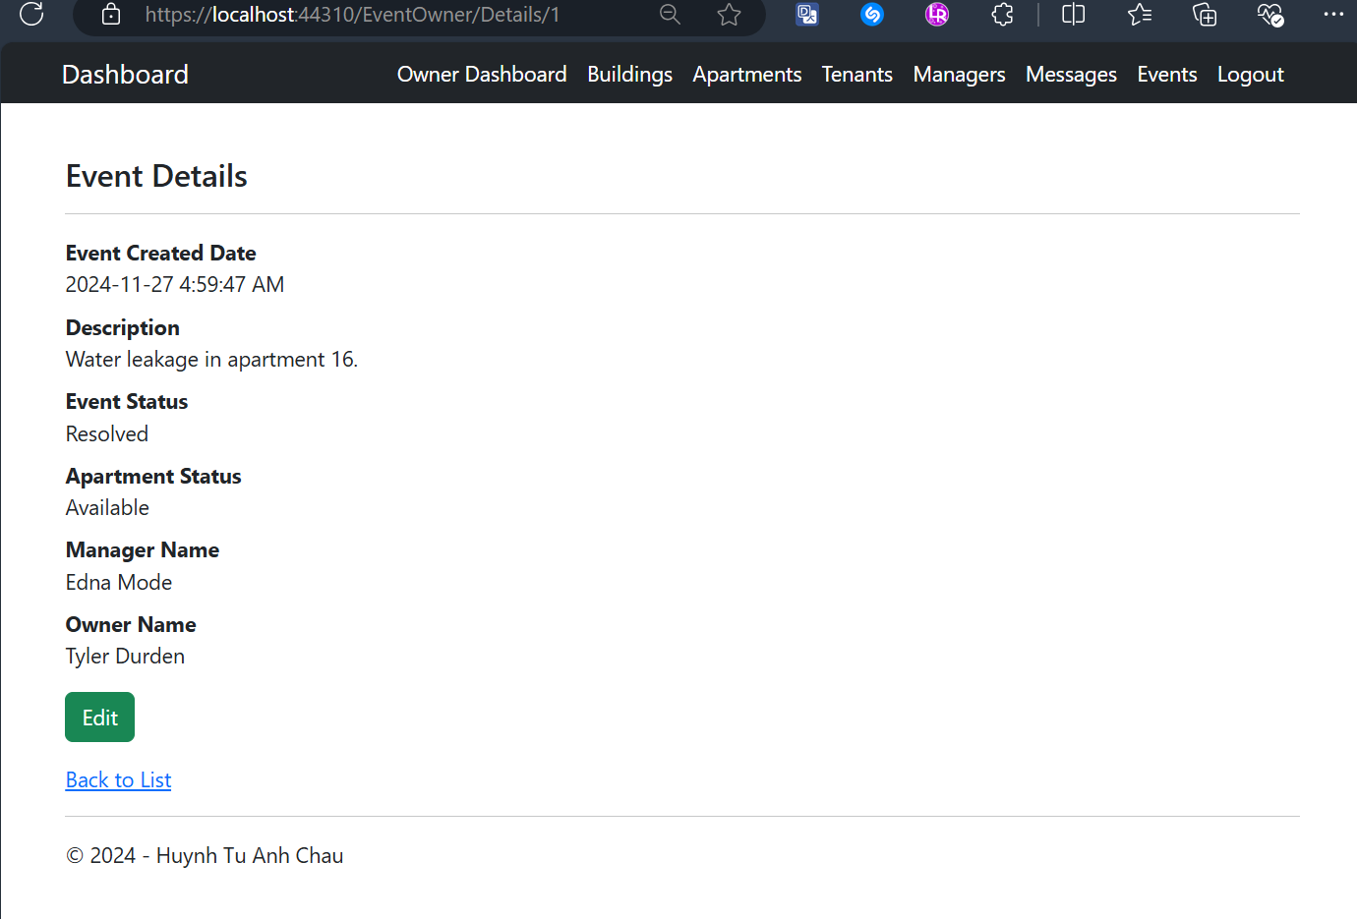

## Manager Dashboard After Logging-In Screen

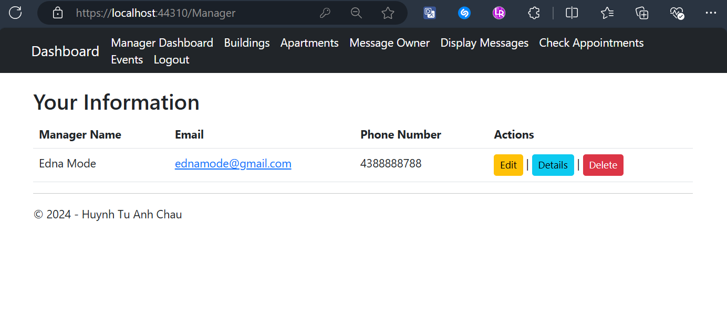

## Managers Edit Their Profile with Validation Screen

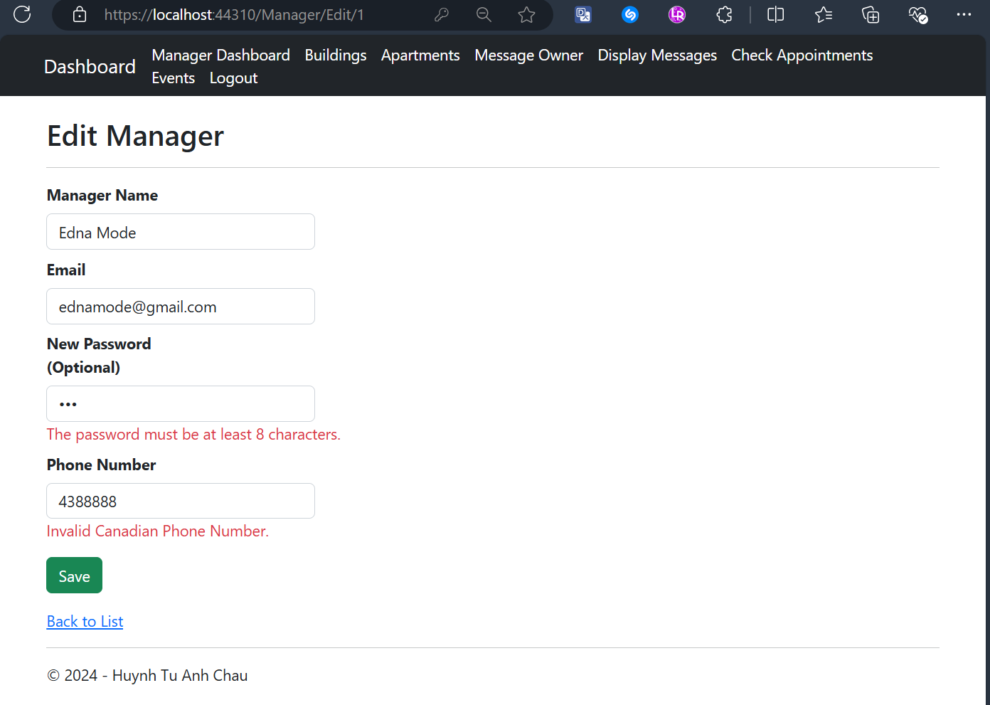

## Managers Delete Their Accounts with Confirmation Screen

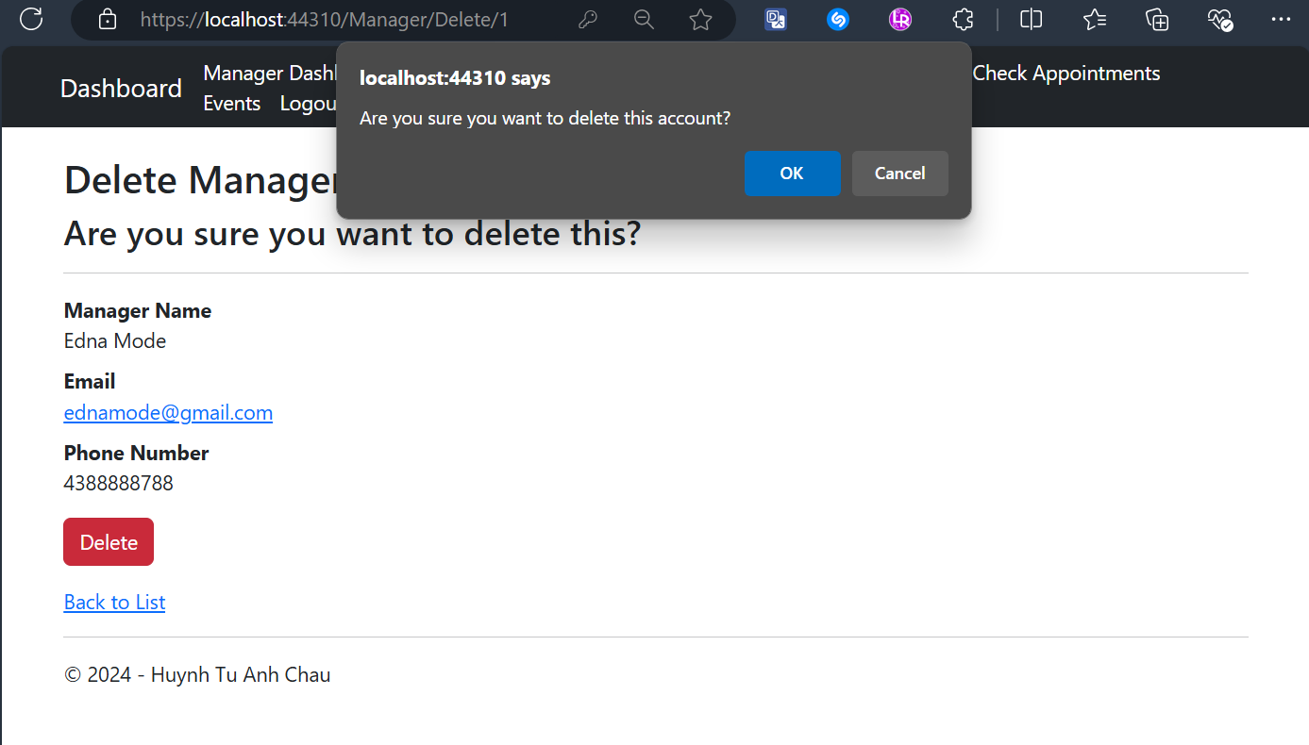

## Manager Views Assigned Buildings with CRUD actions Screen

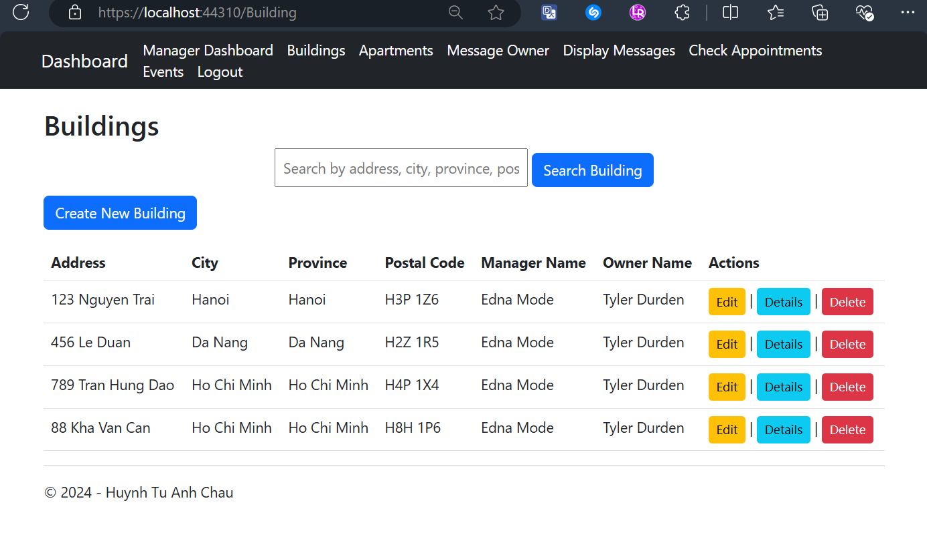

## Manager Edits One Building with Validation Screen

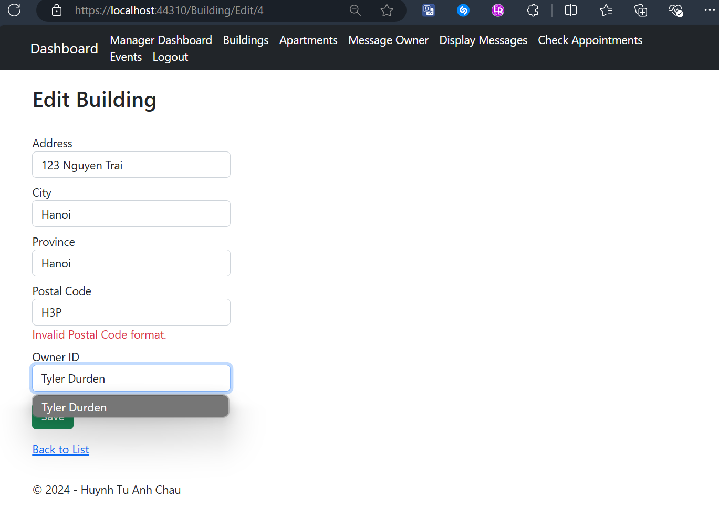

## Manager Views One Building’s Details

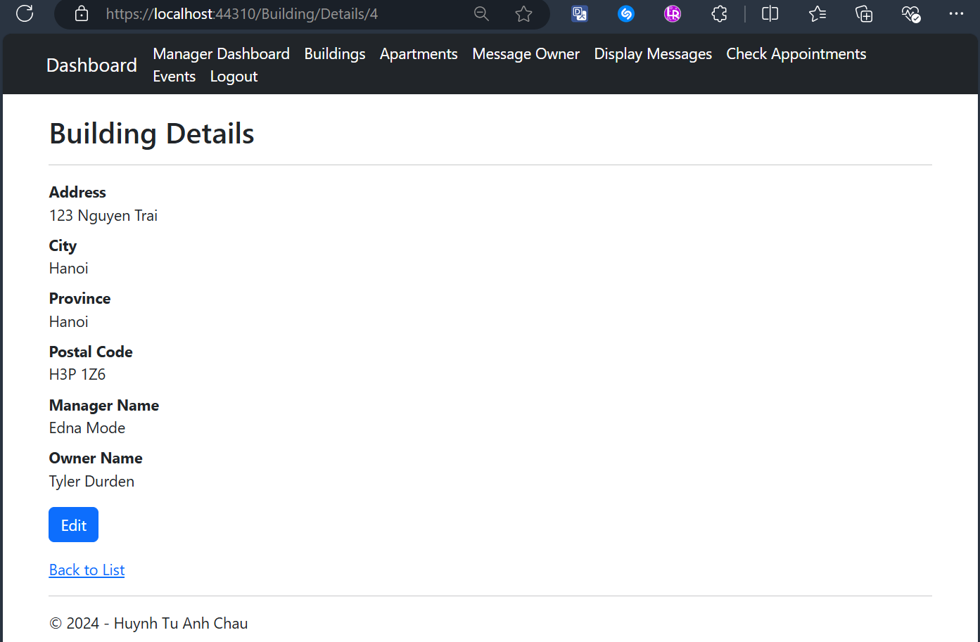

## Manager Deletes One Building with Confirmation Screen

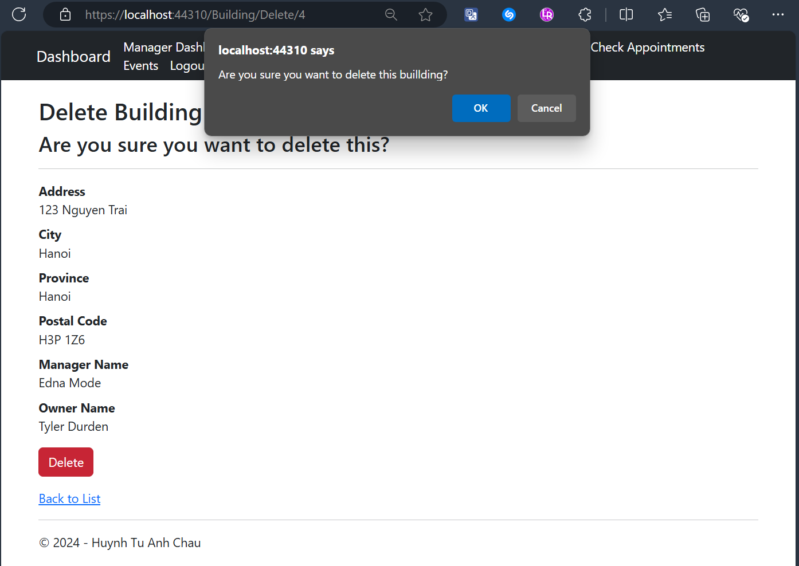

## Manager Searches for A Building Result Screens

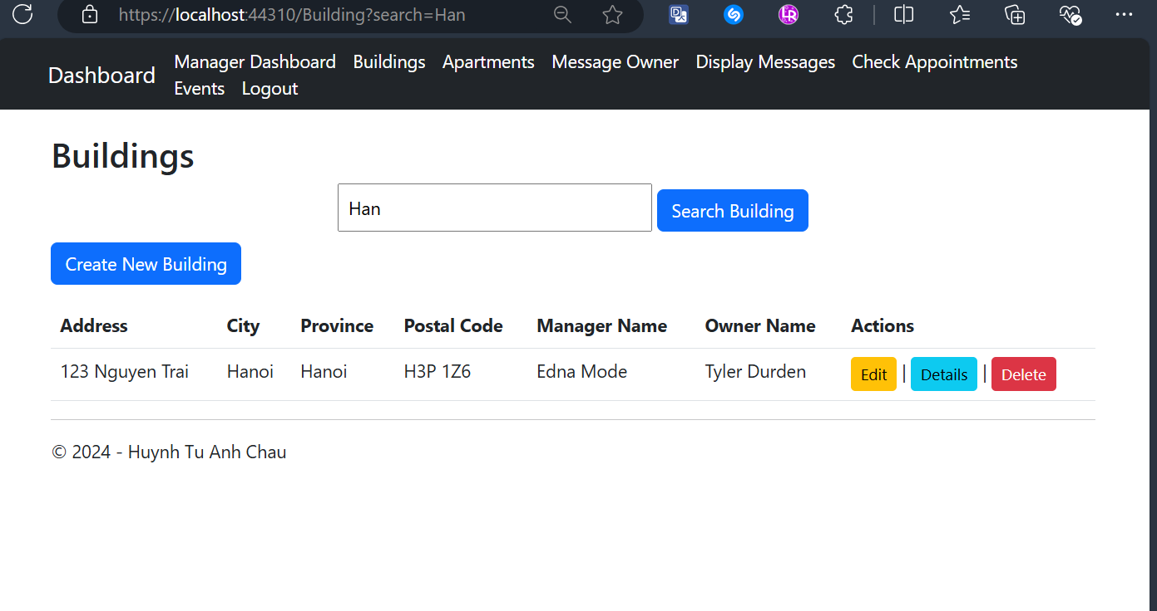

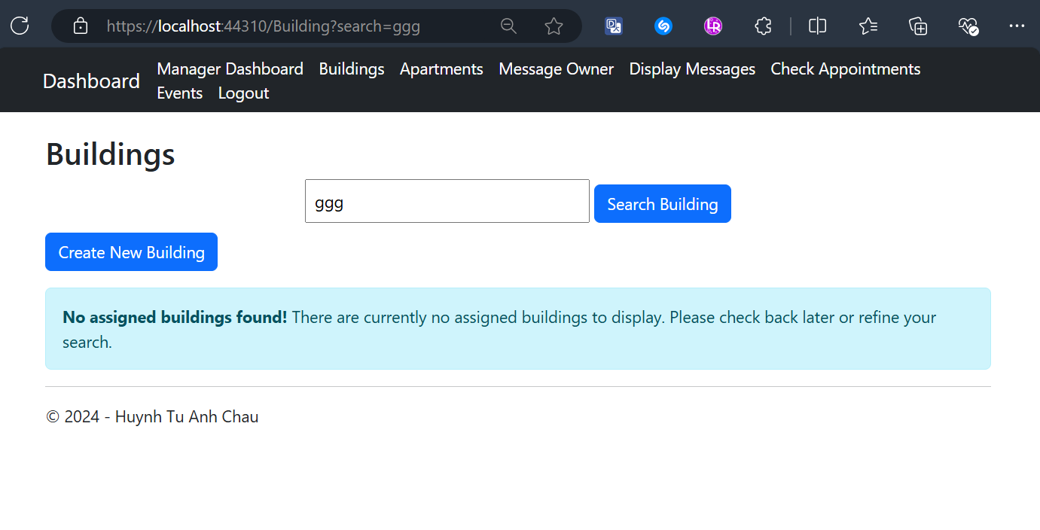

## Manager Creates a New Building with Validation Screen

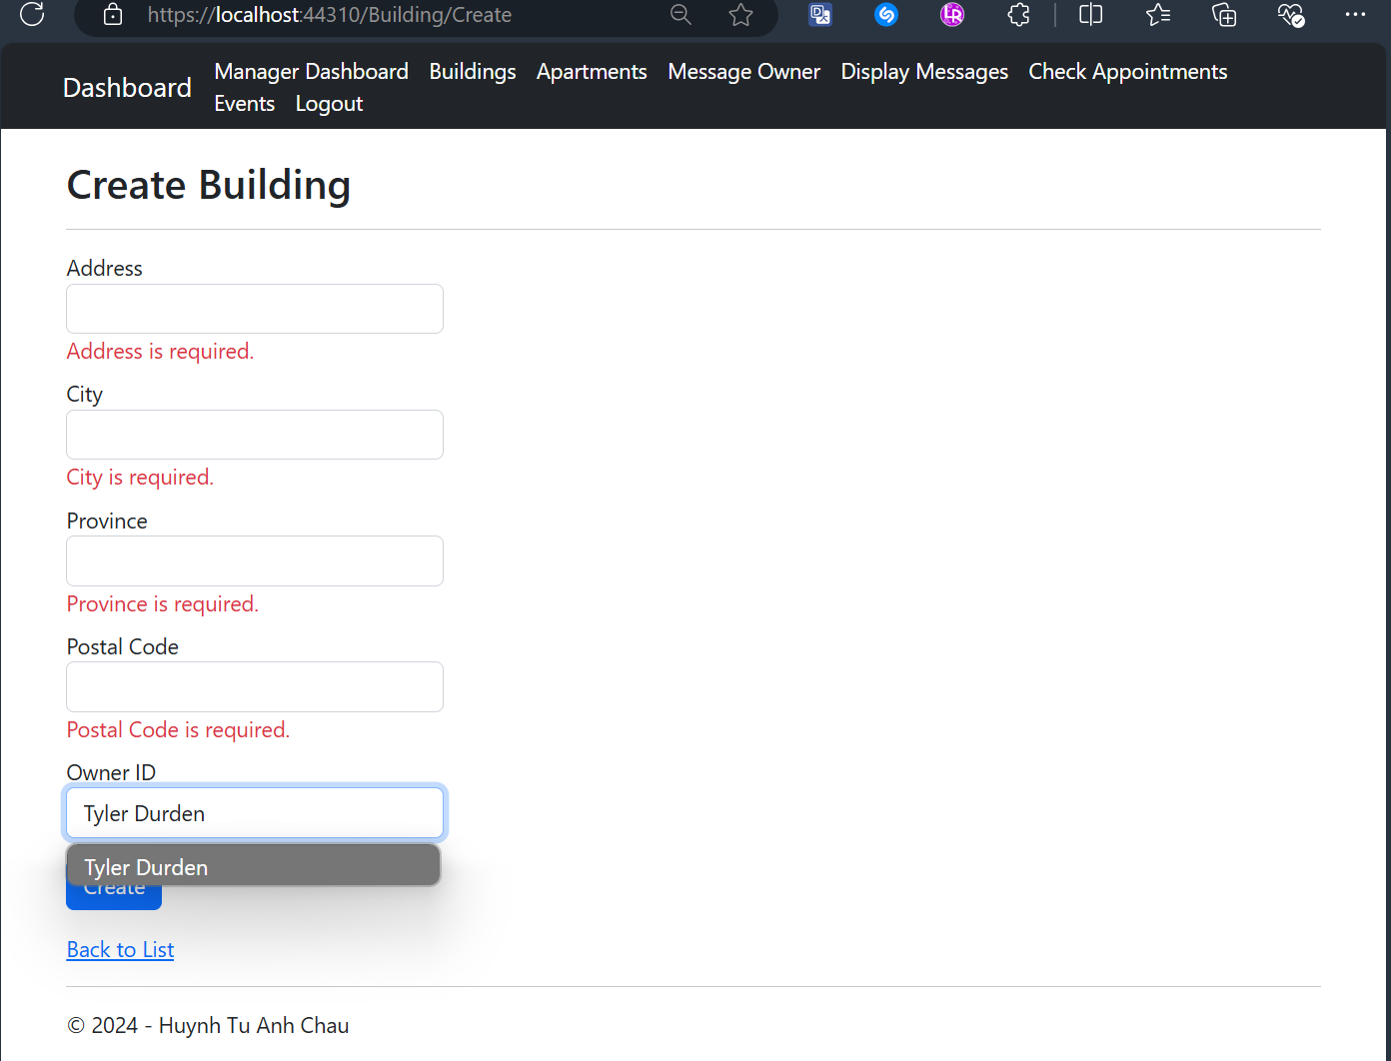

## Manager Views All Apartments related to Assigned Buildings with CRUD actions Screen

## A screenshot of a computer Description automatically generatedManager Edits an Apartment’s Details with Validation Screen

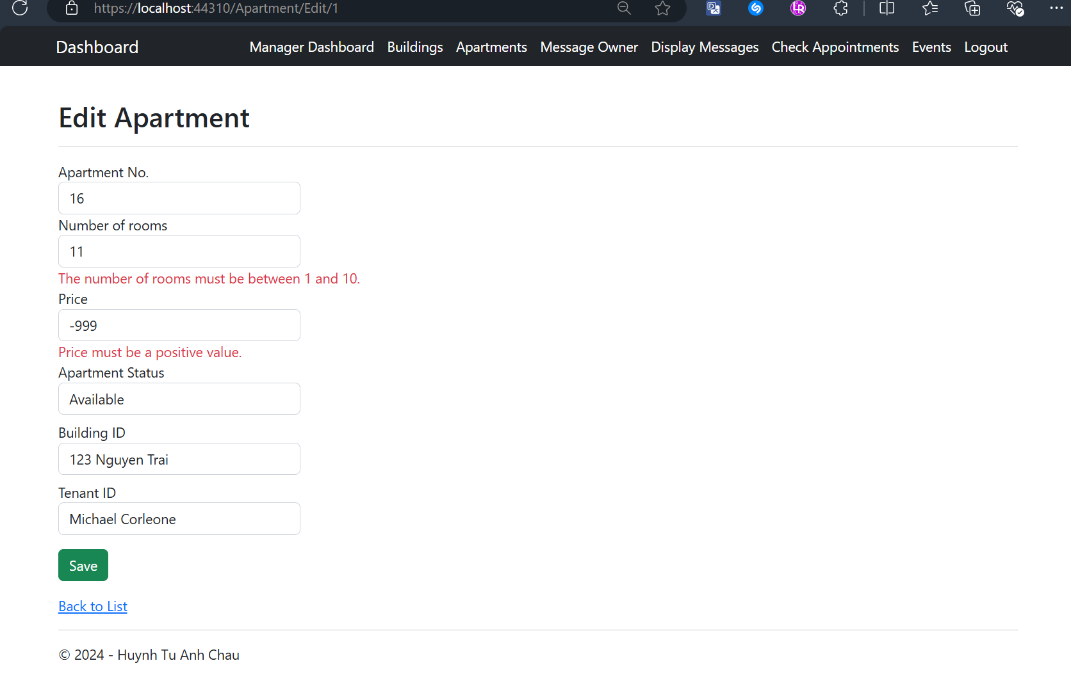

## Manager Views an Apartment's Details Screen

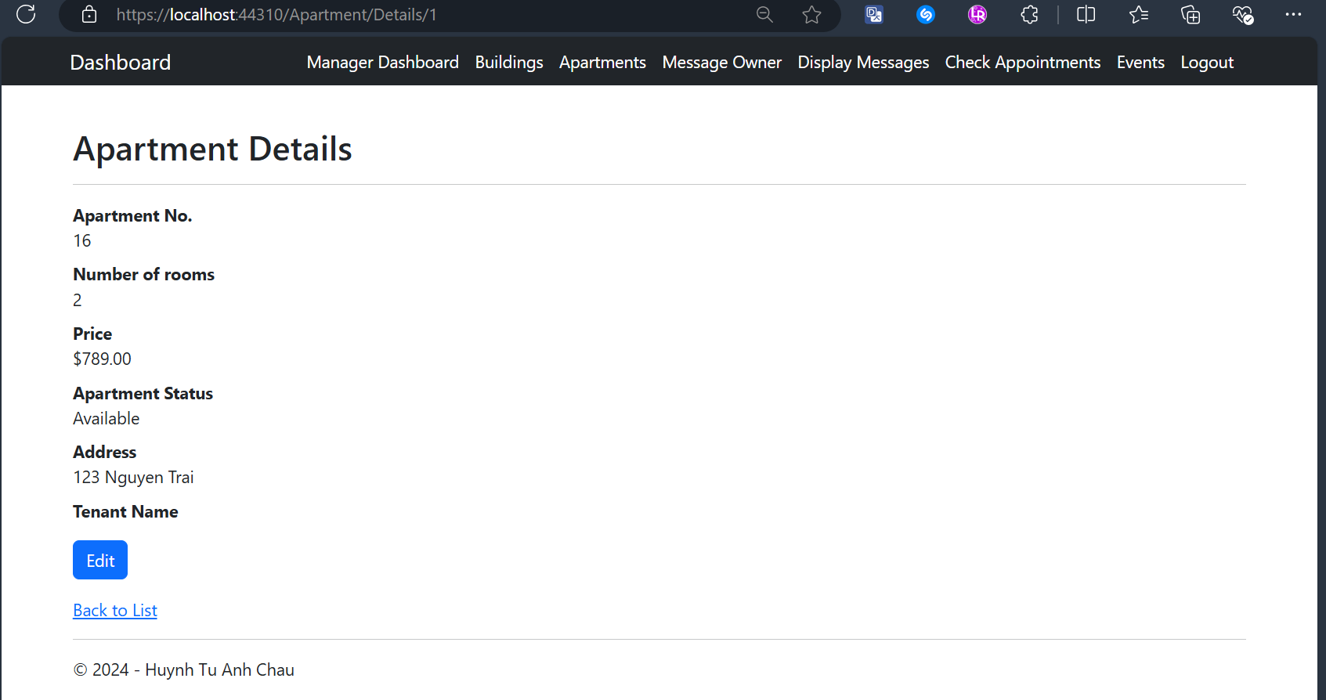

## Manager Deletes an Apartment with Confirmation and Informative Message Screens

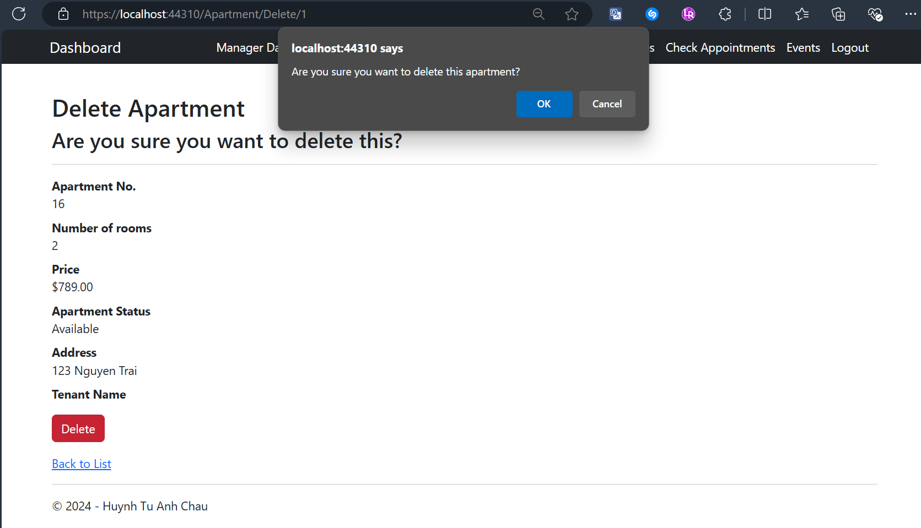

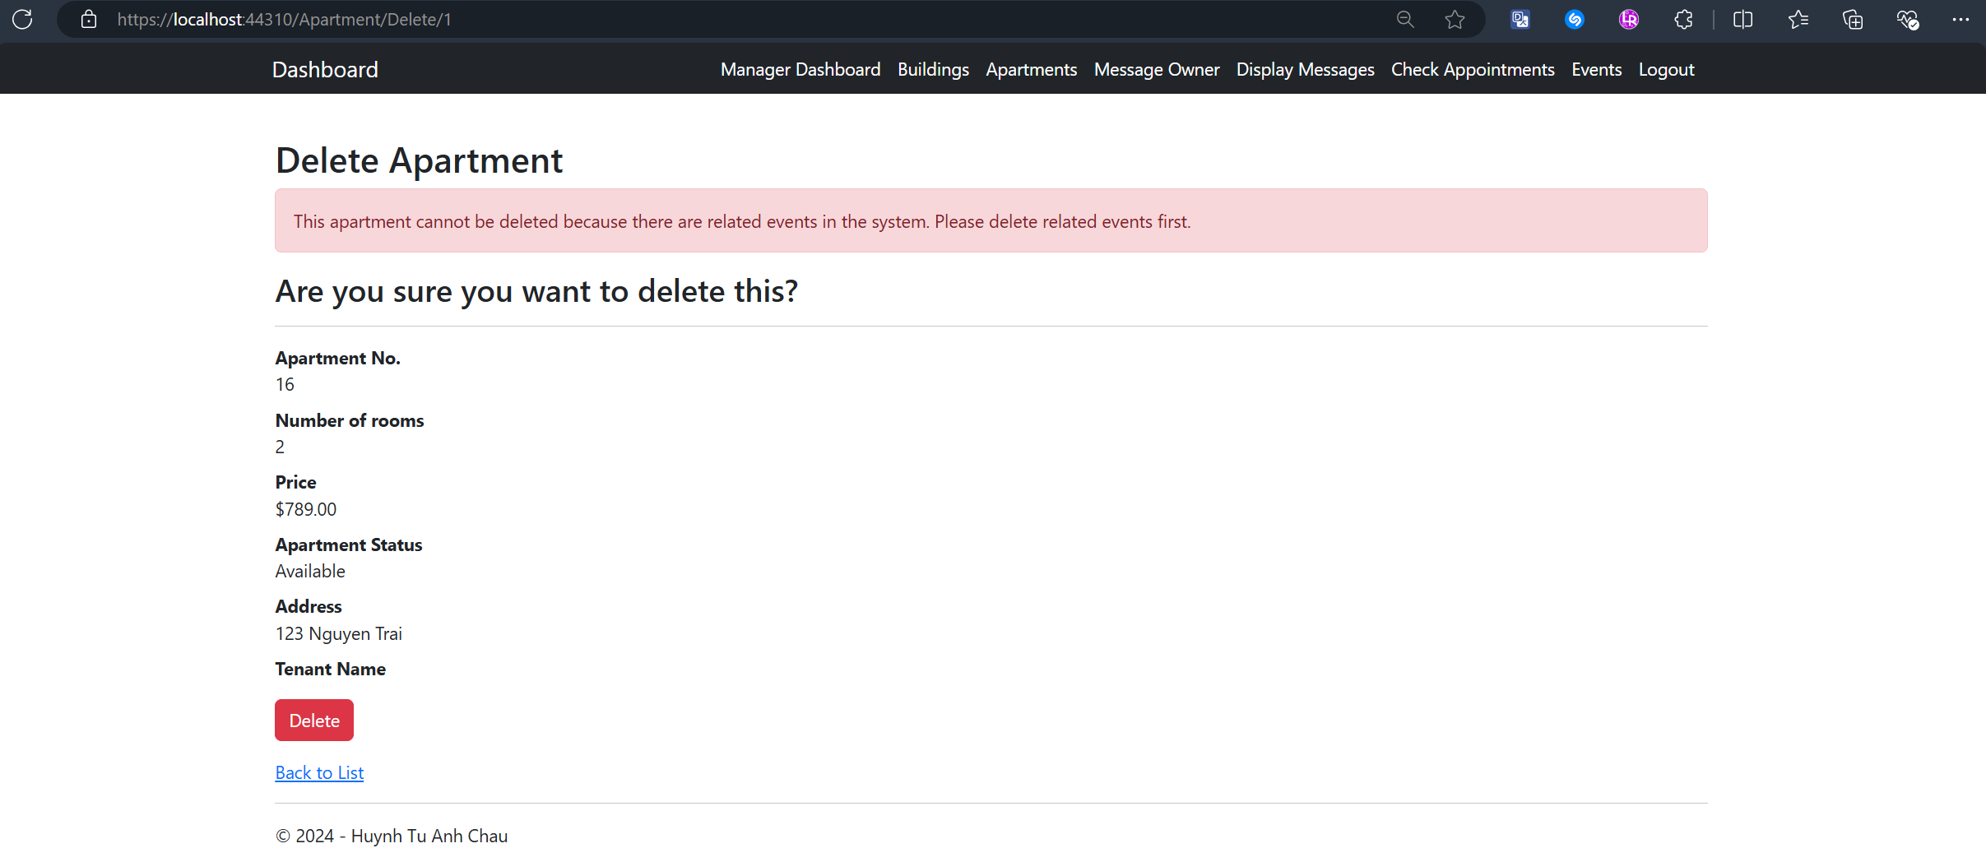

## Manager Views Assigned Message Sent by Owners Screen

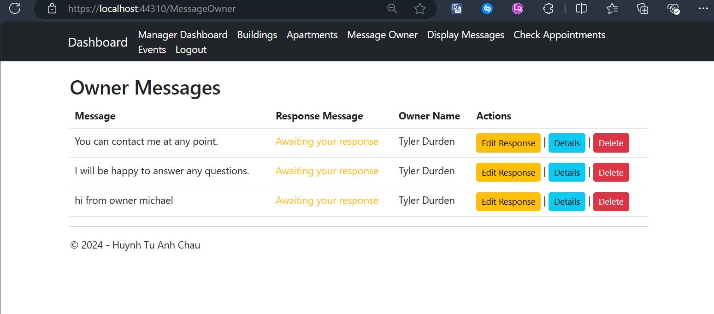

## Manager Responses to A Message Screen

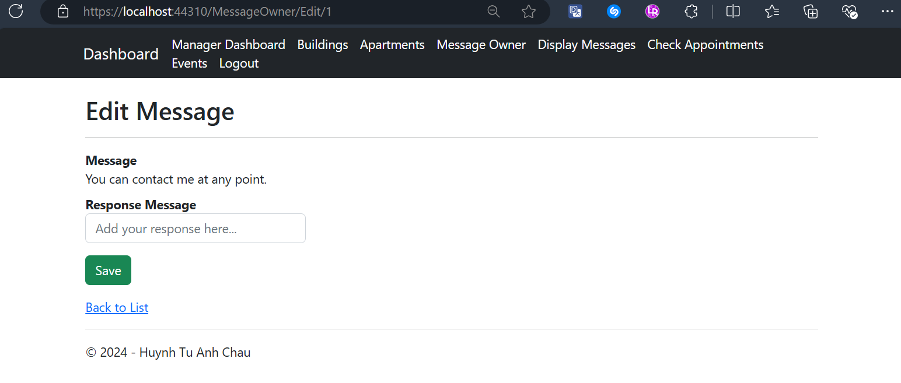

## Manager Views One Message’s Details Screen

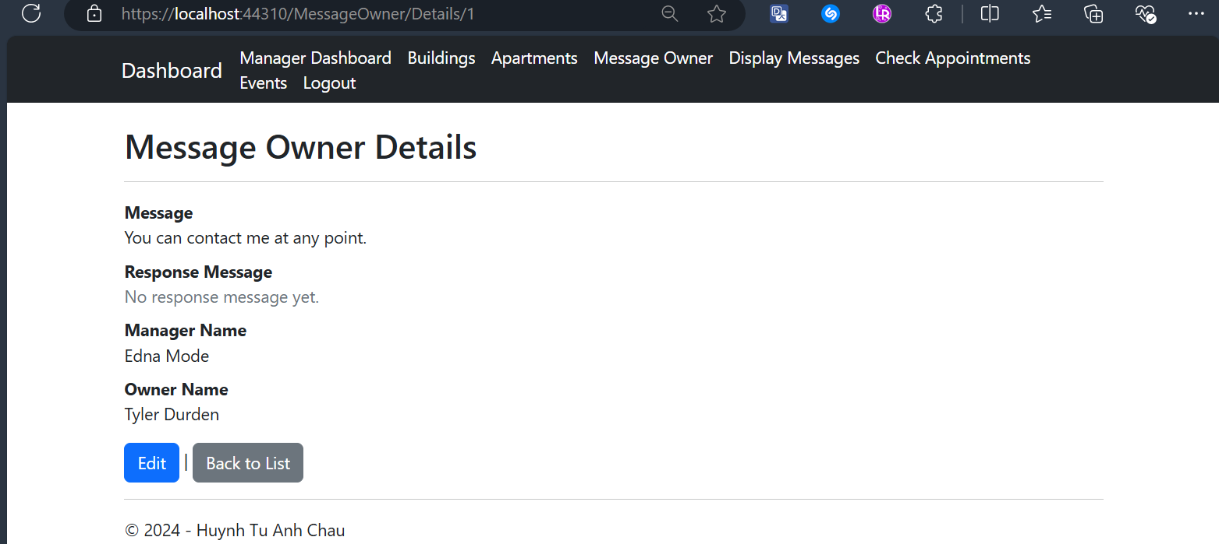

## Manager Deletes a Message with Confirmation Screen

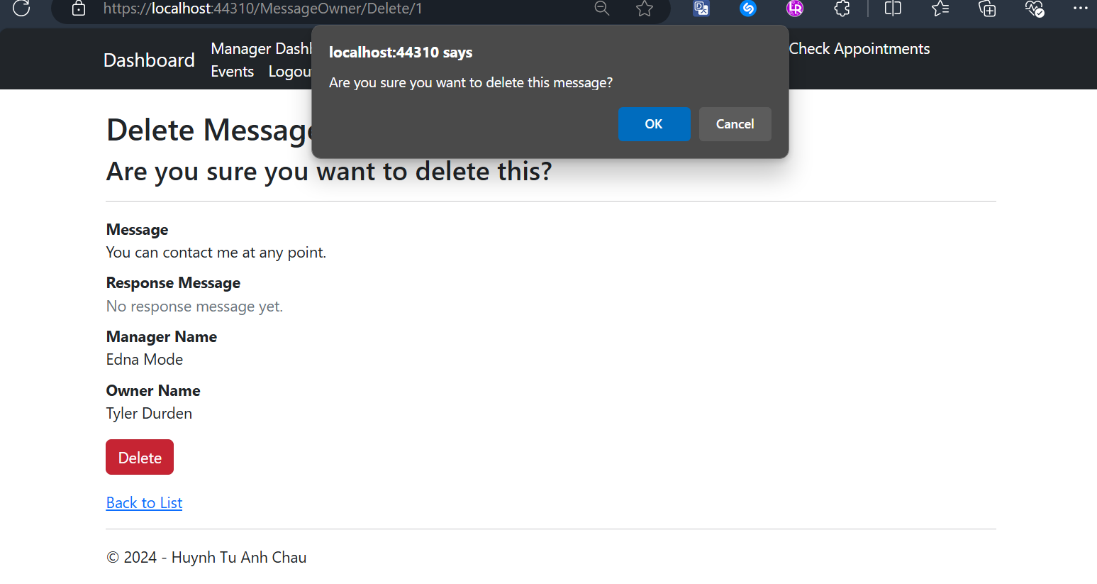

## Manager Views Assigned Messages Sent by Tenants Screen

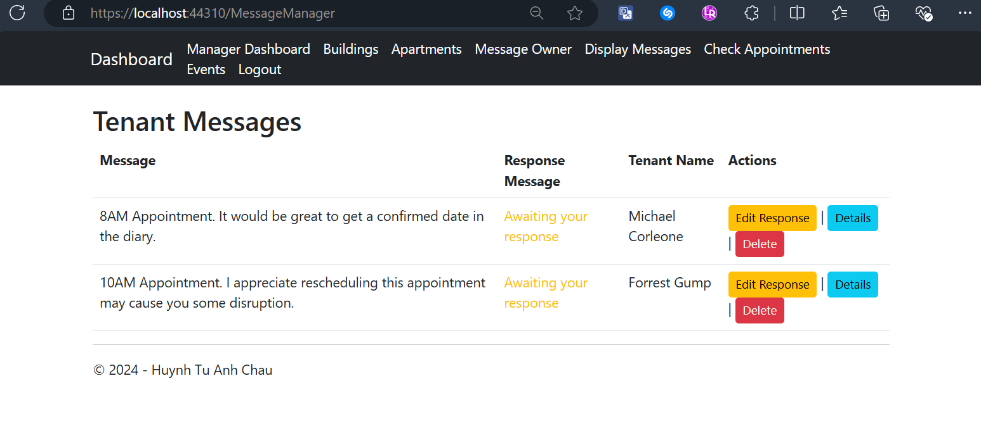

## Manager Responses to a Message Screen

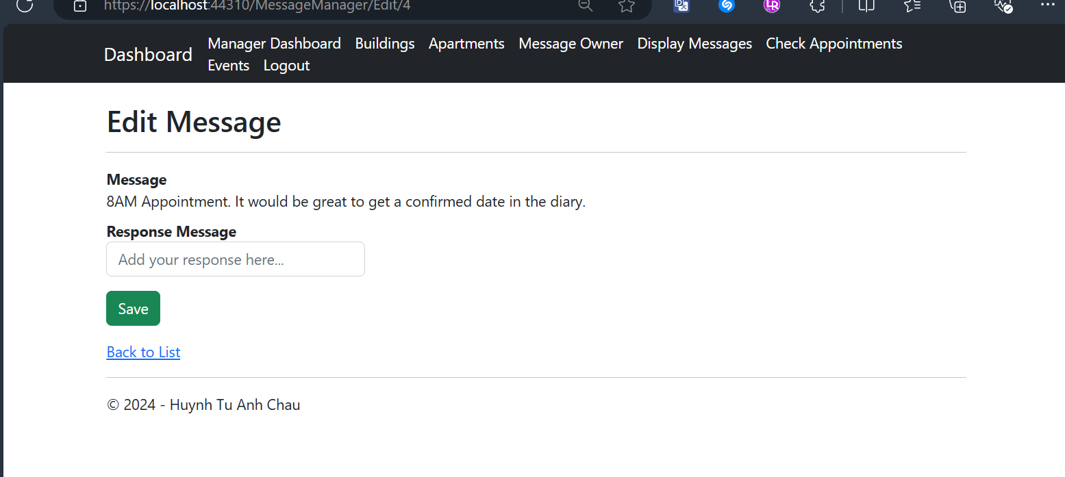

## Manager Views a Message’s Details Screen

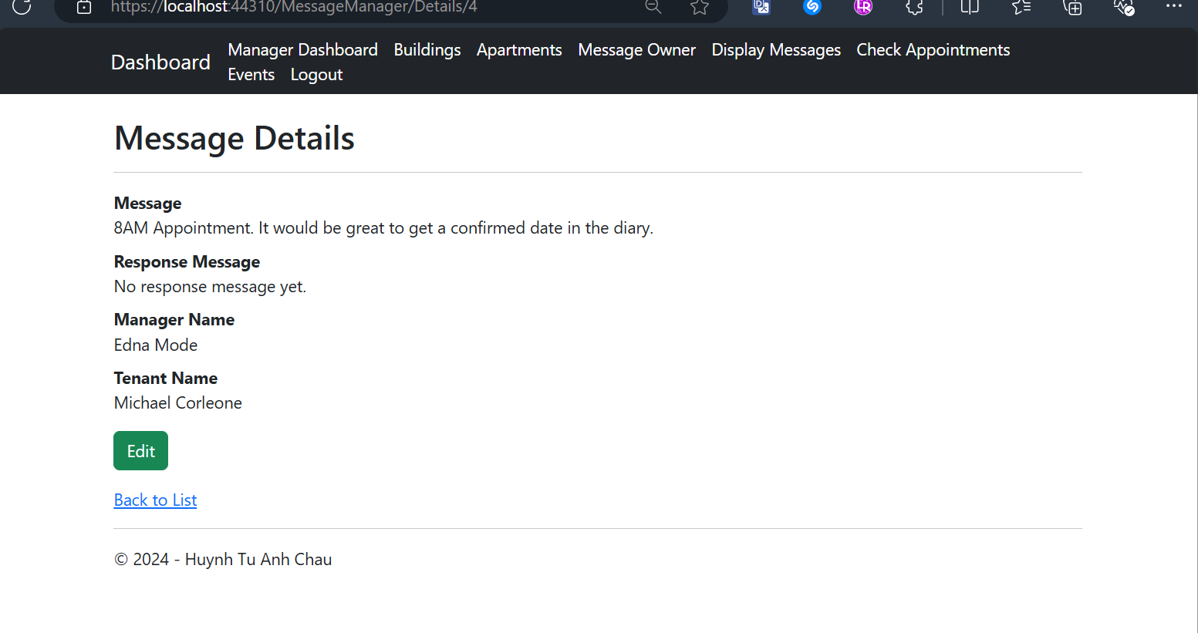

## Manager Deletes a Message with Confirmation Screen

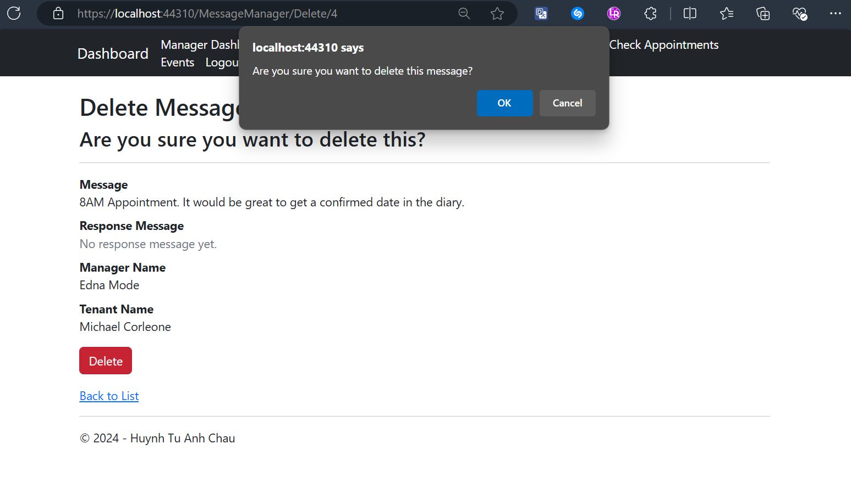

## Manager Views All Created Appointments with CRUD actions Screen

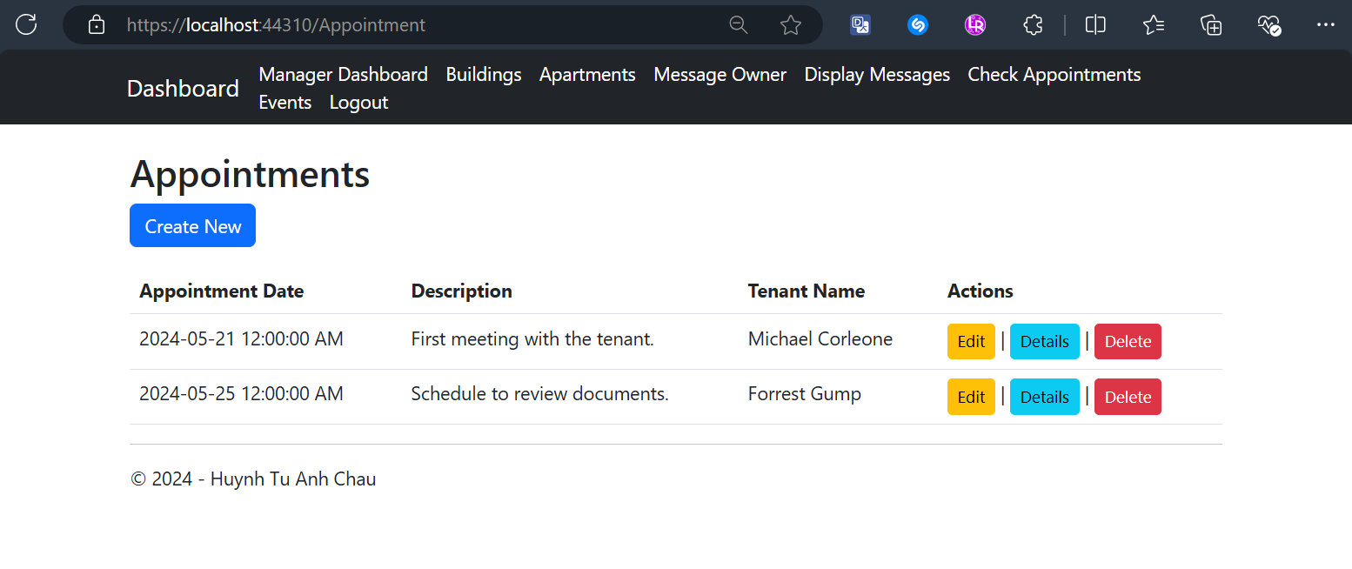

## Manager Edits an Appointment with validation Screens

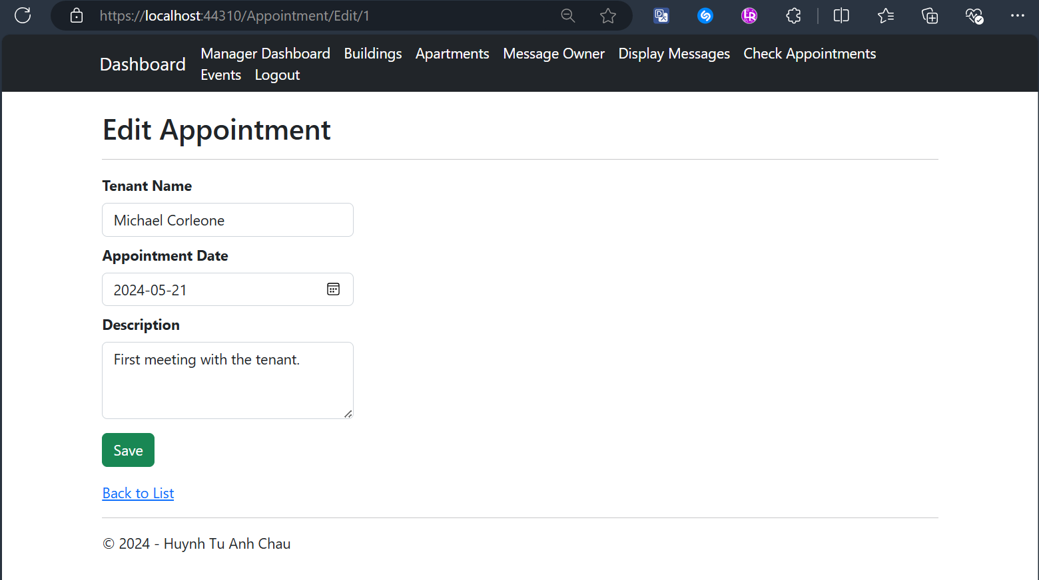

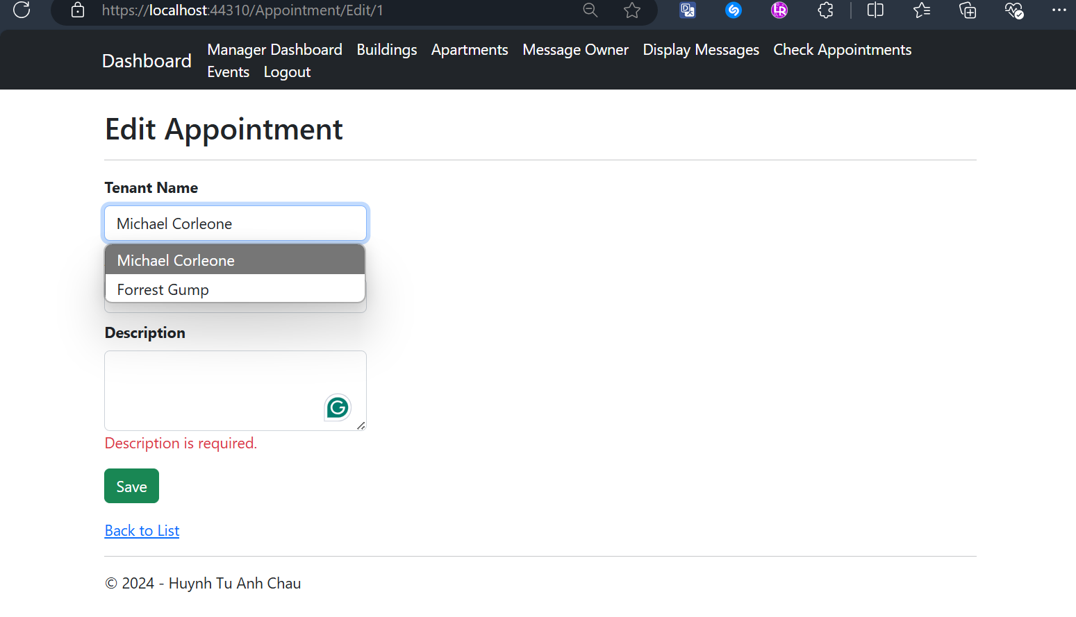

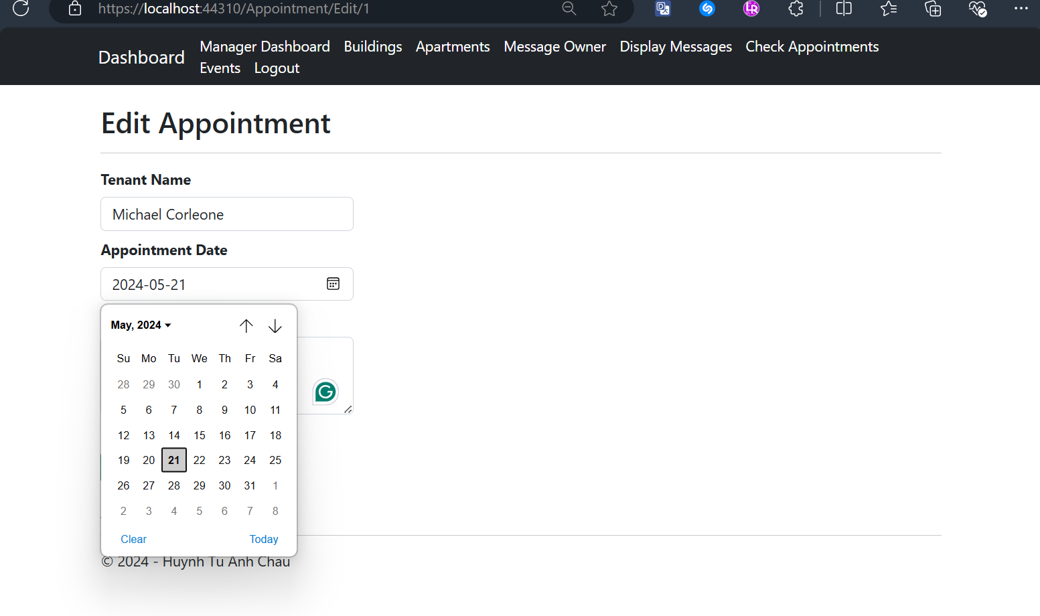

## Manager Deletes an Appointment with confirmation Screen

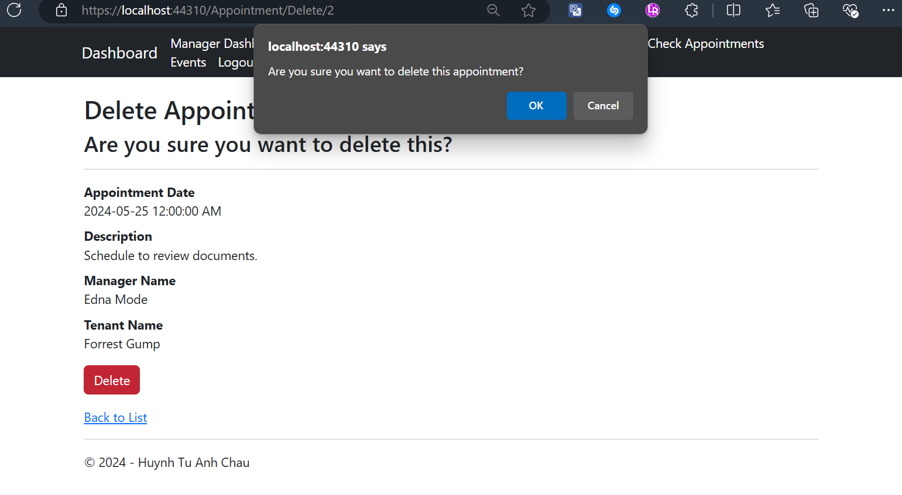

## Manager Creates an Appointment with Tenants (fetching from database) with Validation Screens

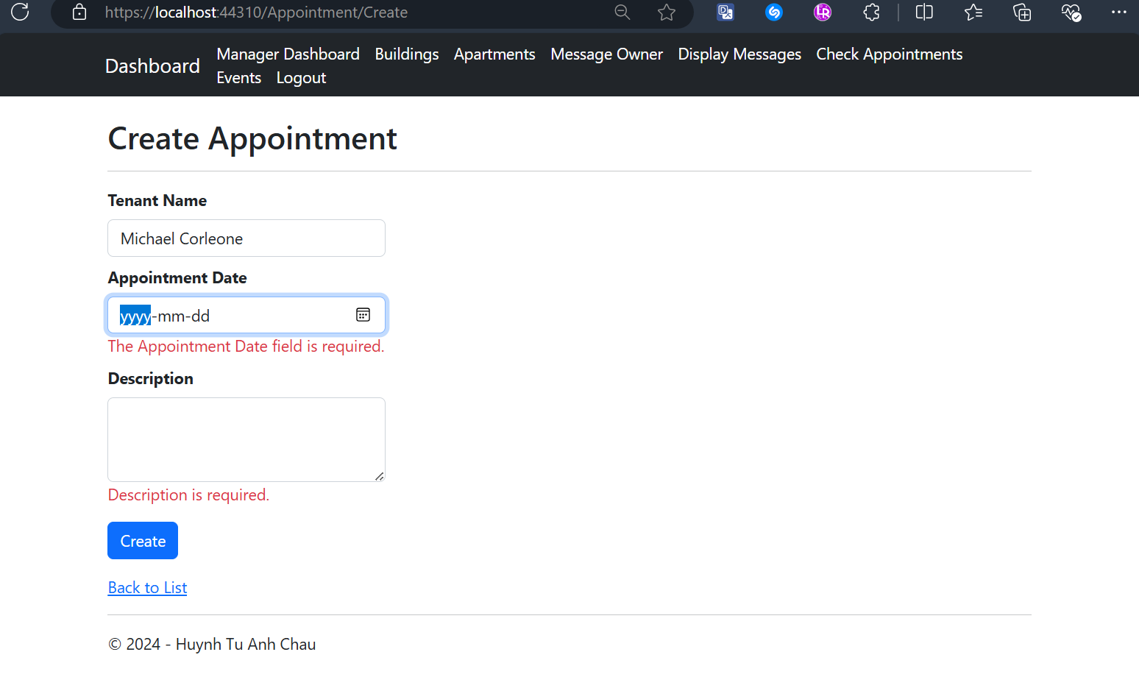

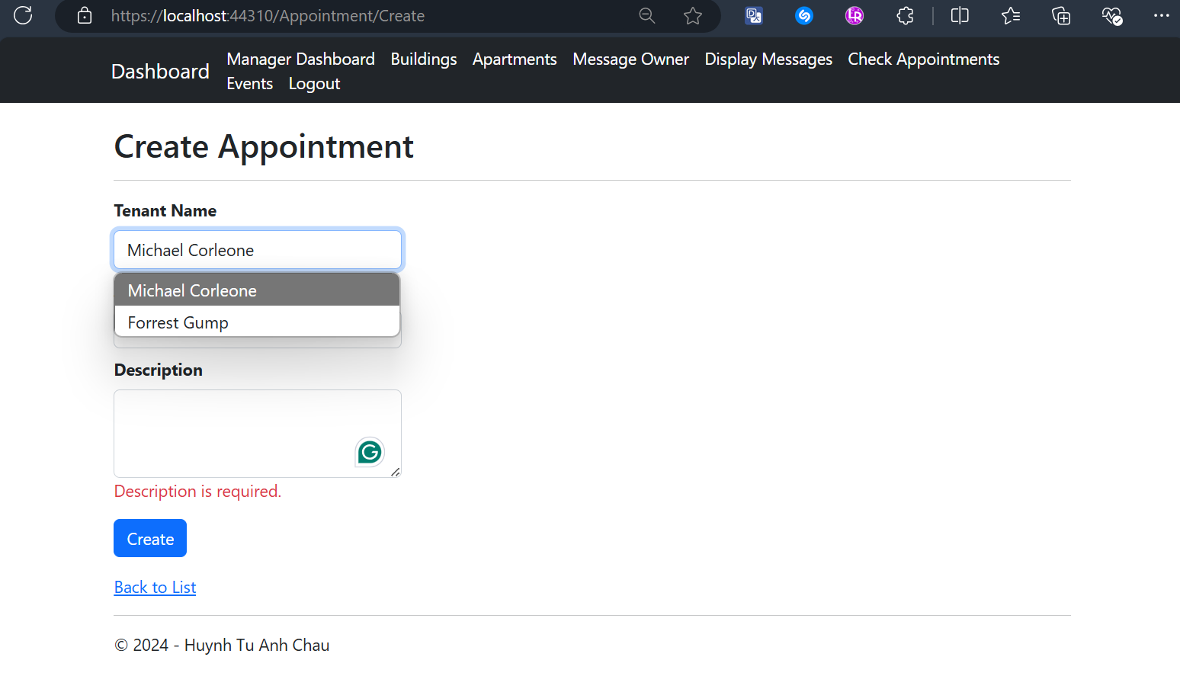

## Manager Views All Created Events with CRUD actions Screen

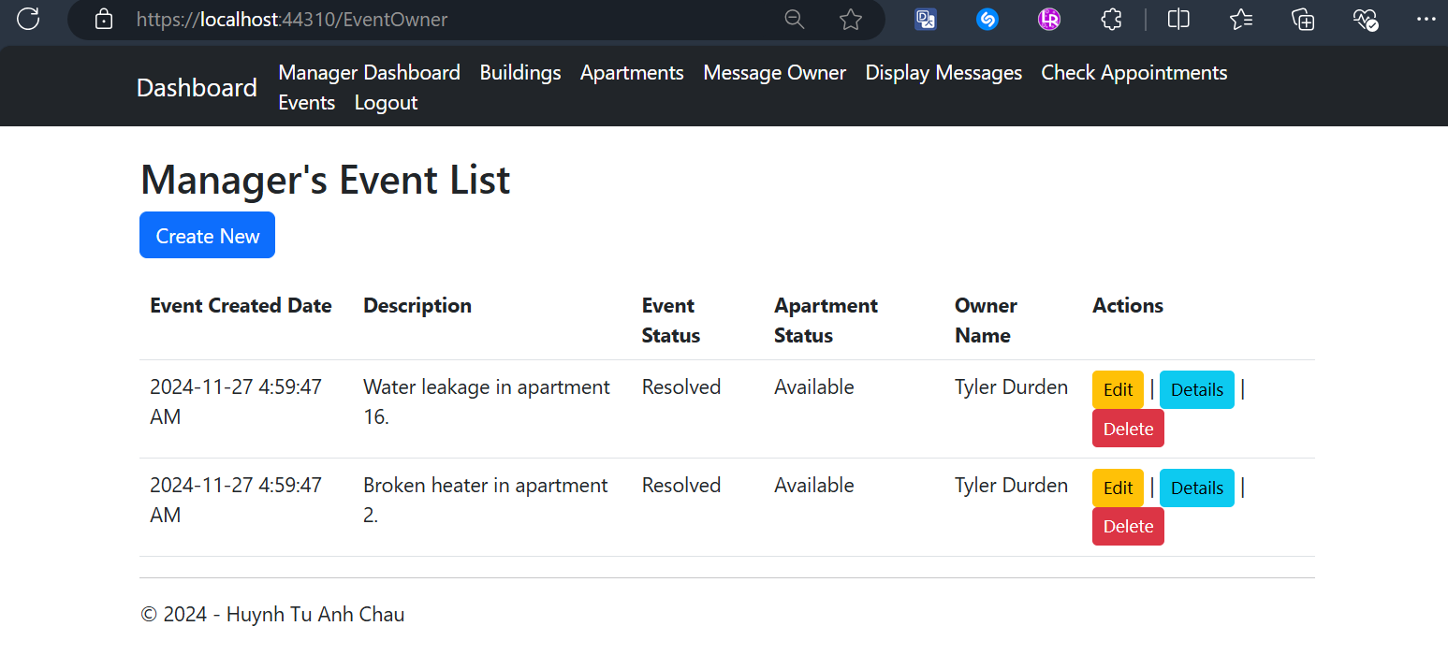

## Managers Views and Edits Description of an Event Screen

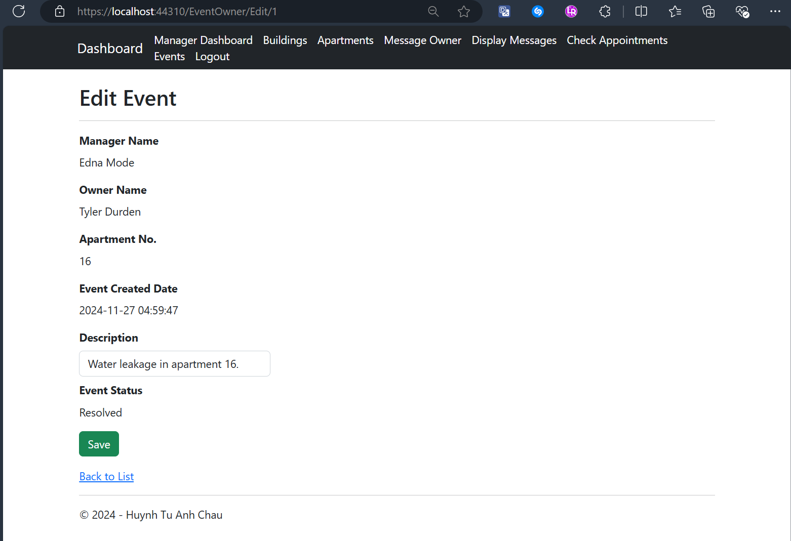

## Manager Views Details of an Event Screen

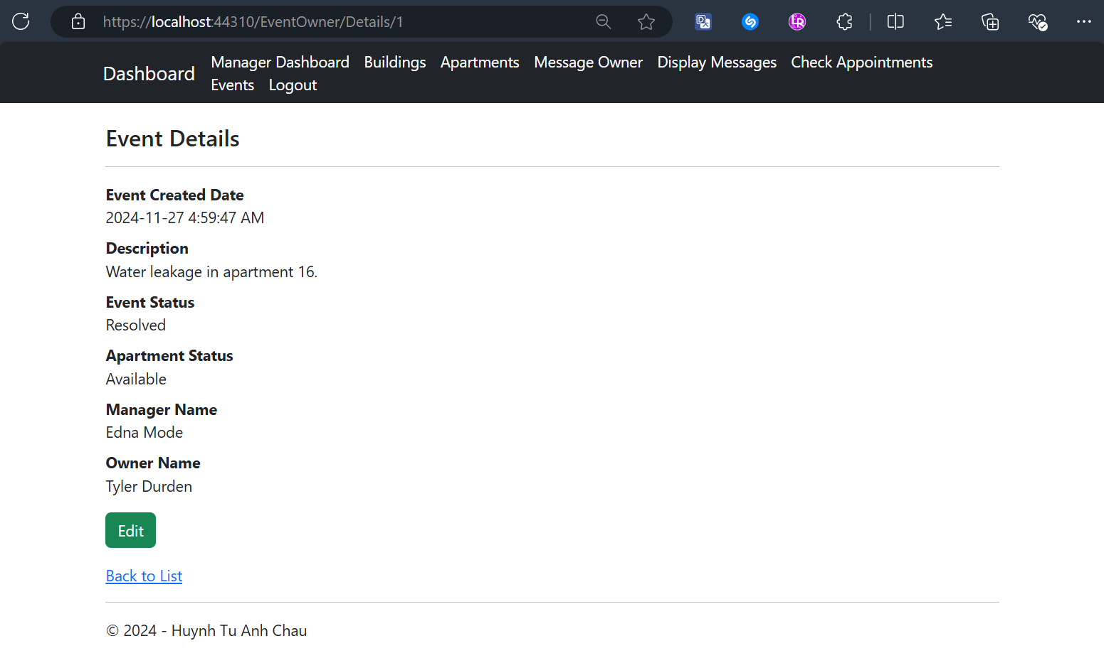

## Manager Deletes an Event with Confirmation Screen

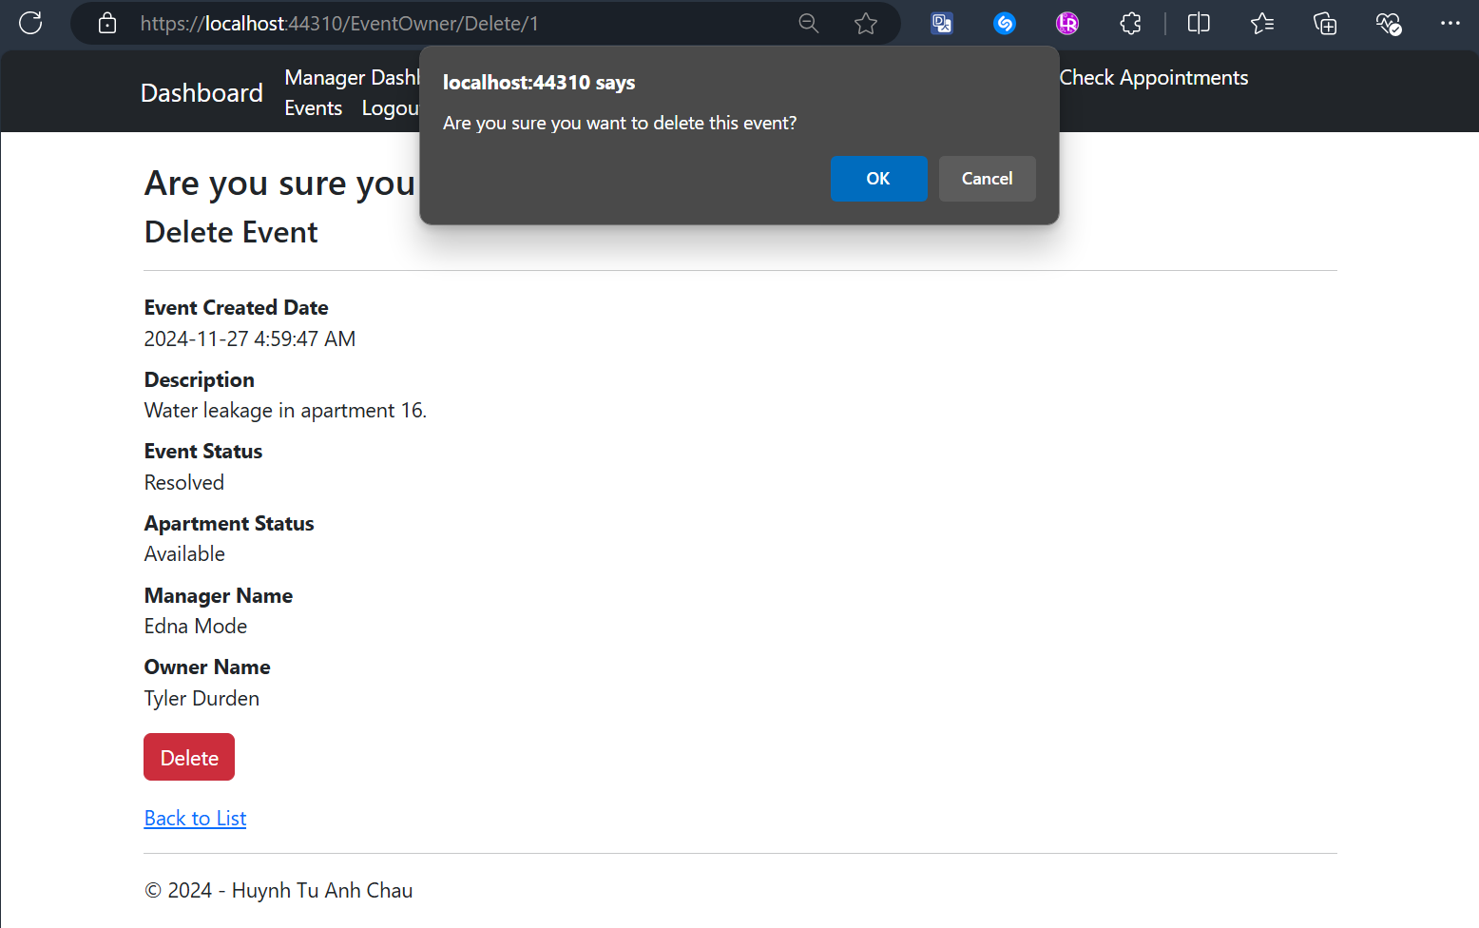

## Manager Creates an Event with Validation Screen

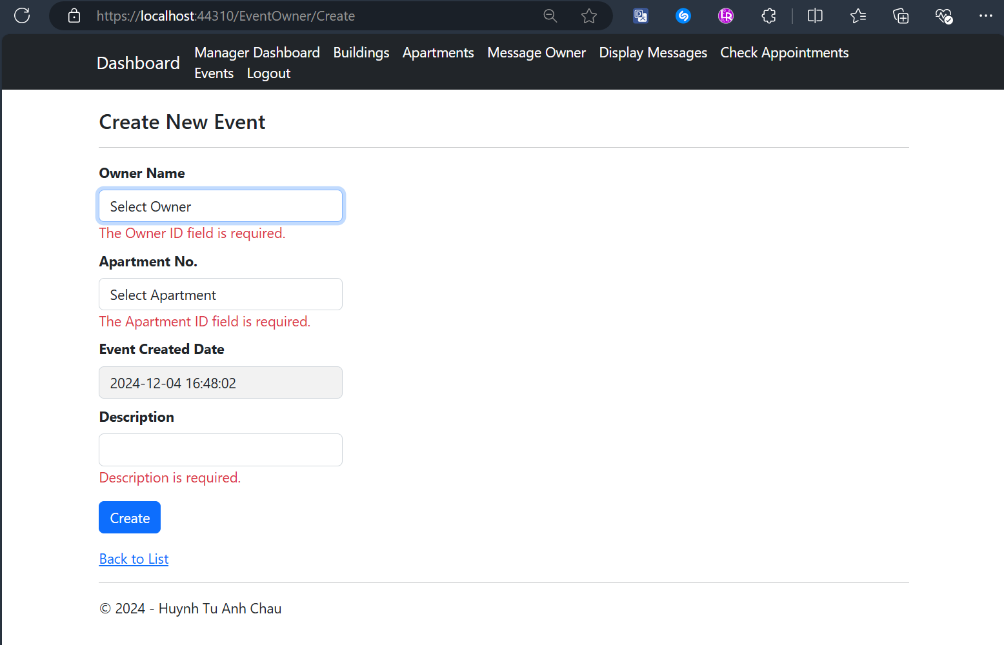

## Tenant Dashboard After Logging-In Screen

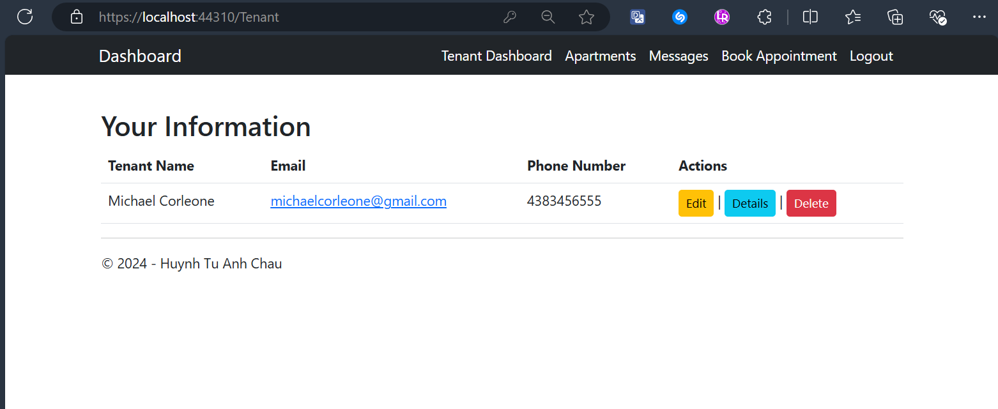

## Tenants Edit Their Profile with Validation Screen

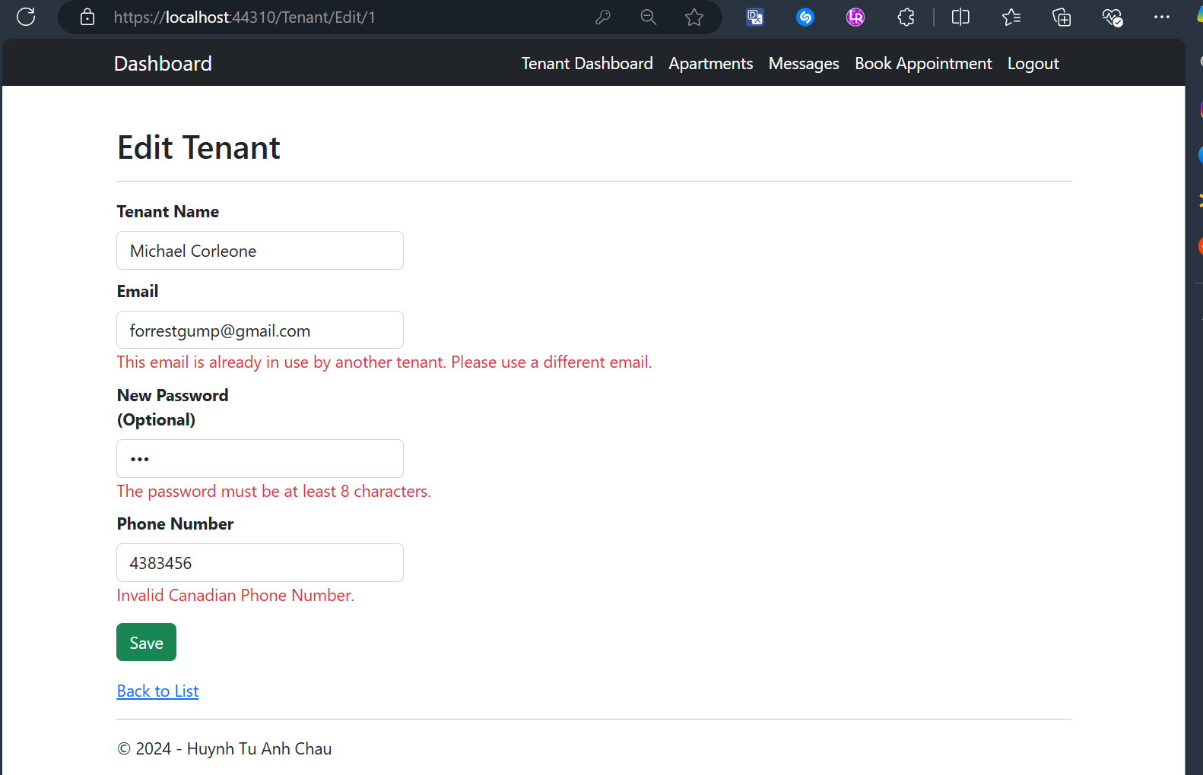

## Tenants View Their Profiles’ Details

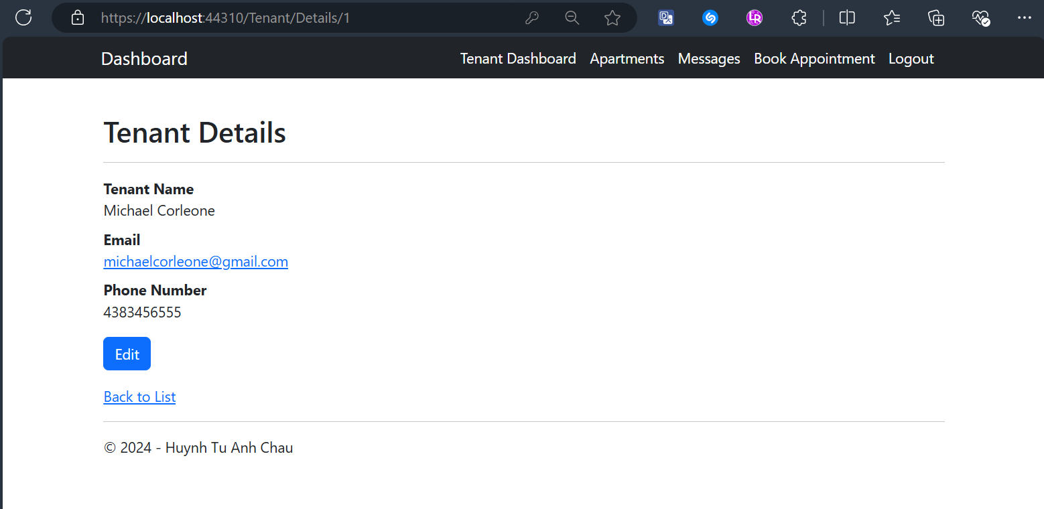

## Tenants Delete Their Profile with Confirmation Screen

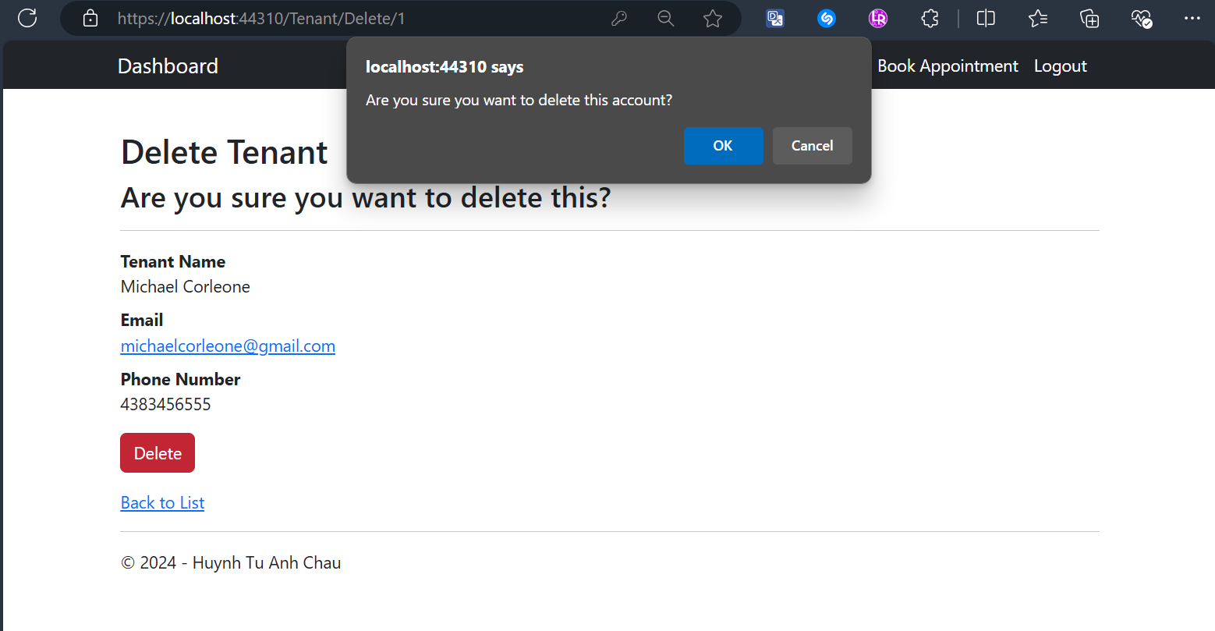

## Tenant Views Only Available and Assigned Apartments with Details Button Screens

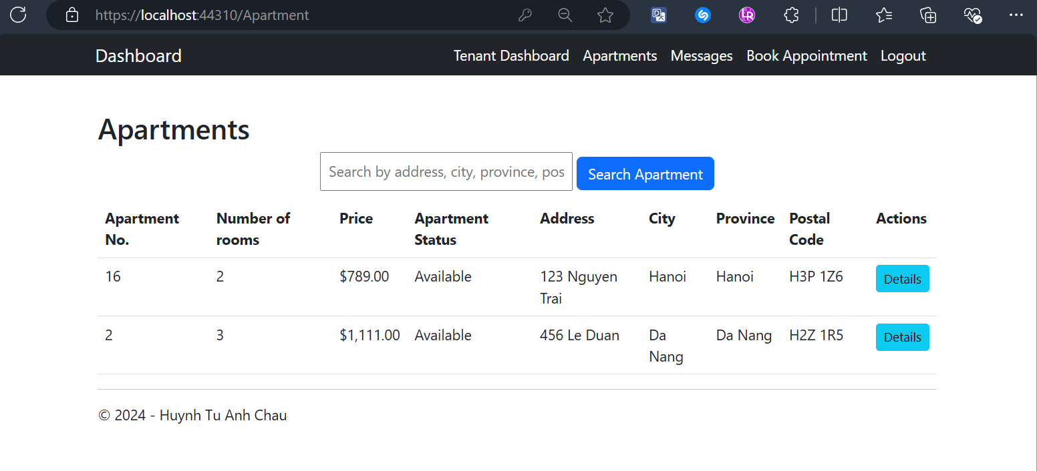

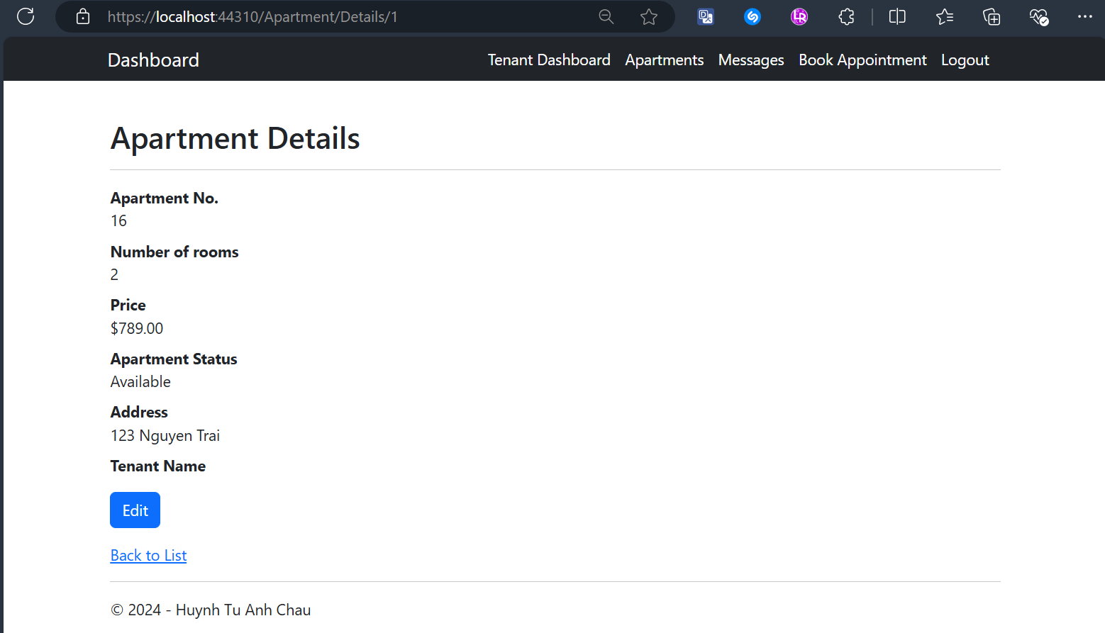

## Tenant Searches for an Apartment Result Screens

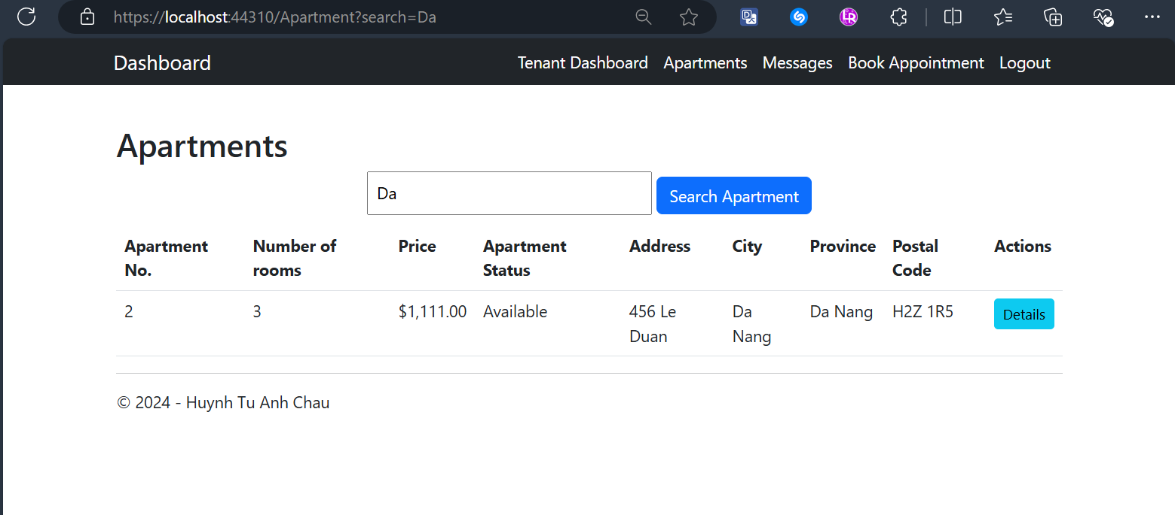

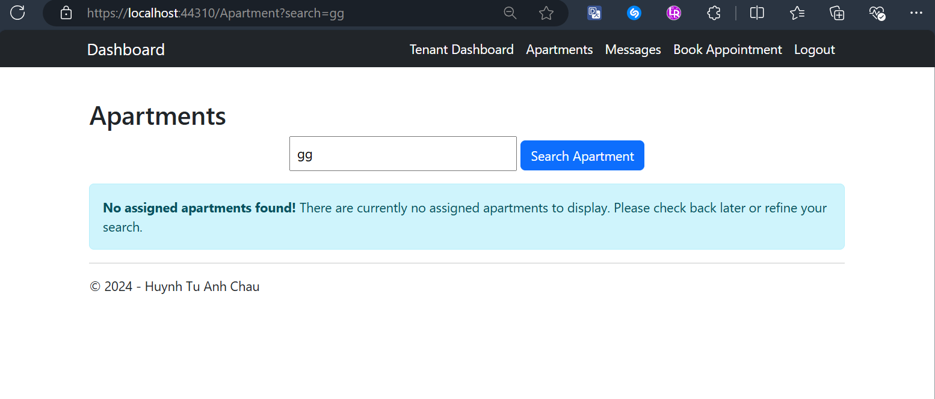

## Tenant Views All Created Messages with CRUD actions Screen

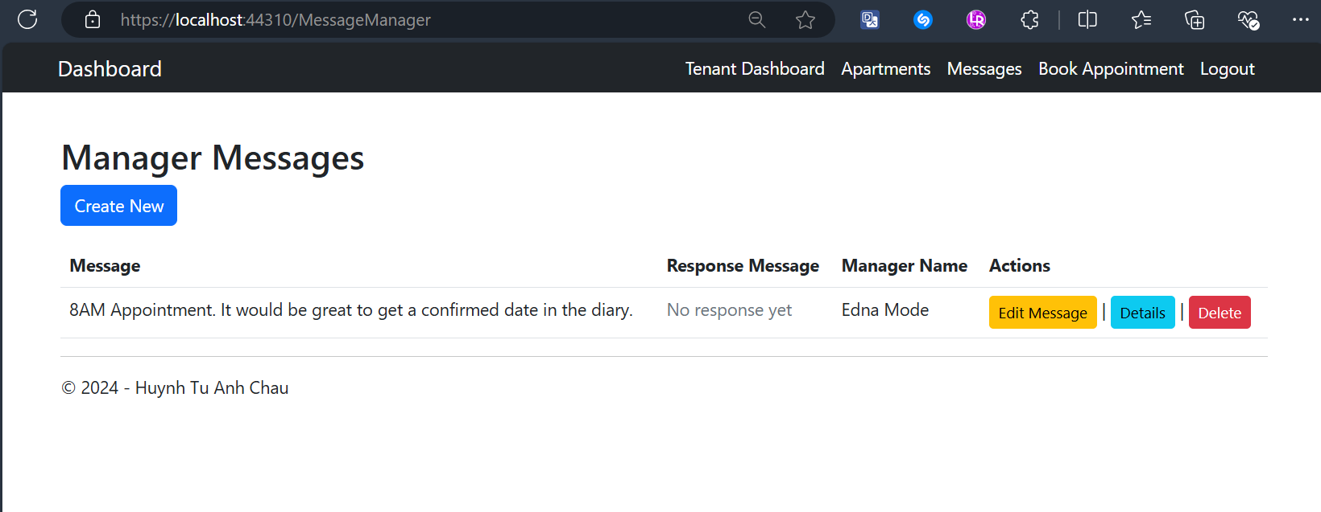

## Tenant Edits a Message with Validation Screen

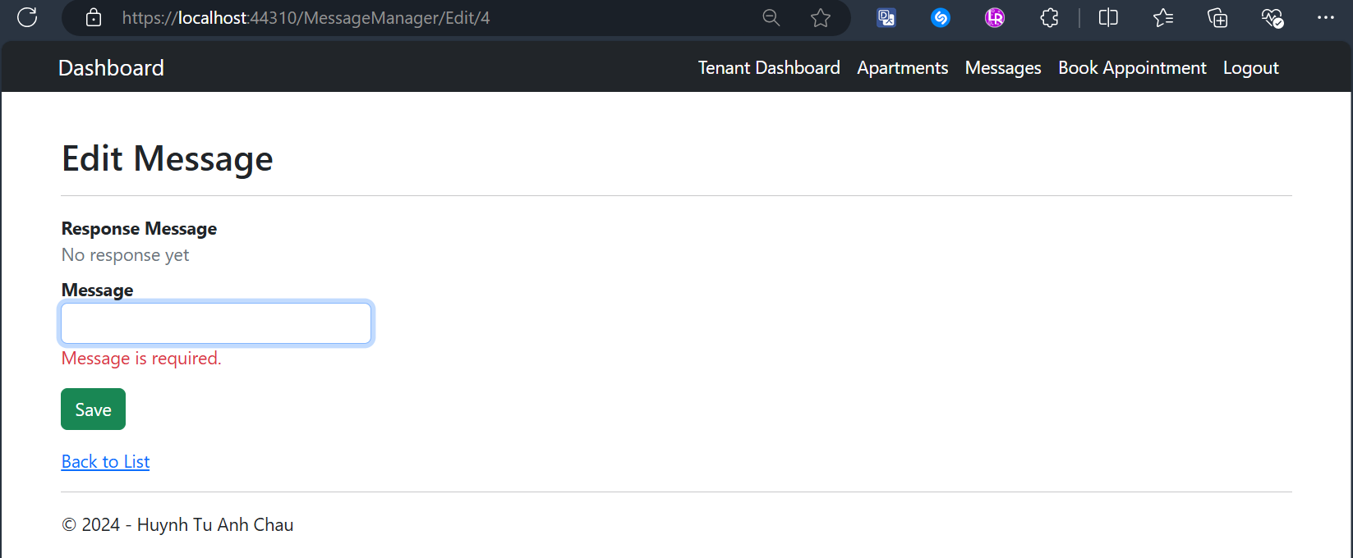

## Tenant Views a Message’s Details Screen

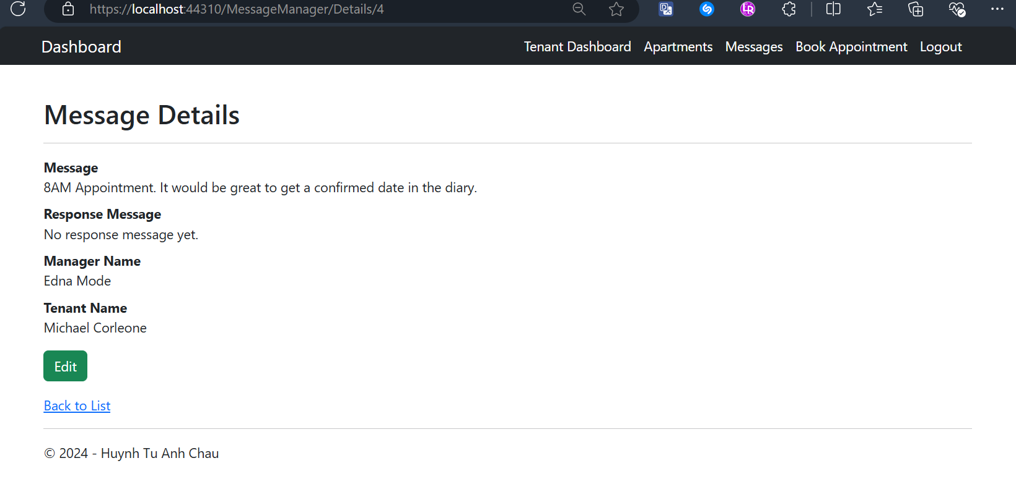

## Tenant Deletes a Message with Confirmation Screens

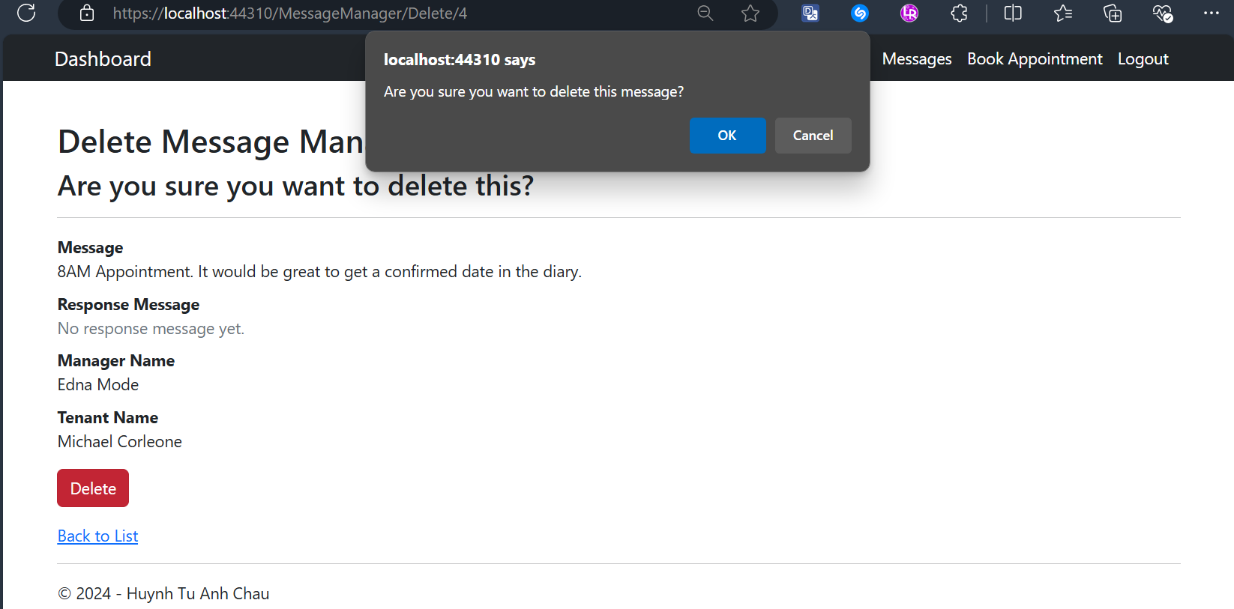

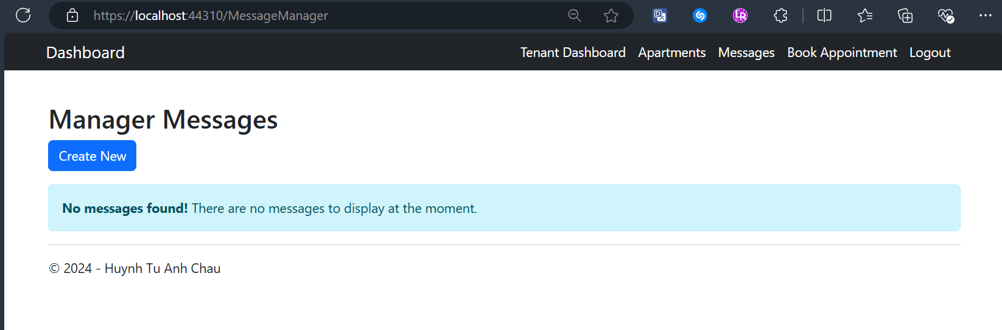

## Tenant Creates a New Message to Managers (fetching from database) with Validation Screen

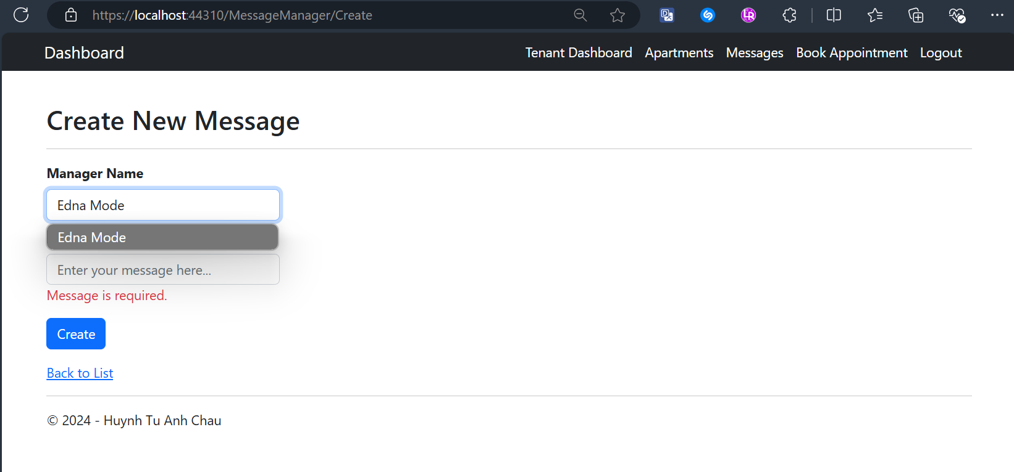

## Tenant Creates a New Appointment with Validation Screen

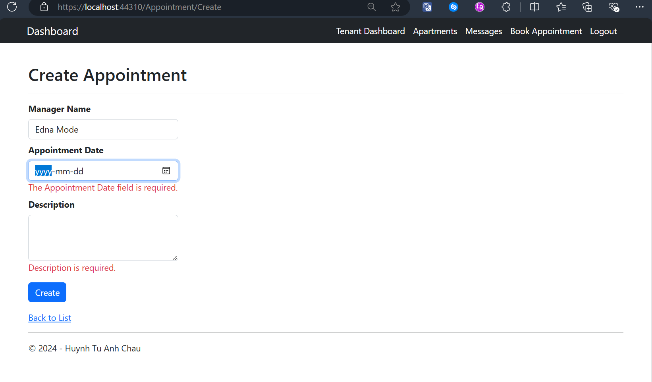

## Tenant Views All Created Appointments with CRUD actions Screen

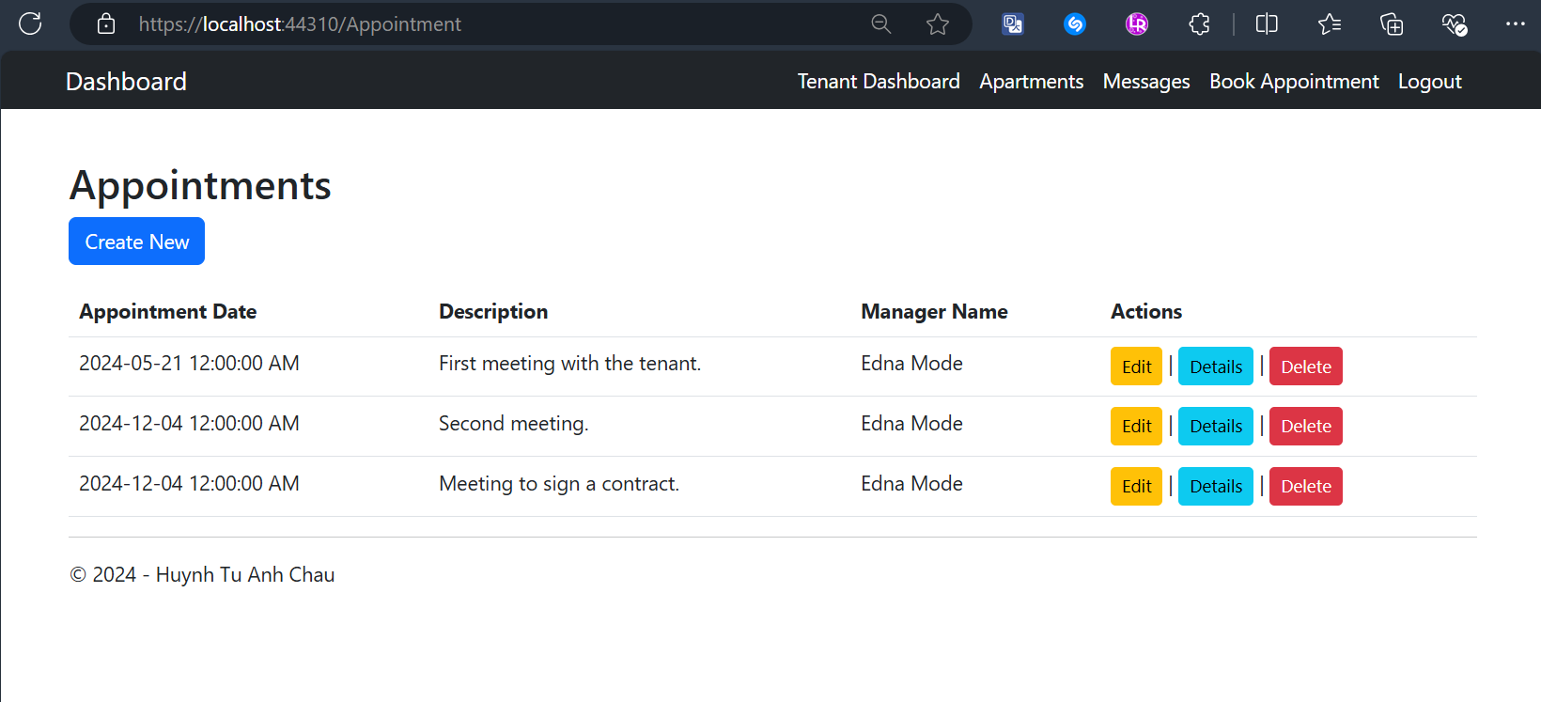

## Tenant Edits an Appointment with Validation Screen

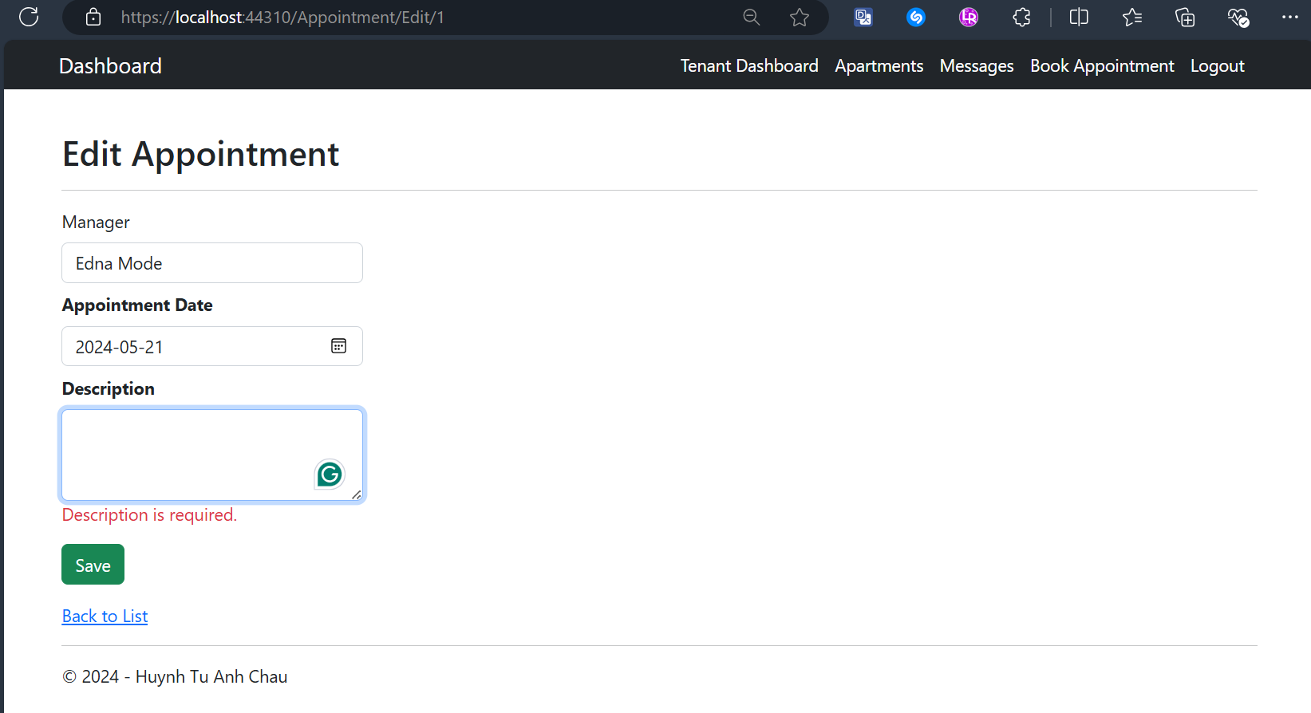

## Tenant Deletes an Appointment with Confirmation Screen

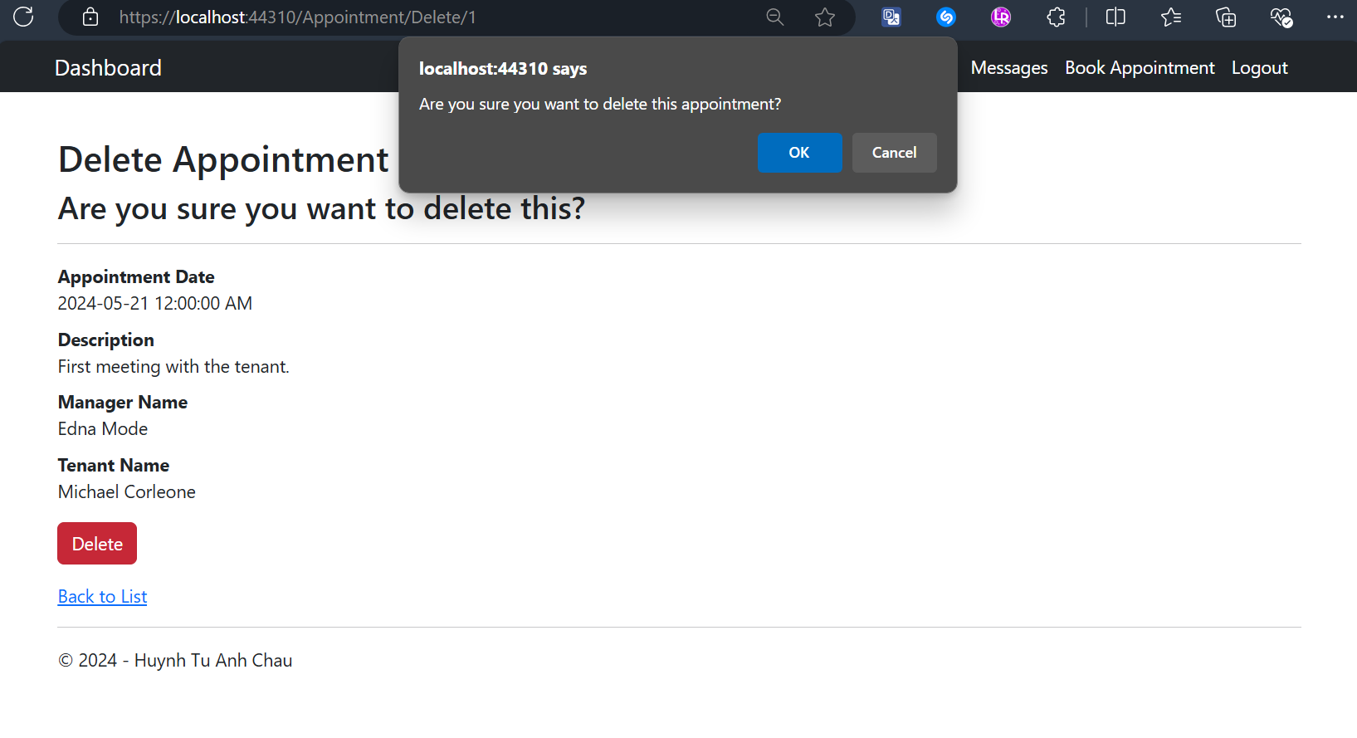

# Conclusion

This project provided hands-on experience with ASP.NET MVC and Entity Framework. The implementation emphasized:

* Leveraging Entity Framework for efficient database operations.
* Applying session-based access control to enhance security.
* Developing user-friendly and responsive web interfaces.

The project also reinforced the importance of planning, testing, and adhering to best practices in web development.

# Sample Data for User Login

## Login as an Owner

* + **Email:** [**tylerdurden@gmail.com**](mailto:tylerdurden@gmail.com)
  + **Password:** password123

## Login as a Manager

* + **Email:** [**ednamode@gmail.com**](mailto:ednamode@gmail.com)
  + **Password:** password123

## Login as a Tenant

* + **Email:** [**michaelcorleone@gmail.com**](mailto:michaelcorleone@gmail.com)
  + **Password:** password123

# Bibliography

• Microsoft ASP.NET Documentation: <https://learn.microsoft.com/aspnet>

• Entity Framework Documentation: <https://learn.microsoft.com/ef>

• Bootstrap Framework: <https://getbootstrap.com>